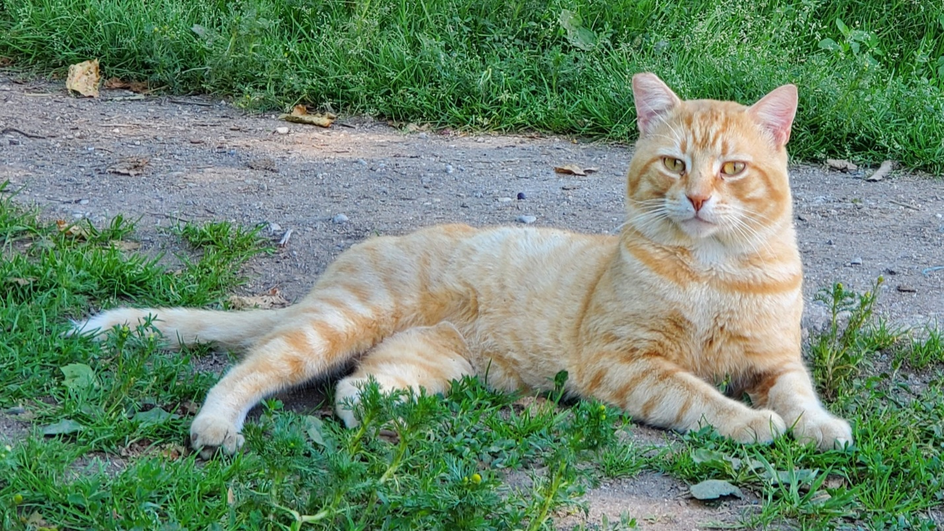
Contemplation and Conversation: 13th Sunday after Pentecost, September 4, 2022
Scripture: Psalm 139 :1-6, 13-18 https://www.biblegateway.com/passage/?search=Psalm%20139%3A1-6%2CPsalm%20139%3A13-18&version=NRSVUE
From Brian Mack
This individual hymn of thanksgiving is a profound prayer addressed to God. It reflects the intimate bond between the Holy One and humankind that was forged in the Garden of Eden, acknowledged by the Prophets, and sealed by covenant through time. The Comforter knows us before the womb and stays with us through all eternity. In turn, we are expected to seek to better understand the essence of the one we call both Holy Mystery and Wholly Love.
The words of the psalmist reassure me that this summer when I am …
walking with another along a narrow path at Marden Park…
working in the fields bringing in hay…
admiring newly hatched wild turkeys…
cuddling with my cats on the couch…
observing the birth pangs of a cow…
driving to a medical appointment…
admiring the athletic ability of a coyote catching mice…
interacting with vendors at the Farmer’s Market…
watching a wheat field ripen…
reading a book or watching an old movie…
having a coffee with a friend in an internet café….
listening to the news on CBC radio…
or watching a crow with a dislocated wing seek nourishment at my cattle feeders…
the Creator is with me.
Like the psalmist, as we continue on our life journey, we are privileged to experience an ever-deepening relationship with God. We can show our gratitude by offering simple words of acknowledgement. We do not have to possess the poetic elegance of David. We can also show our appreciation through everyday acts such as planning a garden, observing the intricacies of the flora and fauna we encounter, looking out a window and noting the changing colors of the sky throughout the day, or humming a song. The list of possibilities is endless. Thanks be to God.
Contemplation and Conversation
How do you show your appreciation to God?
Prayer
Ever present God, thanks for all that you have created and are creating. Help me to find ways to express gratitude for the relationship that we are forging together. Be patient with me when I forget to acknowledge your presence and to honor the central role that you play in my life. Amen
Know you are a valued part of our Rockwood and Stone United Church families.

Further Conversation … Would you like to talk more about today’s reflection? Email Heather at hleffler@rogers.com. Following worship next Sunday, she will invite others to join you in a Zoom break out room to share in further conversation.

Our Rockwood Stone Family
If you missed today’s worship service, email rockwoodstoneuc@gmail.com for a YouTube link.

United Church of Canada
The 11th Assembly of the World Council of Churches (WCC) is in Karlsruhe, Germany this year. The Assembly, a meeting of the WCC’s highest governing body, takes place August 31–September 8, with the theme “Christ's Love Moves the World to Reconciliation and Unity.” United Church of Canada delegates, selected through the church’s nominations process, will share in prayer and celebration, while participating in crucial decision making. Several members of the delegation have leading roles in the Assembly. You can follow the livestream of the Assembly, and watch The United Church of Canada Facebook page and our other social channels for updates from delegation members, video interviews, and more.
"Christ's Love Moves the World". A song for the 11th Assembly of the World Council of Churches: https://www.youtube.com/watch?v=xsITpikbe3U
A gift of belonging to a church is that the practice of gathering together for worship … to pray, sing, listen to scripture and share how God touches our lives – helps us grow in deeper relationship with God and each other. We are offering this practice of sharing beyond Sunday morning to deepen our connection. Each week you are offered a picture, a scripture and a question for contemplation, as well as a short reflection for you to contemplate, have conversation with people in your life and/or join an online conversation on our Rockwood Stone Facebook page.

