Contemplation and Conversation: 2nd Sunday of Creation Time, September 18, 2022
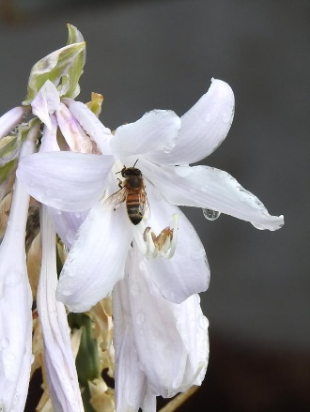
Scripture: 1 Timothy 2:1-7 https://www.biblegateway.com/passage/?search=1%20Timothy%202%3A1-7&version=NRSVUE
From Rev. Heather Leffler:
The letter writer is urging us to pray for everyone – for ourselves and our family, for the people in our neighbourhoods, communities, churches, country and the world. We are particularly asked to pray for leaders in high places.
Whatever we think of our leaders, whether they are elected or acclaimed or there by birth, they need our prayers. It is easy to form opinions about people from what we read or hear in the news or on social media and give up on our leaders or openly condemn them. If we are going to help bring about God’s kingdom, we need to hold all people in prayer, especially those who have the power to make positive changes.
Leading can be a very lonely, challenging place. People in positions of power face temptations to make choices that benefit the people closest to them regardless of the impact of others. Leaders, like all of us, need prayers to resist temptation and to have the wisdom to make decisions that care for all people and creation. The epistle writer is inviting us to surround them in prayer.
Contemplation and Conversation
Who are you being invited to pray for today?
Prayer
Holy One, we pray for wisdom and discernment for King Charles III as he lives into his new role.
May his example help our leaders in Canada and across the Commonwealth
make choices that care for your creation and your people. Amen.

Know you are a valued part of our Rockwood and Stone United Church families.

Further Conversation … Would you like to talk more about today’s reflection? Email Heather at hleffler@rogers.com.

Our Rockwood Stone Family
If you missed today’s worship service, email rockwoodstoneuc@gmail.com for a YouTube link.

United Church of Canada From Moderator Carmen Lansdowne on September 12
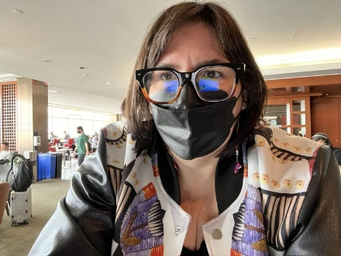
For the coming three days I’ll be in Edmonton, AB, attending the first of 8 national gatherings by invite of the federally appointed interlocutor on unmarked graves. I have been asked to witness the gathering, and to share back (along with representatives of the Roman Catholic and Anglican Church of Canada) “what we heard” as representatives of denominations who operated Indian Residential Schools.
I imagine there will be some hard sharing - and I firmly believe that part of making things right is to continue to show up as an institution and to be accountable for the harm we have caused and continue to cause when we don’t see the humanity in the other.
Our position as a denomination is that we will never lead on investigations (taking a trauma-informed approach), but that we will always be present and willing partners to communities who want support to investigate what happened on the sites of those schools run by the UCC.
This continued willingness to be accountable will be challenging for some in our church. But for many of the past 40 years since we started on this journey, we have only done the bare minimum. We have an ethical and moral obligation to do better and to encourage the Crown (in terms of our government and the monarchy) to do the same. There will never be enough reparations for the damage done and the failure to address that damage. AND… this is not something non-indigenous people in the church can simply “fix” on their own timeline. Our position should always be to respect indigenous-led approaches.

A gift of belonging to a church is that the practice of gathering together for worship … to pray, sing, listen to scripture and share how God touches our lives – helps us grow in deeper relationship with God and each other. We are offering this practice of sharing beyond Sunday morning to deepen our connection. Each week you are offered a picture, a scripture and a question for contemplation, as well as a short reflection for you to contemplate, have conversation with people in your life and/or join an online conversation on our Rockwood Stone Facebook page.

