Contemplation and Conversation: 3rd Sunday of Creation Time, September 25, 2022
Scripture: Jeremiah 32:1-3, 6-15 https://www.biblegateway.com/passage/?search=Jeremiah%2032%3A1-3%2CJeremiah%2032%3A6-15&version=NRSVUE
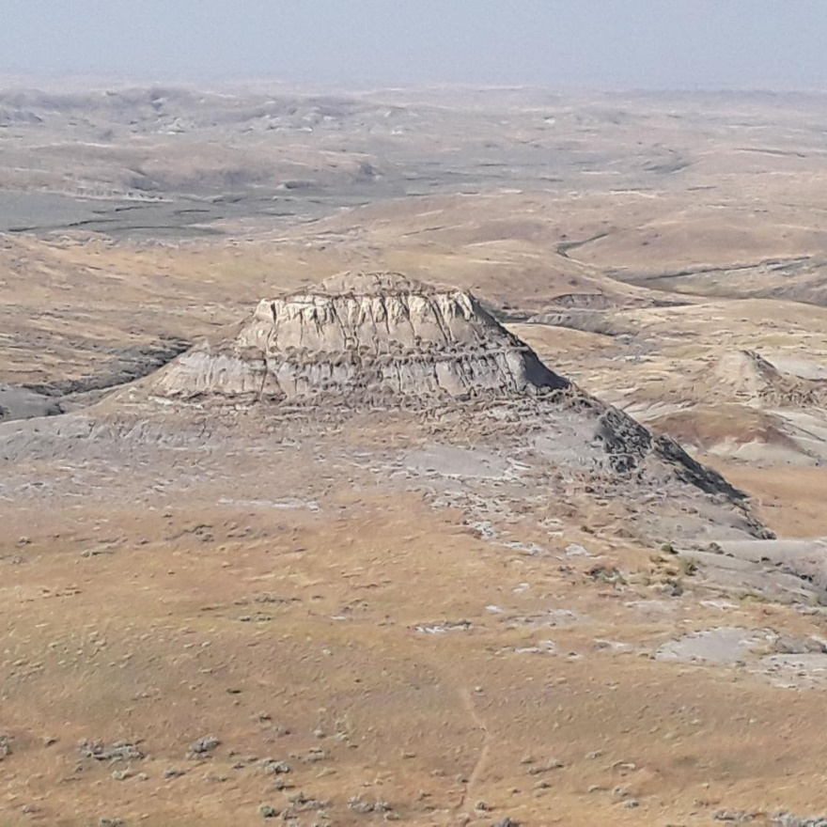
¹ The word that came to Jeremiah from the Lord in the tenth year of King Zedekiah of Judah, which was the eighteenth year of Nebuchadrezzar. ² At that time the army of the king of Babylon was besieging Jerusalem, and the prophet Jeremiah was confined in the court of the guard that was in the palace of the king of Judah, ³ where King Zedekiah of Judah had confined him. Zedekiah had said, “Why do you prophesy and say: Thus says the Lord: I am going to give this city into the hand of the king of Babylon, and he shall take it;
¹Photo by Barb Parker
⁶ Jeremiah said, “The word of the Lord came to me: ⁷ Hanamel son of your uncle Shallum is going to come to you and say, ‘Buy my field that is at Anathoth, for the right of redemption by purchase is yours.’ ” ⁸ Then my cousin Hanamel came to me in the court of the guard, in accordance with the word of the Lord, and said to me, “Buy my field that is at Anathoth in the land of Benjamin, for the right of possession and redemption is yours; buy it for yourself.” Then I knew that this was the word of the Lord.
⁹ And I bought the field at Anathoth from my cousin Hanamel and weighed out the silver to him, seventeen shekels of silver. ¹⁰ I signed the deed, sealed it, got witnesses, and weighed the silver on scales. ¹¹ Then I took the sealed deed of purchase containing the terms and conditions and the open copy, ¹² and I gave the deed of purchase to Baruch son of Neriah son of Mahseiah, in the presence of my cousin Hanamel, in the presence of the witnesses who signed the deed of purchase, and in the presence of all the Judeans who were sitting in the court of the guard. ¹³ In their presence I charged Baruch, saying, ¹⁴ “Thus says the Lord of hosts, the God of Israel: Take these deeds, both this sealed deed of purchase and this open deed, and put them in an earthenware jar, in order that they may last for a long time. ¹⁵ For thus says the Lord of hosts, the God of Israel: Houses and fields and vineyards shall again be bought in this land.”
From Rev. Heather Leffler:
Many of us long for this to be a time of getting back to normal. Not only is Covid-19 still active, the impacts of the pandemic on individuals, families and communities, businesses, our health care and education systems continue to be very real. Where can we find hope, when so many people are struggling?
Jeremiah’s story is a reminder that in the most challenging times we can be confident that God is with us. Locked in the palace with the King, knowing that they were about to be exiled to Babylon or worse, Jeremiah bought his family’s land from his cousin Hanamel. He saw his cousin’s request as a sign from God that the people of Judah had not been abandoned. He carried out the transection and ensured the deed would be preserved for the future to show his deep trust that no matter what the people were facing God would return them to Jerusalem.
Jeremiah urges us to look for signs of God’s activity no matter what is happening in our lives and hold on to the promise that God will be with us through our challenges.
Contemplation and Conversation
When have you experienced God with you in a challenging time?
Prayer
Faithful God, remind us through Jeremiah’s story that you are always with us.
Help us recognize your activity in our lives so we can offer hope to those
who are struggling in this time. Amen.
Know you are a valued part of our Rockwood and Stone United Church families.

Further Conversation … Would you like to talk more about today’s reflection? Email Heather at hleffler@rogers.com.

Our Rockwood Stone Family
If you missed today’s worship service, email rockwoodstoneuc@gmail.com for a YouTube link.
The Orange Shirt Story shared in worship can be found at https://youtu.be/EuW4WbekhxY.
Anishnabeg Outreach’s Orange Shirt Pin Sponsorship Program video can be fount at https://share.vidyard.com/watch/J1R3E72UEVAhWLiETsMSZu.

United Church of Canada – Prayer for Orange Shirt Day/National Day for Truth and Reconciliation.
Powerful Christ,
we are grateful that you came to us as a child,
who grew out of a community that nurtured, supported, and taught you the way of your ancestors.
You have asked us to do the same:
to treat every child as we would treat you,
to love every person as you have loved us.
We are grateful that
your power is rooted in love, not force;
your strength is displayed through community, not might.
You have taught us to work toward a better world where all of creation thrives,
and where every child matters.
On this Orange Shirt Day,
we remember Phyllis Webstad as a child,
and the stolen childhood of all the children forcibly raised by church-run institutions, known as residential schools.
We lament how these institutions
stole from children the opportunity to grow in a safe and loving environment,
stole from Elders the opportunity to share their teachings and wisdom with younger
generations; and
stole from communities the opportunity to live intergenerationally.
We mourn the children who never made it home,
the communities that were destroyed,
the broken hearts,
the stories never shared, and
the shattered relationships.
We ask that you provide
comfort to all who are seeking healing and who daily wrestle with the ongoing harmful legacy of
these colonial institutions,
strength to all who name how colonial powers have harmed us as peoples and as a nation;
often at great personal cost, and
courage to all who are working toward reconciliation.
Christ Child,
As you grew, you reminded us to always welcome and care for children.
We remember your children today.
We lament and acknowledge the sinful ways that colonial powers tried to eradicate Indigenous cultures within Canada,
breaking Indigenous families,
removing children from their homes while destroying communities.
And we pray for healing,
so that we who live together in this country
can also work together to build a better future
where all children are cherished, beloved, and given what they need to thrive.
So that we may treat all children as we would treat you, our Beloved.
May it be so.
Amen.

A gift of belonging to a church is that the practice of gathering together for worship … to pray, sing, listen to scripture and share how God touches our lives – helps us grow in deeper relationship with God and each other. We are offering this practice of sharing beyond Sunday morning to deepen our connection. Each week you are offered a picture, a scripture and a question for contemplation, as well as a short reflection for you to contemplate, have conversation with people in your life and/or join an online conversation on our Rockwood Stone Facebook page.

