Contemplation and Conversation: 4th Sunday of Creation Time, October 02, 2022
Scripture: Lamentations 1:1-6 NRSVUE https://www.biblegateway.com/passage/?search=lamentations+1%3A1-6&version=NRSVUE
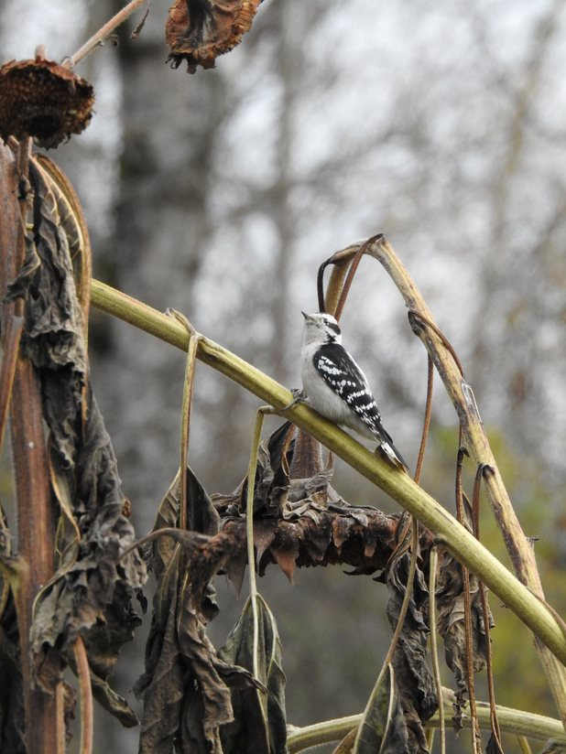
¹ How lonely sits the city
that once was full of people!
How like a widow she has become,
she that was great among the nations!
She that was a princess among the provinces
has become subject to forced labor.
Photo by Lisa Leffler
² She weeps bitterly in the night,
with tears on her cheeks;
among all her lovers,
she has no one to comfort her;
all her friends have dealt treacherously with her;
they have become her enemies.
³ Judah has gone into exile with suffering
and hard servitude;
she lives now among the nations;
she finds no resting place;
her pursuers have all overtaken her
in the midst of her distress.
⁴ The roads to Zion mourn,
for no one comes to the festivals;
all her gates are desolate;
her priests groan;
her young girls grieve,
and her lot is bitter.
⁵ Her foes have become the masters;
her enemies prosper
because the Lord has made her suffer
for the multitude of her transgressions;
her children have gone away,
captives before the foe.
⁶ From daughter Zion has departed
all her majesty.
Her princes have become like stags
that find no pasture;
they fled without strength
before the pursuer.
From Rev. Heather Leffler:
We all face challenges and struggles in our lives but most of us have not been exiled or held captive in another land. Still the words of Lamentations touch our hearts and remind us that God will listen to our groans and laments, with the same grace and love that our praise and thanks are received. Hearing the words of distress from the people of Judah reminds us of our siblings around the world today who are directly impacted by climate change, war and political or religious persecution. Whether their crops have failed, they are struggling to rebuild their homes or have had to seek refuge in another city or country, there are countless people around the world who will struggle to feed their families this year.
How did your garden grow? We are a little disappointed as we look forward to Stone’s Foodgrains Celebration. Many of the pumpkins and sunflowers withered and died in the drought of this summer. Those that survived aren’t in the giant category. We can still gather and have good time together.
Even as we share our laments with God, we are urged to pray for the people of Ukraine and Afghanistan, all the places where harvest has been impacted by climate change and geopolitics, for the refugees here in Canada who face language, cultural, religious and racial barriers as they seek to find homes and employment to feed their families and for our First Nations, Metis and Inuit families struggling though intergenerational trauma. As we prepare to celebrate Thanksgiving, may we find ways to make a difference in the lives of people who are struggling.
Contemplation and Conversation
Who might the Spirit be inviting you to pray for or reach out to?
Prayer
God who receives our lamentations and thanks with love and grace,
show us where we can make a difference
with our words, prayers and actions. Amen.
Know you are a valued part of our Rockwood and Stone United Church families.

Further Conversation … Would you like to talk more about today’s reflection? Email Heather at hleffler@rogers.com.

Our Rockwood Stone Family
If you missed today’s worship service, email rockwoodstoneuc@gmail.com for a YouTube link.
Pictures – if you have pictures of fall or harvest to share please send them to hleffler@rogers.com by Thursday, October 6, 2022 to be included in Offering Praise on Thanks giving Sunday.
Canadian Foodgrain Bank Project
Join in Stone’s Canadian Foodgrains Project Celebration on October 16 from 12:30 to 20 pm at Paul and Diane May’s Farm 5233 Eramosa 4th Line, Rockwood. Bring your family and friends; your pumpkins and sunflowers for weighing and measuring; and carved or decorated pumpkins for judging. Enjoy being together. Take part in bale rolling, pumpkin bocci and represent your church in the tug-of-war, young and young at heart activities and trivia contests. Help make a difference in the world by taking part in the silent auction and/or making a donation to the CFGB.

United Church of Canada From Richard Bott, Author & Consultant 10 September at 10:57
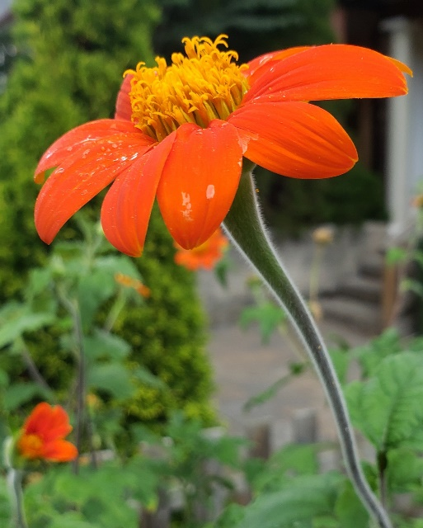
In the beginning,
when creation was without form,
the breath of the Divine
moved (above/in/through/?) the void,
and Creation came into beingness.
Movingness.
Livingness.
So much life, in so many forms
(some we would recognize,
and much we wouldn't)
existed, exists, goes on existing...
and in this tiny place
in the continuum of time,
in the vastness of space-that-has-become,
is a tiny blue-green bauble,
simply teeming with life!
Single cells, multi-celled,
arobic and anaerobic,
energy producing,
self-reproducing,
growing and changing and ever-evolving,
and web of connection that reaches
to the outer limits of the atmospheric envelope,
to the depths of the earth,
in every cubic centimeter of water,
in places that we humans
simply cannot believe that life exists!
And it is good.
It is great.
Beloved.
Alive.
Breathed into being...

A gift of belonging to a church is that the practice of gathering together for worship … to pray, sing, listen to scripture and share how God touches our lives – helps us grow in deeper relationship with God and each other. We are offering this practice of sharing beyond Sunday morning to deepen our connection. Each week you are offered a picture, a scripture and a question for contemplation, as well as a short reflection for you to contemplate, have conversation with people in your life and/or join an online conversation on our Rockwood Stone Facebook page.

