Contemplation and Conversation: 5th Sunday of Creation Time, October 09, 2022
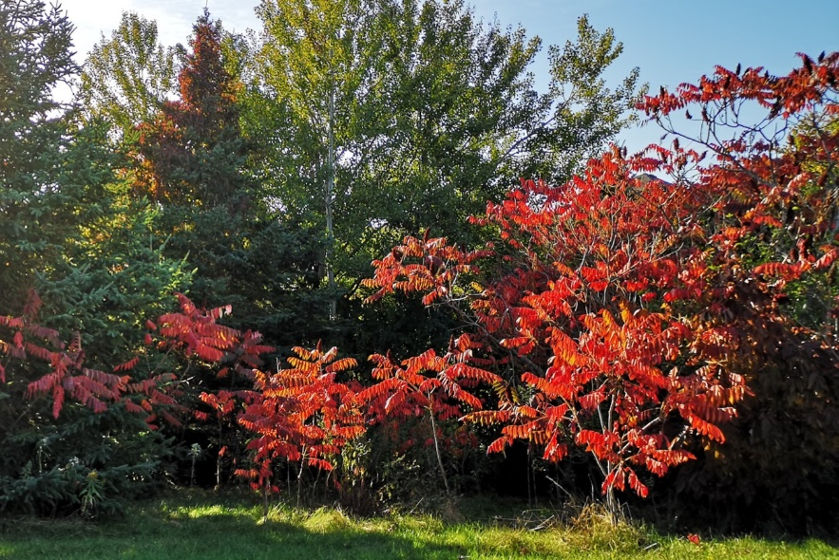
Scripture: Philippians 4:4-9 https://www.biblegateway.com/passage/?search=Philippians%204%3A4-9&version=NRSVUE
Heather Leffler
From Rev. Heather Leffler:
Happy Thanksgiving! This is truly a day to rejoice in the Lord. What a gift to be able to see people we care about face to face amidst these breathtaking fall days in our corner of Southern Ontario! I pray you are enjoying precious time with family and friends this Thanksgiving weekend.
Meister Eckhart tells us that if the only prayer we ever say in our entire life is thank you, it will be enough. He might have been reflecting on these words from Philippians. When we live our lives giving thanks to God and praying for what we need, we live in Christ Jesus and his peace. I am thankful for a secular holiday that encourages people to pause and give thanks. May our gratitude draw us closer to God and each other.
Contemplation and Conversation
What are you grateful for?
Prayer
Creator God, thank you for the breathtaking colours
and bountiful harvest of fall, for Thanksgiving celebrations and
the gift of knowing your Son
Know you are a valued part of our Rockwood and Stone United Church families.

Further Conversation … Would you like to talk more about today’s reflection? Email Heather at hleffler@rogers.com.

Our Rockwood Stone Family
If you missed today’s worship service, email rockwoodstoneuc@gmail.com for a YouTube link.
Thank you to Barb Parker, Liz Guthrie, Marcia Haworth, John Leffler, Heather Leffler and Lisa Leffler for sharing photos of fFall and harvest and to Liz Guthrie and Barb Eley for the God of the Sparrow Medley in this morning’s offering praise. https://www.youtube.com/watch?v=Cc-a3VHcaxQ .

Pictures – if you have pictures of activities at Stone in the last year to share, please send them to hleffler@rogers.com by Thursday, October 13, 2022 to be included in Offering Praise on Thanks giving Sunday.
World Food Sunday, October 16 join us for Stone's Anniversary Service at 10 am at Stone and on Zoom. Our guest speaker will be Cathy Lennon, General Manager of the Ontario Federation of Agriculture. This is a combined service. There is no service at Rockwood today.
Plan to stay for our Stone Soup Lunch at Stone.
Following come to Stone’s Canadian Foodgrains Project Celebration from 12:30 to 2 pm
at Paul and Diane May’s Farm 5233 Eramosa 4th Line, Rockwood.
Bring your family and friends; your pumpkins and sunflowers for weighing and measuring; and carved or decorated pumpkins for judging. Enjoy being together. Take part in bale rolling, pumpkin bocce and represent your church in the tug-of-war, young and young at heart activities and trivia contests. Our silent auction will include a picnic knapsack, pickles, a halloween basket, apple sauce and more.
In this year when so many people around the world are facing food insecurity, help us reach out and make a difference. Donations can be brought to the celebration, sent to by etransfer to stoneuc.treasurer@gmail.com , https://www.canadahelps.org/en/charities/stoneunitedchurch/ or by cheque to Stone United Church, PO Box 57 Rockwood, ON N0B 2K0.

From Paul and Diane,
Thank you so much for your kindness, prayers, food, cards, calls and visits while we were in the hospital.
Your kindness will never be forgotten – in fact it kept us going and to finally get home again.
You are all very special to us.

Our sympathies to Joyce, Marg and Murray Duffield as they mourn the death of Joyce and Murray’s brother-in-law Stu Wilson.

United Church of Canada from Moderator Carmen Lansdowne, Sunday, October 9, 2022
I've been quiet and resting, catching up on administrivia while preparing for another big marathon of quick turnaround trips and lots of meetings. Like many indigenous peoples, I'm ambivalent at best about Thanksgiving - not least of which being the ways that The American Thanksgiving Narrative takes over our ideas of what Thanksgiving is or should be (re: complete fiction). Our Thanksgiving actually has it's roots in gratitude for the harvests of fall, but the fact it's on the same day as C*lumbus Day in the US doesn't make the parallels with that colonial icon of US Thanksgiving much easier.
Anyway - I digress about that.
This weekend, I'm in Texas on a quick personal trip to celebrate the marriage of two indigenous professors at the University of North Texas (coincidentally where I did my first two years of University a million years ago - but that's a different story). I was also having mixed feelings about coming - I made the commitment and bought my tickets before I knew I was getting evicted from our apartment this summer, and before I knew for certain I would be moderator (and was still assuming I had a 1/10 or so chance).
But I am glad I came. Our mutual friend Vance Blackfox, head of indigenous ministries for the Evangelical Lutheran Church in America will preside at the ceremony, and Robert (the groom) and I have so much in common we could be siblings. And I love Aja, his new partner. This week I also had a blog post come out at Vanderbilt University's Wendall-Cook Program in Religion and Justice blog, Interventions. I join a list of other constructive and liberationist theologians who have interacted with advance copies of Joerg Rieger's forthcoming book "Theology in the Capitalocene: Ecology, Identity, Class & Solidarity."
My blog post is entitled "Wired for Solidarity" (see below) - and I re-read it this morning and it reminded me why I'm here. When we have circles of faith and friendship and love, we show up for each other.
And for that I give thanks - as I do for all of you out there in the wider church family. So today I share with you that blog series and hope that you are finding ways to celebrate the harvest of abundance that Creator imagined for us this weekend. Enjoy your traditional indigenous foods of turkey, cranberries, sweet potatoes, squashes and pumpkins, and practice the deep gratitude of knowing that we are all connected in God's created order.

A gift of belonging to a church is that the practice of gathering together for worship … to pray, sing, listen to scripture and share how God touches our lives – helps us grow in deeper relationship with God and each other. We are offering this practice of sharing beyond Sunday morning to deepen our connection. Each week you are offered a picture, a scripture and a question for contemplation, as well as a short reflection for you to contemplate, have conversation with people in your life and/or join an online conversation on our Rockwood Stone Facebook page.

WIRED FOR SOLIDARITY
The Right Rev. Dr. Carmen Lansdowne
6 October 2022
Nearly a decade ago when I started to work for an environmental legal charity in Canada, my offices were in the historic “Gastown” neighborhood of downtown Vancouver. Rugged cobblestone streets patched with little black spots of asphalt and century-old buildings harken back to a time of colonization and European settlement of lands that were once flourishing and used by the hunquamemim and squaismnisken speaking peoples — tribes we now define legally as the Musqueam, Squamish and Tseil-Watuth. With 1%-er Chip Wilson (the founder of LuluLemon)’s newest venture “Kit & Ace” flagship store for “technical cashmere” and expensive art galleries lining the streets, the also century-old issue of poverty shows up in the precariously housed living and overdosing in single room occupancy hotels (SROs) and panhandlers, jones-ing for a fix.
It was on this street that I observed a woman with some combination of mental illness and addiction – a woman I’d later come to know as Susan (name changed to protect her privacy) when I moved back into ministry with the United Church of Canada in Vancouver’s notoriously poor Downtown Eastside (DTES). She approached a man, immaculately dressed and groomed (in clothing and accessories on his person that likely exceeded her annual income), and asked him for money. Without acknowledging her request, without making eye contact, without saying sorry, without really acknowledging her existence, he walked past her in a dehumanizing move that rendered her completely invisible. He intended to simply ignore her existence. But Susan, never one to be ignored, regarded him with defiance and yelled after him down the street: “Hey buddy! You owe a debt to society – and you can start by paying yours to me!!!”
In so many ways she wasn’t wrong. In the DTES, Canada’s poorest urban postal code, the evidence of the imbalance of our economic and social systems are on display everywhere. The media perpetuates a stereotype that sees mental health & addiction as some kind of personal moral failing, and the situations of folks in the neighborhood as intractable and unchanging. After years of working alongside this vibrant community, I see the evidence: people get housed, get healthy, people recover, people die … the neighborhood is anything but static. So why does the situation appear to get only worse, never better?
I believe that there is a constant pipeline of human misery that ends up in this alleged “dead end” neighborhood that is more driven by economic and social factors that we are willing to realize. There are failures in our healthcare system (namely, the inability to adequately address mental health & addiction as health issues), housing affordability, equity for people from marginalized communities, and most importantly extractivist forms of capitalism. Public policy fails to address these failures and humans who face one or more traumas (personal, physical, racial, economic, family, etc.) could be pushed over the edge, into a space where our so called “social safety nets” do not catch them.
Rieger’s wrestling with whether to reform or overturn capitalist structures offers a critical look into the ways economic thought is rooted in colonialism. The ways in which economic thought has interwoven itself is not only rooted in colonialism and neocolonialism. The oversimplified bases upon which economic modeling, and thus political and financial and social decisions, are made are deeply rooted in euro-Christian thinking that rests on binary dualisms, the mind-body divide, and individualism over collectivism. These epistemological hegemonies result in a disciplinary ease by which oversimplified models rest on justified truth claims that are confined to a singular way of understanding and being in the world. It is through this epistemological hegemony that it becomes both easy and normalized to ‘externalize’ the things that are simply too difficult to measure in the most basic of economic arguments.
Rieger argues that “economics can be reconstructed from the ground up, in touch with the ecological, sociological, and political dynamics described in this chapter.” And maybe that’s true, but it also assumes a high degree of knowledge about sources of material, supply chains, reliance on regulated goods and trade. Is it really possible to start from the ground up? What does solidarity really look like in this case? It must be vaster, and more open to transformation, than has been evidenced so far. Rieger rightly critiques that the primary issue is not consumerism (symptom) but the over-production of goods (cause) and then creation of a desire manufactured to consume that which is produced. His arguments are also grounded in labor, but what of those who are not included in the ability to or experience of labor? Often the people facing the biggest marginalization are people whose inherent/intrinsic value is not counted as having any value.
What I do know is that in the streets of the DTES, we never go wrong when we start from a place of human-centred design – a fancy way of saying solidarity – in how we respond to the needs of the community around us. The people who best understand how they ended up on the underside of society are also best placed to tell us what they need. And that will likely come as a cost to society – but isn’t that what we are called to - costly solidarity?
The good news, if Dutch historian Rutger Bregman is to believed in Humankind: A Hopeful History, is that humans are hardwired for solidarity – it’s what makes violence so difficult. That violence isn’t limited to physical violence, but also economic, racial, spiritual, and emotional violence. Throughout his hopeful history, Bregman builds a case for solidarity building on evidence that we are, in fact, hardwired for solidarity. This is good news for creating a world with a new, more sustainable, and humane economic order that seeks to co-create the world we believe we’re called to as people of faith: one where we have life, and have it in abundance.
The Right Rev. Dr. Carmen Lansdowne is Moderator of the United Church of Canada. Carmen is a member of the Heiltsuk First Nation and a lifelong member of The United Church of Canada. Carmen Lansdowne is a member of the Heiltsuk First Nation, and a life-long member of The United Church of Canada (UCC). She attended the Vancouver School of Theology (VST) in the MDiv program from 2003-2007, and after successful completion of her internship Marengo Pastoral Charge (Alsask & Loverna, SK), she was ordained to further study in 2007. She completed coursework for a ThM degree at VST in 2008, then moved to Berkeley, CA where she commenced coursework for a PhD at the Graduate Theological Union. She completed the ThM in 2011 and the PhD in 2016.
From https://www.religionandjustice.org/interventions-forum-theology-capitalocene?fbclid=IwAR1ZxnsAsWqyKVhU0xvo46YbgPApRYgOsiJIPj5OIiBrcUa8oMSQX3_bzvk#contributorthree

