Contemplation and Conversation: 20th Sunday of Creation Time, October 23, 2022
Scripture: Luke 18:9-14 NRSVUE

⁹ He also told this parable to some who trusted in themselves that they were righteous and regarded others with contempt: ¹⁰ “Two men went up to the temple to pray, one a Pharisee and the other a tax collector. ¹¹ The Pharisee, standing by himself, was praying thus, ‘God, I thank you that I am not like other people: thieves, rogues, adulterers, or even like this tax collector. ¹² I fast twice a week; I give a tenth of all my income.’
¹³ But the tax collector, standing far off, would not even lift up his eyes to heaven but was beating his breast and saying, ‘God, be merciful to me, a sinner!’
¹⁴ I tell you, this man went down to his home justified rather than the other, for all who exalt themselves will be humbled, but all who humble themselves will be exalted.”
From Rev. Heather Leffler:
The Pharisee believed he was a good person. He followed all the laws of Moses, gave more than was asked of him and fasted twice a week. Comparing himself to people who were seen as sinners, he was confident that he was righteous. What he missed in his religious practice was the law to love God and love your neighbour as yourself.
God created us to be in relationship with each other not to judge one another. Knowing that there would be times when we let God down or hurt others with our actions or inactions, God always meets us with forgiveness and mercy. It is in confessing, like the tax collector, that we find forgiveness and new life. Recognizing where we have done harm and asking for forgiveness opens us to new directions for ourselves and deepening relationships with others.
Instead of measuring ourselves against others to make us feel good or seeing ourselves as sinners. I hear Jesus inviting us to focus on caring for each other and creation. Being in relationship allows us to learn and grow from one another and deepen our relationship with God through our worship and church community. May it be so.
Contemplation and Conversation
When has offering or accepting forgiveness opened new possibilities for you?
Prayer
Merciful God, instead of justifying ourselves by comparing ourselves to others,
help us confess the ways we have let you down and broken relationships
so we can receive your forgiveness, healing and hope. Amen.
Know you are a valued part of our Rockwood and Stone United Church families.

Further Conversation … Would you like to talk more about today’s reflection? Email Heather at hleffler@rogers.com.

Our Rockwood Stone Family
If you missed today’s worship service, email rockwoodstoneuc@gmail.com for a YouTube link.
x

United Church of Canada From Richard Bott, Author & Consultant 10 September
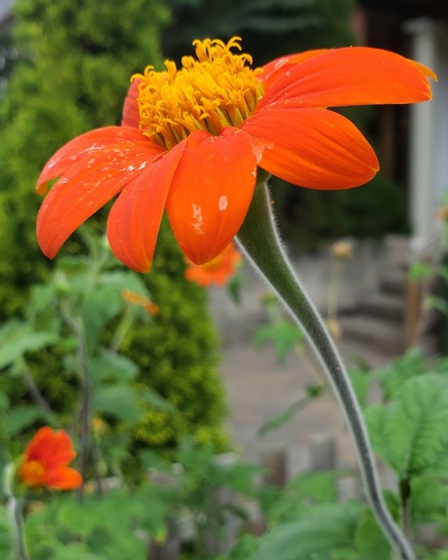
In the beginning,
when creation was without form,
the breath of the Divine
moved (above/in/through/?) the void,
and Creation came into beingness.
Movingness.
Livingness.
So much life, in so many forms
(some we would recognize,
and much we wouldn't)
existed, exists, goes on existing...
and in this tiny place
in the continuum of time,
in the vastness of space-that-has-become,
is a tiny blue-green bauble,
simply teeming with life!
Single cells, multi-celled.
arobic and anaerobic,
energy producing,
self-reproducing,
growing and changing and ever-evolving,
and web of connection that reaches
to the outer limits of the atmospheric envelope,
to the depths of the earth,
in every cubic centimeter of water,
in places that we humans
simply cannot believe that life exists!
And it is good.
It is great.
Beloved.
Alive.
Breathed into being...

A gift of belonging to a church is that the practice of gathering together for worship … to pray, sing, listen to scripture and share how God touches our lives – helps us grow in deeper relationship with God and each other. We are offering this practice of sharing beyond Sunday morning to deepen our connection. Each week you are offered a picture, a scripture and a question for contemplation, as well as a short reflection for you to contemplate, have conversation with people in your life and/or join an online conversation on our Rockwood Stone Facebook page.

