Contemplation and Conversation: 21st Sunday after Pentecost, October 30, 2022

Scripture: Luke 19:1-10 https://www.biblegateway.com/passage/?search=Luke+19%3A1-10&version=NRSVUE
¹ He entered Jericho and was passing through it. ² A man was there named Zacchaeus; he was a chief tax collector and was rich. ³ He was trying to see who Jesus was, but on account of the crowd he could not, because he was short in stature. ⁴ So he ran ahead and climbed a sycamore tree to see him, because he was going to pass that way. ⁵ When Jesus came to the place, he looked up and said to him, “Zacchaeus, hurry and come down, for I must stay at your house today.” ⁶ So he hurried down and was happy to welcome him. ⁷ All who saw it began to grumble and said, “He has gone to be the guest of one who is a sinner.” ⁸ Zacchaeus stood there and said to the Lord, “Look, half of my possessions, Lord, I will give to the poor, and if I have defrauded anyone of anything, I will pay back four times as much.” ⁹ Then Jesus said to him, “Today salvation has come to this house, because he, too, is a son of Abraham. ¹⁰ For the Son of Man came to seek out and to save the lost.”
From Rev. Heather Leffler:
The people in the crowd were angry with Jesus for going to the house of Zacchaeus – a sinner. As a tax collector he had taken more than was a fair wage above what he owed the Romans for the taxes in his district. The people couldn’t understand why Jesus would choose him to go to home with. How often are we like the crowd – judging and condemning people for their worst behaviour.
As followers of Jesus, we are asked to forgive as we have been forgiven and love as we have loved. This isn’t easy. Sometimes we have to call people to account for the harm they have done, but we can’t stop there. We need to see the places where they do good in their lives too. Sometimes we can be in relationship with them. Sometimes we have to keep our distance and pray for God to care for them and change their hearts.
What we know is always true from Zacchaeus’ story is that God never gives up on people and if we hold them in love in person or in prayer, we may be a part of helping them find the life God longs for them.
Contemplation and Conversation
Who might God be asking you to hold in love and prayer?
Prayer
Forgiving God, how often do we let you down
and wonder if we are worthy of your love. Yet again and again you forgive us.
Help us forgive others and hold them in love and prayer. Amen.

Further Conversation … Would you like to talk more about today’s reflection? Email Heather at hleffler@rogers.com.

Our Rockwood Stone Family
If you missed today’s worship service, email rockwoodstoneuc@gmail.com for a YouTube link.

United Church of Canada from Moderator Carmen Lansdowne, Facebook, 6 days ago
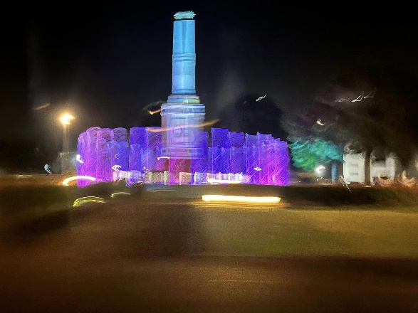
I’m sitting in Manila airport waiting to fly home in 90 mins. Boarding in an hour.
This is not my first trip to the Philippines but it is the first time I had this much time to engage with local partners (as rushed as it was compared to usual moderator ecumenical visits, I’m told).
Filipinos are so incredibly generous and kind, and our partners put their lives on the line every day – practicing daring justice. One of the reasons I haven’t posted much on my Moderator page or personal is to keep myself and our partners safe. I haven’t heard about human rights abuses like this (outside of Israel/Palestine) since the armed conflicts in Central America in the 80’s.
Even Roman Catholics priests and bishops are now “red tagged” as alleged communists, as are some lawyers and judges. The so called “war on drugs” continues unchecked. Anyone accused of communism or drug use has the potential to be arrested, is often denied due process, and many are assassinated in extrajudicial killings.
We heard from mothers of children killed by police for drug use - 30,000 killed so far (for as little as smoking pot). The criminalization of poverty here is rampant. And the current president apparently used Cambridge Analytica to ”rebrand” the Marcos name and to propagate revisionist history that erases the reality of the martial law period - instead referring to it as ”a new Philippines” under his parents rule.
Our partners really are beacons of light and hope in this struggle. I’m posting this without referring to anyone in particular to keep folks safe. Some of the partners we have longstanding relationships are already read tagged or going through criminal litigation processes on bogus charges.
And – there are parallel hypocrisies to how we treat the poor and indigenous in Canada. We have our own work to do. Thank you to Ndhlovu Japhetatucc for being an incredible staff support this trip.
I’m sure I’ll continue to reflect and process and post once I’m back in the homelands. For this post I’m choosing photos that show the deep hospitality and welcome our partners offered (often edible). #UCCan #DaringJustice #globalpartnerships #ecumenism #solidarity

A gift of belonging to a church is that the practice of gathering together for worship … to pray, sing, listen to scripture and share how God touches our lives – helps us grow in deeper relationship with God and each other. We are offering this practice of sharing beyond Sunday morning to deepen our connection. Each week you are offered a picture, a scripture and a question for contemplation, as well as a short reflection for you to contemplate, have conversation with people in your life and/or join an online conversation on our Rockwood Stone Facebook page.

