Contemplation and Conversation: 22nd Sunday after Pentecost, November 6, 2022
Scripture: Psalm 145 1-5, 17-21 NRSVUE
https://www.biblegateway.com/passage/?search=Psalm+145+1-5%2C+17-21+&version=NIV
From Brian Mack:
Keeping a vow or pledge can be hard. How many times after a gluttonous meal have we resolved to eat more nutritionally? How many times after we’ve lost our temper have we promised ourselves not to go out of control again? How many times have we tried to make a smaller environmental footprint only to succumb to the temptations of attractive (but excessive) packaging? My personal list of failure to keep a resolution could probably go on for pages…enough said.
In this passage, the Psalmist makes a genuine vow to praise God. This is not a frivolous promise that will lead to abandonment. He asserts that it is the responsibility of all who know God to constantly offer praise and to pass these praises from generation to generation. According to David, the list of the praises we are to offer to God are inexhaustible: for his greatness, for his graciousness and mercy, for his justice or righteousness, for his goodness and compassion, and for his everlasting kingdom.
At first glance, making a vow to continuously praise Holy Mystery seems like an impossible task. We worry that we will do it for a few days and then our resolve will fade so we are tempted to not try at all. Perhaps it would be easier to make a commitment and follow through on our vow if we remember that all praise comes from the heart. The psalmist encourages us to let this praise flow unobstructed and in whatever way is best suited to us. It can be a single word utterance, the penning of a poem, or an upward glance at a star filled sky at night. How we offer praise is as individual as each one of us. There is no right or wrong way. Thanks be to God.
Contemplation and Conversation
How do you offer praise to God?
Prayer
Holy One, we give you thanks for the wisdom of David.
Give us the resolve to follow his example.
In fulfilling our vow, may we find an infinite number of ways
to offer you our humble thanks for all you do in our lives. Amen.

Know you are a valued part of our Rockwood and Stone United Church families.

Further Conversation … Would you like to talk more about today’s reflection? Email Heather at hleffler@rogers.com.

Our Rockwood Stone Family
If you missed today’s worship service, visit our Rockwood Stone YouTube page.

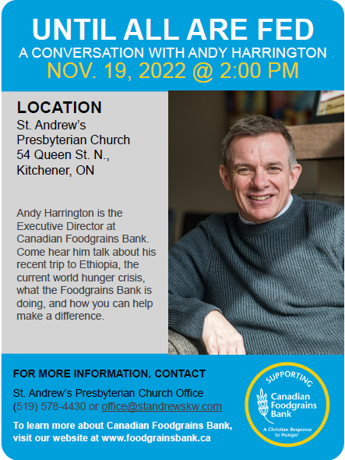

United Church of Canada from Former Moderator Richard Bott
In a world of war...we search for peace.
In a world of confusion...we search for calm.
In a world of pain...we search for healing.
In a world of isolation...we search for communion.
Communion with each other...and communion with God.
Let us search together...and let us worship our God.

A gift of belonging to a church is that the practice of gathering together for worship … to pray, sing, listen to scripture and share how God touches our lives – helps us grow in deeper relationship with God and each other. We are offering this practice of sharing beyond Sunday morning to deepen our connection. Each week you are offered a picture, a scripture and a question for contemplation, as well as a short reflection for you to contemplate, have conversation with people in your life and/or join an online conversation on our Rockwood Stone Facebook page.

