Contemplation and Conversation: 23rd Sunday after Pentecost, November 13, 2022
Scripture: Isaiah 12 https://www.biblegateway.com/passage/?search=Isaiah+12&version=NRSVUE
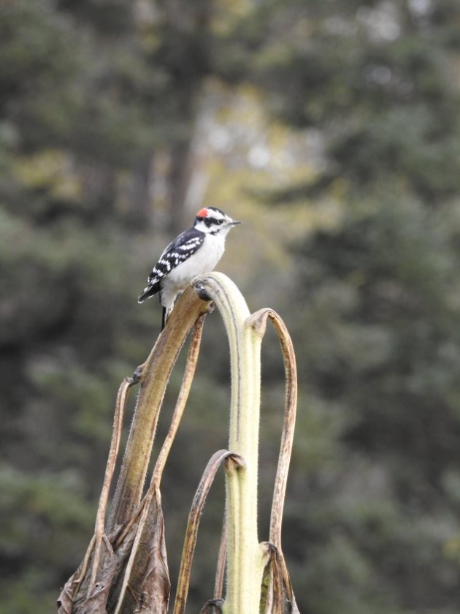
Lisa Leffler
From Rev. Heather Leffler:
Reading these words from Isaiah invites my heart to sing. Singing in Sunday School and worship, at church camp and Everton cub camp, at church meetings and other gatherings has helped me feel the presence of the Holy One in my life. Singing when I am alone or feeling lonely, brings me comfort. There is a saying that singing is to pray twice.
Isaiah reminds me that God never gives up on us. The Holy One always sets aside anger to receive us in love. Isaiah points to the forgiveness and love we know through Jesus. Gathering as people of faith and raising our voices in song gives us courage in the face of struggles. Singing in times of joy in our faith community inspires us to reach out and make a difference in the world.
I hear Steve Angrisano’s chorus …
Go Make a difference
We can make a difference
Go make a difference in the world.
Contemplation and Conversation
What song is on your heart today?
Prayer
God of all Goodness, thank you for our churches of Rockwood and Stone,
for the people who sing with us and those who sing for us
when our hearts are heavy, and we can’t sing.
Help us know the fullness of your love in our lives
so that together we can go and make a difference in your world. Amen.

Further Conversation … Would you like to talk more about today’s reflection? Email Heather at hleffler@rogers.com.

Our Rockwood Stone Family
If you missed today’s worship service, you can watch it on YouTube: https://youtu.be/H2N-vROMhEI
Congregational Packages for Advent and Christmas – Do you have winter or Christmas pictures you would share? Would you be willing to bake cookies or help with preparing the packages, please contact Heather at hleffler@rogers.com or 519-265-7385.

United Church of Canada From Moderator Carmen Lansdowne … posted on Facebook on October 31.
Just had an awesome interview with The Rev. Cheri DiNovo for her show The Radical Reverend – aired Tuesday, Nov. 8 at 11am EST on CIUT 89.5FM in Toronto. https://ciut.fm/shows/the-radical-reverend/ .

A gift of belonging to a church is that the practice of gathering together for worship … to pray, sing, listen to scripture and share how God touches our lives – helps us grow in deeper relationship with God and each other. We are offering this practice of sharing beyond Sunday morning to deepen our connection. Each week you are offered a picture, a scripture and a question for contemplation, as well as a short reflection for you to contemplate, have conversation with people in your life and/or join an online conversation on our Rockwood Stone Facebook page.

