Contemplation and Conversation: Reign of Christ Sunday, November 20, 2022
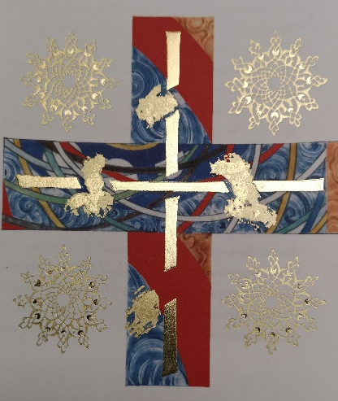
Scripture: Jeremiah 23:1-6 NRSVUE https://www.biblegateway.com/passage/?search=Jeremiah%2023%3A1-6&version=NRSVUE
¹ Woe to the shepherds who destroy and scatter the sheep of my pasture! says the Lord. ² Therefore thus says the Lord, the God of Israel, concerning the shepherds who shepherd my people: It is you who have scattered my flock and have driven them away, and you have not attended to them. So I will attend to you for your evil doings, says the Lord. ³ Then I myself will gather the remnant of my flock out of all the lands where I have driven them, and I will bring them back to their fold, and they shall be fruitful and multiply. ⁴ I will raise up shepherds over them who will shepherd them, and they shall no longer fear or be dismayed, nor shall any be missing, says the Lord.
⁵ The days are surely coming, says the Lord, when I will raise up for David a righteous Branch, and he shall reign as king and deal wisely and shall execute justice and righteousness in the land. ⁶ In his days Judah will be saved, and Israel will live in safety. And this is the name by which he will be called: “The Lord is our righteousness.”
From Rev. Heather Leffler:
As we prepare for Advent and Christmas, we are reminded by Jeremiah of the promise that Jesus fulfills. He is the righteous Branch of David that God raised up to rule our lives. While he lived as one of us, he fed the hungry, gave drink to the thirsty, healed the sick, invited us to love our neighbours and ourselves.
There are many people who will lead us astray and times when we lead others astray, intentionally and unintentionally. We get caught up in systems and cultures that hurt others and the earth. We can be the shepherds that scatter flocks and drive them away and we can be the flocks that are led astray.
What we are assure of is that God never gives up on us. Though the Spirit of the Living Christ, we are invited into communities that help us return to God’s Word, care for one another and reach out to care for all creatures and creation. God is with us whatever is happening in our lives.
Contemplation and Conversation
How do we know when we are being led astray or leading someone astray?
Prayer
Good Shepherd, draw us to you so that we can be the sheep of your pasture.
Teach us to love and forgive, as you love and forgive us. Amen.

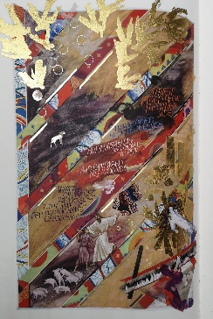
The cross is from the Saint John’s Bible … In 1998 Saint John’s Abbey and University commissioned renowned calligrapher Donald Jackson to produce a hand-written, hand-illuminated Bible. You are invited to explore this work of art that unites an ancient Benedictine tradition with the technology and vision of today, illuminating the Word of God for a new millennium. https://saintjohnsbible.org/ … This picture was taken from the Gospel of Luke that was on display at the Lester Randall Preaching Fellowship. You can page through all the volumes of the Bible online. The pictures incorporate ancient and modern images including the twin towers on this page of Jesus parables as they were destroyed while the manuscript was in process.

Further Conversation … Would you like to talk more about today’s reflection? Email Heather at hleffler@rogers.com.

Our Rockwood Stone Family
If you missed today’s worship service, visit our Rockwood Stone YouTube page.
x

United Church of Canada published on: November 10, 2022
Statement on United Church Maternity Homes
The United Church of Canada has been named in a class-action lawsuit regarding forced adoptions and abuse at several of the maternity homes it ran from the 1920s to the 1980s. Since 2010, the United Church has been listening, learning, and reflecting on its involvement in its maternity homes and the practice of pressured or forced adoptions. The church issued an apology in 2020.
The church recognizes the pain and suffering that was experienced by mothers who were pressured or forced to give up their babies. While we understand that the social mores of the time contributed to a sense that these homes and the practice of pressured or forced adoption was in children’s best interest, and that the intent of those who supported these homes was generally good, we now know that the actual consequences of these homes were often harmful. The church is committed to continuing to listen to the experiences of those at the homes.
With respect to the sensitive questions of records related to these homes, there are issues of both privacy and access that need to be considered. Adoption records are primarily held by provincial and territorial government bodies, and so access to those records is governed by the legislation of each province or territory. United Church archival records can be accessed through the archives collection in Toronto, either in-person (by appointment)(opens in a new tab) or through digital requests. Permission to access these records is guided by United Church Archives policy on access to archival records on adoption. (opens in a new tab)
A gift of belonging to a church is that the practice of gathering together for worship … to pray, sing, listen to scripture and share how God touches our lives – helps us grow in deeper relationship with God and each other. We are offering this practice of sharing beyond Sunday morning to deepen our connection. Each week you are offered a picture, a scripture and a question for contemplation, as well as a short reflection for you to contemplate, have conversation with people in your life and/or join an online conversation on our Rockwood Stone Facebook page.

