Contemplation and Conversation: 1st Sunday after Pentecost, November 27, 2022
Scripture: Luke 1:26-38 CEV
https://www.biblegateway.com/passage/?search=Luke+1%3A26-38+&version=CEV
From Rev. Heather Leffler:
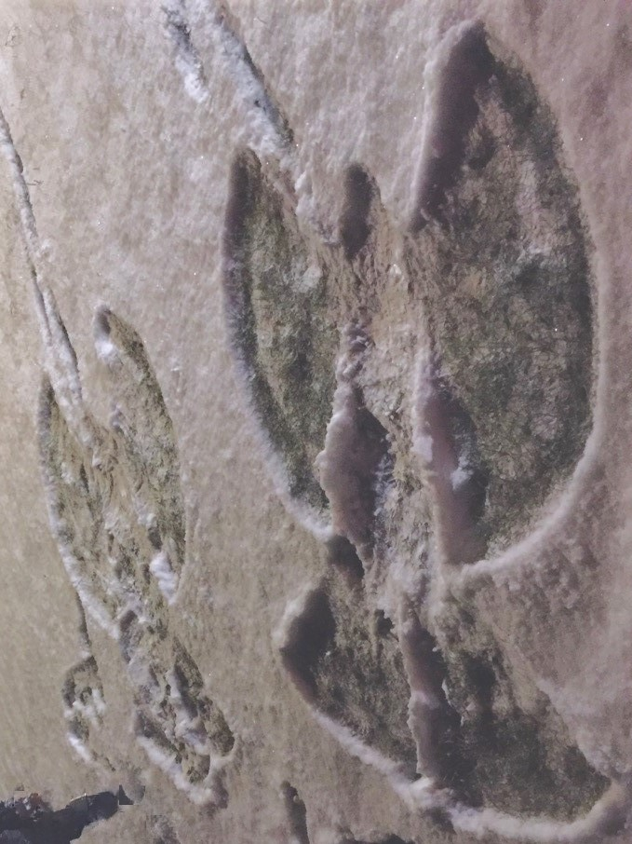
Did you know that angel means messenger? Tradition tells us that Gabriel came to the well – we aren’t sure whether it is the Roman Catholic site or the spring at the Greek Orthodox Church in Nazareth –to invite Mary to be part of God’s message of hope to the world.
Promised in marriage to Joseph at 14 or 15, what the angel was asking threatened the future Mary’s family had planned for her. Did she stop to think how Joseph would respond to her pregnancy? Did she consider what it could mean to have a child on her own? Was it Gabriel’s presence that gave her the courage to say yes?
How grateful I am that Mary trusted the angel’s assurance that there was nothing to be afraid of. God had chosen her and would be with her as her body nurtured God’s son. Her acceptance that nothing is impossible with God has brought us to this time and place where – invited into the Christmas story again – we open ourselves to being a part of bringing God’s kingdom on earth as it is in heaven.
Contemplation and Conversation
When have you said yes to an expected opportunity?
Prayer
God of hope, help us to be open to your messengers.
May the opportunities we say yes to
be part of bringing your hope and healing to the world. Amen.
Everyday Activity as a Spiritual Practice
Often a new opportunity can bring anxiety with it. Colouring or painting can be a calming activity that can become a prayer. Take time to colour your nativity and let the Spirit’s calming presence surround you.

Further Conversation … Would you like to talk more about today’s reflection? Email Heather at hleffler@rogers.com.

Our Rockwood Stone Family
If you missed today’s worship service, visit our Rockwood Stone YouTube page.
Thanks to Barb Eley and Liz Guthrie for sharing music for Offering Praise: https://www.youtube.com/watch?v=66aY3HsHaDo

United Church of Canada From Advent Unwrapped
What is all this talk about revolution and what does it have to do with Advent?
This new "What is Advent?" video explains why we often refer to Advent as time to anticipate, prepare and wait for a revolution (that won’t be televised). The coming of Jesus, brings the coming of a new world, a new way of being that is truly revolutionary.
https://www.youtube.com/watch?v=6rbTXZakvsA
Follow Advent Unwrapped on Facebook for more contact: https://www.facebook.com/AdventUnwrapped

A gift of belonging to a church is that the practice of gathering together for worship … to pray, sing, listen to scripture and share how God touches our lives – helps us grow in deeper relationship with God and each other. We are offering this practice of sharing beyond Sunday morning to deepen our connection. Each week you are offered a picture, a scripture and a question for contemplation, as well as a short reflection for you to contemplate, have conversation with people in your life and/or join an online conversation on our Rockwood Stone Facebook page.

