Contemplation and Conversation:
3rd Sunday of Advent, December 11, 2022
Scripture: – Luke 1:39-45 CEV
https://www.biblegateway.com/passage/?search=Luke+1%3A39-45+&version=CEV
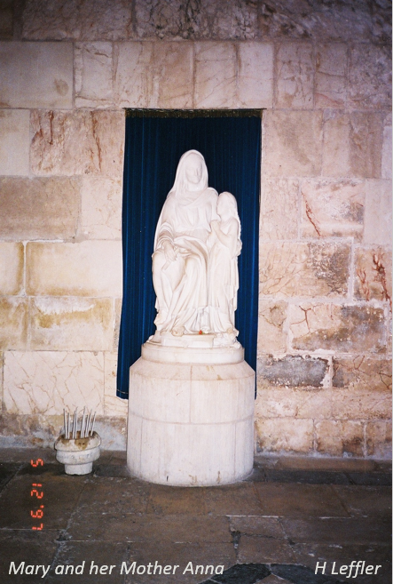
From Rev. Heather Leffler:
Did you know that Mary travelled over 100 kilometres to see Elizabeth? Her parents would have sent her with another family. Had she told them why she needed to see Elizabeth? Did they know she was pregnant?
Mary had said yes to God. She had trust God would be with her when she became pregnant but who could she talk to? Who would understand what she was facing?
The minute she saw Elizabeth – who everyone was sure was barren – glowing with love for the baby she carried, Mary knew beyond a doubt what the angel told her was true. For three months, she basked in the love of Elizabeth and Zechariah’s home. Caring for Elizabeth as Elizabeth cared for her, she found the love and quiet joy she needed to carry her through the challenges she must face.
This story reminds me again that confiding in someone who loves me gives me the strength to face the most difficult experiences life offers me. Most often it is in these intimate relationships that I find joy.
Contemplation and Conversation
Who in your life has helped you through a challenging time?
Prayer
Ever present God, we give thanks
for the people you place in our lives
who share our sorrows and joys. Amen.
Everyday Activity as a Spiritual Practice
Have a coffee with someone you care about or enjoy a favourite drink while you talk on the phone or online. While you talk, listen with your heart. Share a silent or spoken prayer for your friendship and lift up any cares and concerns you have shared to God.

Further Conversation … Would you like to talk more about today’s reflection? Email Heather at hleffler@rogers.com.

Our Rockwood Stone Family
If you missed today’s worship service, visit our Rockwood Stone YouTube page.
Thank you to the Eramosa Ensemble Rockwood Chimes Choir for today’s Offering Praise: https://www.youtube.com/watch?v=ymWc8wS6otk

United Church of Canada From Advent Unwrapped
Dear Creator,
We are in the midst of shorter days, busier schedules and longer, darker nights. December is filled with the stress of getting presents and becoming everything to everyone. Despite the music, the decorations and the parties, we are having trouble finding Joy. Help us to know that joy is waiting for us in the stories and the life of Jesus. Help us to be ready to receive real Joy.
Amen.
(Ness Brohman from Eastern Ontario Outaouais Region)
Go to https://youtu.be/jtFMvYMMQHQ watch the Advent Unwrapped video about joy.

A gift of belonging to a church is that the practice of gathering together for worship … to pray, sing, listen to scripture and share how God touches our lives – helps us grow in deeper relationship with God and each other. We are offering this practice of sharing beyond Sunday morning to deepen our connection. Each week you are offered a picture, a scripture and a question for contemplation, as well as a short reflection for you to contemplate, have conversation with people in your life and/or join an online conversation on our Rockwood Stone Facebook page.

