Contemplation and Conversation:
4th Sunday of Advent, December 18, 2022
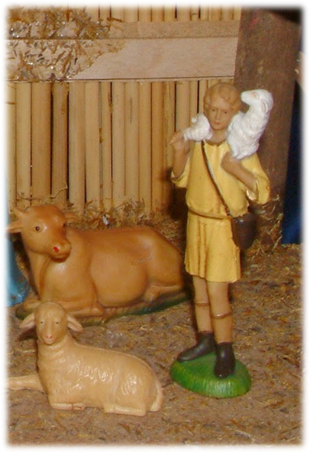
Scripture: – Luke 2:8-15 CEV
⁸ That night in the fields near Bethlehem some shepherds were guarding their sheep. ⁹ All at once an angel came down to them from the Lord, and the brightness of the Lord's glory flashed around them. The shepherds were frightened. ¹⁰ But the angel said, “Don't be afraid! I have good news for you, which will make everyone happy. ¹¹ This very day in King David's hometown a Savior was born for you. He is Christ the Lord. ¹² You will know who he is, because you will find him dressed in baby clothes and lying on a bed of hay.”
¹³ Suddenly many other angels came down from heaven and joined in praising God. They said:
¹⁴ “Praise God in heaven!
Peace on earth to everyone
who pleases God.”
¹⁵ After the angels had left and gone back to heaven, the shepherds said to each other, “Let's go to Bethlehem and see what the Lord has told us about.”
From Rev. Heather Leffler:
Did you know that more than likely the shepherds were homeless – living in the fields with their sheep? Not being able to keep the laws of Moses, they were considered outcasts by religious people – needed for the service they provided but unwelcome in homes and palaces.
From that first Christmas night, God turned the social and religious order upside down. It wasn’t the king or the good people of the temple who welcomed the angels. It was lowly men keeping watch through the night over their sheep. They could have asked what the birth of a baby had to do with them. They could have kept the story to themselves.
Again and again I find myself giving thanks that God turns our ideas about people upside down. In Jesus, I am invited to see all people – young and old, rich and poor, faithful and secular, gay and straight, powerful and marginalized – as beloved children of God. When I see people through God’s eyes, I discover gifts in them that bless my life again and again.
Contemplation and Conversation
When has God surprised you with a person
you would never have reached out to?
Prayer
Holy Mystery, you are Wholly love.
thank you for the people you place in our lives
who bring us joy and love. Amen.
Everyday Activity as a Spiritual Practice
Go for a walk in the bush or park or sit at the window. Contemplate the beauty and bounty God has given us and pray for the Spirit’s guidance that we can help restore creation.

Further Conversation … Would you like to talk more about today’s reflection? Email Heather at hleffler@rogers.com.

Our Rockwood Stone Family
If you missed today’s worship service, visit our Rockwood Stone YouTube page.

United Church of Canada – Consider catching up on the Ecumenical Advent Series: What are We Waiting For? With Moderator Carmen Lansdowne
December 1 Hope, “The Signs of the Times” https://www.youtube.com/watch?v=hc7vS4pA0xg
December 8 Peace, “Finding the Good Path” https://www.youtube.com/watch?v=d56hRJT2Hzg
December 15 Joy,“God’s Love Includes Everyone” https://www.youtube.com/watch?v=dghguMt6HJo
December 22 Love, “The Cost of Discipleship”
A gift of belonging to a church is that the practice of gathering together for worship … to pray, sing, listen to scripture and share how God touches our lives – helps us grow in deeper relationship with God and each other. We are offering this practice of sharing beyond Sunday morning to deepen our connection. Each week you are offered a picture, a scripture and a question for contemplation, as well as a short reflection for you to contemplate, have conversation with people in your life and/or join an online conversation on our Rockwood Stone Facebook page.

