Contemplation and Conversation:
Christmas Day, December 25, 2022

Scripture: – Luke 2:1-7, 16-21 CEV
https://www.biblegateway.com/passage/?search=Luke+2%3A1-7%2C+16-21+&version=CEV
From Rev. Heather Leffler:
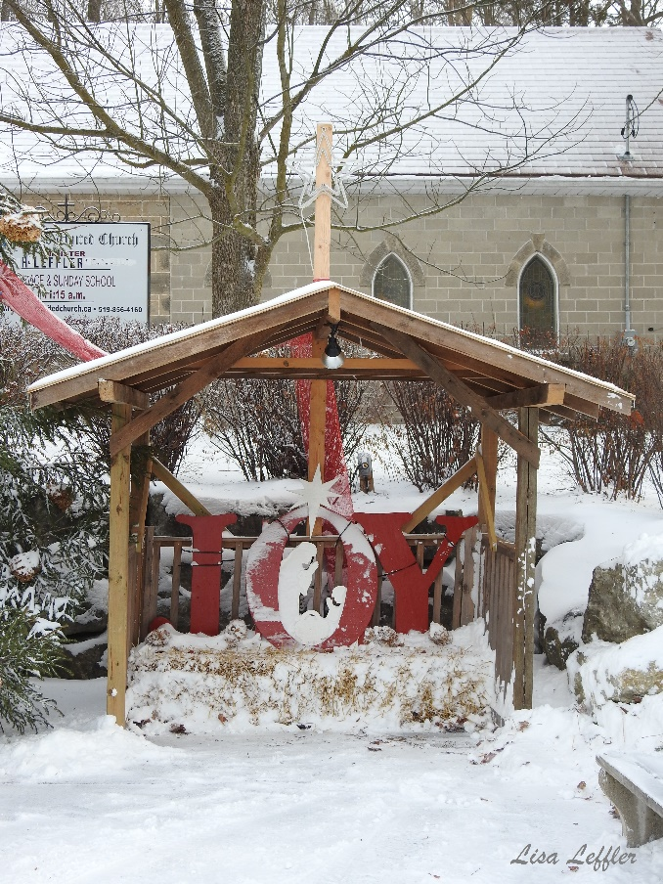
Contemplation and Conversation
What gift do you find in the birth of Jesus?
Prayer
Emmanuel, thank you for your willingness to be born among us, swaddled as babe, wrapped in clothes again at your death,
you share all of life’s experiences with us.
Thank you for being with us in life,
in death and life beyond death. Amen.
Everyday Activity as a Spiritual Practice
As you open gifts, share in food and festivities with family and friends, keep Jesus in your heart and mind. At the end of the day do an Examen and offer thanks for what you are most grateful for and ask for God to transform what you are least grateful for.

Further Conversation … Would you like to talk more about today’s reflection? Email Heather at hleffler@rogers.com.

Our Rockwood Stone Family
Christmas Worship Services:
Rockwood’s Reading and Reflection Service: https://youtu.be/l_uoPTDmk9A
Stone’s Christmas Eve Service: https://youtu.be/clmQ3ApBQJ0
Christmas Eve Offering Praise: https://youtu.be/IO8MQXSc4aY
Christmas Day Offering Praise: https://youtu.be/sNw1qYqXpt0

United Church of Canada From Moderator Carmen Lansdowne
In her Christmas video message, Moderator Carmen Lansdowne reminds us that when so much seems uncertain and the news amplifies all the hard news stories, there is One who came to show us that all the ends of the earth should see the salvation of God―and that through that One, we are capable of coming together to achieve the impossible.
Watch it here: https://www.youtube.com/watch?v=EJk922g8JPA

A gift of belonging to a church is that the practice of gathering together for worship … to pray, sing, listen to scripture and share how God touches our lives – helps us grow in deeper relationship with God and each other. We are offering this practice of sharing beyond Sunday morning to deepen our connection. Each week you are offered a picture, a scripture and a question for contemplation, as well as a short reflection for you to contemplate, have conversation with people in your life and/or join an online conversation on our Rockwood Stone Facebook page.

