Contemplation and Conversation:
2nd Sunday after Epiphany, January 15, 2023
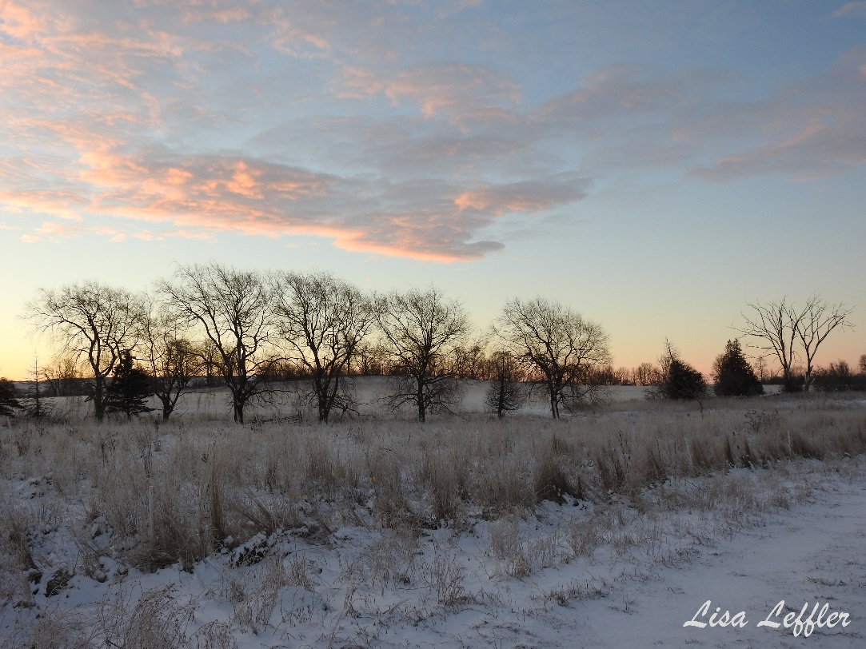Scripture: – Psalm 40:1-11 NRSVUE https://www.biblegateway.com/passage/?search=Psalm%2040%3A1-11&version=NRSVUE
¹ I waited patiently for the Lord; he inclined to me and heard my cry.
² He drew me up from the desolate pit, out of the miry bog,
and set my feet upon a rock, making my steps secure.
³ He put a new song in my mouth, a song of praise to our God.
Many will see and fear and put their trust in the Lord.
⁴ Happy are those who make the Lord their trust,
who do not turn to the proud,
to those who go astray after false gods.
⁵ You have multiplied, O Lord my God,
your wondrous deeds and your thoughts toward us;
none can compare with you.
Were I to proclaim and tell of them,
they would be more than can be counted.
⁶ Sacrifice and offering you do not desire,
but you have given me an open ear.
Burnt offering and sin offering you have not required.
⁷ Then I said, “Here I am; in the scroll of the book it is written of me.
⁸ I delight to do your will, O my God; your law is within my heart.”
⁹ I have told the glad news of deliverance in the great congregation;
see, I have not restrained my lips, as you know, O Lord.
¹⁰ I have not hidden your saving help within my heart;
I have spoken of your faithfulness and your salvation;
I have not concealed your steadfast love and your faithfulness
from the great congregation.
¹¹ Do not, O Lord, withhold your mercy from me;
let your steadfast love and your faithfulness keep me safe forever.
From Rev. Heather Leffler:
We don’t know what God saved the Psalmist from. Whether it was a literal pit or bog, or his day-to-day life was so filled with challenges he felt trapped, the Psalmist was saved when he put his trust in the Lord. He was filled with gratitude and felt the Holy One’s love and faithfulness through the great congregation.
Again and again I am amazed by where God is at work in our lives – where we experience grace and love especially in our congregations. I was filled with gratitude preparing for our Christmas Eve worship. Hearing the weather reports our musicians and choir stayed late on Thursday to record all the music. Our caretakers made the call early to say snow was drifting in and would impact driving and visibility. People made phone calls and sent emails so everyone could stay home where it was safe and warm. We were able to move worship to Zoom, thanks to your patience and persistence in learning the technology over the past two and a half years. Again and again, I feel God’s love and care through the love and care you have for each other and your commitment to care for people beyond our congregations. I give thanks to God for each one of you.
Contemplation and Conversation
When have you felt God’s love and care in your life?
Prayer
Faithful God, thank you for inviting us to be part of your Church.
In Rockwood and Stone churches,
we experience your love and care.
Help us share that love with each person we meet. Amen.

Further Conversation … Would you like to talk more about today’s reflection? Email Heather at hleffler@rogers.com.

Our Rockwood Stone Family
If you missed today’s worship service, visit our Rockwood Stone YouTube page.
Thank you to everyone for their patience as we learn new technology. At Stone, this morning we selected the wrong speaker so sound should be better next week.

Thank you
From Charlotte McIntosh at Rockwood Centennial Public School
Thank you for dontatin to our Food Program.
Wishin you a magical and blissful holiday.

From East Wellington Community Services
As we look back at another year, we would like to take this opportunity to thank you for your support throughout 2022. Your contributions and efforts in support of EWCS Rockwood food bank have enabled us to provide food to those in our community who struggle during difficult times.
We could not do our work without the support of partners like you and we truly value your assistance. We are humbled by your generosity and grateful for all your help.
On behalf of our board of directors, volunteers, staff and the clients who receive your food, gifts and monetary contributions, we thank you for the impact you have made.
May 2023 bring us all good health and hope for a bright future.
Many thanks,
Dawn Raynard Community Support Worker

Coming Up
Saturday, January 28, 2023 from 8 to 11 am plan to attend the Country Breakfast at Rockwood United 119 Harris Street. Bring your family, friends and neighbours for a delicious breakfast and lively conversation. Breakfast is $10 per person for scrambled eggs, bacon, sausage, potato casserole, toast, juice, coffee or tea. If you can help serve, cook, clear tables or clean the kitchen afterwards, please contact Sherol Steinberg.

United Church of Canada Shared on Western Ontario Waterways Facebook page on January 11 by Reverend David Shearman and in worship this morning.
The name of The Reverend David Sheldon Fearon may or may not be familiar to you. If it is not, it should be.
His story, which is told in this article, is one of challenging scriptural interpretation, mistranslation and acknowledging a unique and special call to ministry. He is one of the pioneers and saints of the United Church of Canada.
David Sheldon Fearon died at the age of 84, peacefully in his home in Nanaimo, Vancouver Island, B.C. at the beginning of January 2023. His scholarly challenge to established scriptural translation is yet to be fully disclosed but will be the subject of an upcoming book to be published in mid-2023.
According to The Walkington Guide, a compendium of the service records of United Church ministers (and incomplete) David Sheldon Fearon served in Norwich, Teeswater and was retained on the roll of Bruce Presbytery, all now within the tri-region, from 1981 to 1995.
Well done, good and faithful servant.
Los Angeles blade Southern California’s LGBTQ News Source
The mistranslation that started a culture war & the man who found it
Published on January 10, 2023
“I used to think God called me to pastoral ministry despite my being gay. I’ve decided He called me to ministry because I am gay” – David Sheldon Fearon
https://www.losangelesblade.com/2023/01/10/the-mistranslation-that-started-a-culture-war-the-man-who-found-it/?fbclid=IwAR0eZovK78EHJs6nfvTM-fQ1Jy1LyegCdZQ6b2zJULmJ4ixWtIWUJOsw6sE

A gift of belonging to a church is that the practice of gathering together for worship … to pray, sing, listen to scripture and share how God touches our lives – helps us grow in deeper relationship with God and each other. We are offering this practice of sharing beyond Sunday morning to deepen our connection. Each week you are offered a picture, a scripture and a question for contemplation, as well as a short reflection for you to contemplate, have conversation with people in your life and/or join an online conversation on our Rockwood Stone Facebook page.

