Contemplation and Conversation:
3rd Sunday after Epiphany, January 22, 2023
Scripture: – 1 Corinthians 1:10-18 NRSVUE https://www.biblegateway.com/passage/?search=1%20Corinthians%201%3A10-18&version=NRSVUE
From Rev. Heather Leffler:
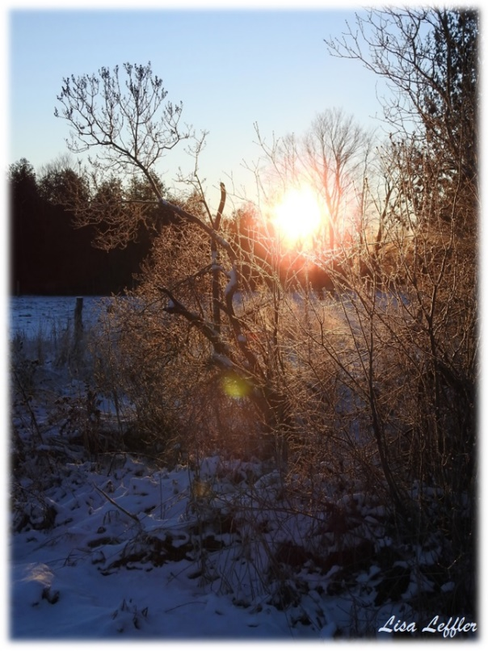
Paul was speaking to a church that was divided. We can only imagine what quarrels and differences had people saying I am part of Chloe’s people, I belong to Paul, I belong to Cephas – Peter, I belong to Apollo or I belong to Christ. It is so easy to separate ourselves from people who don’t agree with us – to decide we have good theology and someone else’s theology is bad. Many of us were raised with a very binary outlook which can leave us feeling confident we are right and someone else is wrong. Even Paul and Peter had their different views about the church should treat Gentile converts.
I don’t hear Paul saying we have to agree on everything. In fact I think we need to create brave space, where we are encouraged to share different understandings and opinions, where we can discern paths forward that take into account different ways of seeing and doing things. I trust our lives are much richer when we can hold one another in our differences.
What Paul is reminding us, is that Jesus came for all people. To be one in Christ, we have to love and respect people who see things differently than we do rather than separating ourselves from them. This seems foolish to people who believe they have the one right answer but if we are to be part of bringing God’s kingdom on earth as it is in heaven we have find our common humanity even when we see things differently.
Contemplation and Conversation
When have you found a new path forward because someone
shared a very different perspective with you?
Prayer
Holy One, help us set aside our belief that we have the right path
to truly listen to people who see things differently.
Together may we discern where your Spirit is leading us. Amen.

Further Conversation … Would you like to talk more about today’s reflection? Email Heather at hleffler@rogers.com.

Our Rockwood Stone Family
If you missed today’s worship service, visit our Rockwood Stone YouTube page.
Thanks to Brent Stiles for his reflection in worship today. If you have questions or suggestions for the Affirming Discernment Circle, please email them to Brent thestiles@sympatico.ca . If you would like to learn more about what it means to be an Affirming Church, go to https://affirmunited.ause.ca/ .

United Church of Canada
Call
The United Church of Canada Call reflects the core of our purpose, sharing who we seek to be in “such a time as this” (Esther 4:14).
Deep Spirituality
Bold Discipleship
Daring Justice
Vision
The United Church of Canada vision reflects what the church aspires to be over a 5- to 10-year span.
Called by God, as disciples of Jesus, The United Church of Canada seeks to be a bold, connected, evolving church of diverse, courageous, hope-filled communities united in deep spirituality, inspiring worship, and daring justice.
After a sustained consultation process, these interlinked statements were adopted by the Annual Meeting of General Council 43(opens in a new tab) on October 23, 2021.
The Call and Vision is commended to regional councils, communities of faith, and United Church incorporated ministries for engagement and discernment for their ministry. It is shared with the broader community as a pledge of identity and hope. These statements also provide purpose and direction within the 2022‒2025 Strategic Plan of the General Council Office.
To learn more go to https://united-church.ca/community-and-faith/welcome-united-church-canada/our-call-and-our-vision.
A gift of belonging to a church is that the practice of gathering together for worship … to pray, sing, listen to scripture and share how God touches our lives – helps us grow in deeper relationship with God and each other. We are offering this practice of sharing beyond Sunday morning to deepen our connection. Each week you are offered a picture, a scripture and a question for contemplation, as well as a short reflection for you to contemplate, have conversation with people in your life and/or join an online conversation on our Rockwood Stone Facebook page.

