Contemplation and Conversation:
5th Sunday after Epiphany, February 5, 2023
Scripture: – Isaiah 58:1-9a NRSVUE https://www.biblegateway.com/passage/?search=Isaiah%2058&version=NRSVUE

¹ Shout out; do not hold back!
Lift up your voice like a trumpet!
Announce to my people their rebellion,
to the house of Jacob their sins.
² Yet day after day they seek me
and delight to know my ways,
as if they were a nation that practiced righteousness
and did not forsake the ordinance of their God;
they ask of me righteous judgments;
they want God on their side.
³ “Why do we fast, but you do not see?
Why humble ourselves, but you do not notice?”
Look, you serve your own interest on your fast day
and oppress all your workers.
⁴ You fast only to quarrel and to fight
and to strike with a wicked fist.
Such fasting as you do today
will not make your voice heard on high.
⁵ Is such the fast that I choose,
a day to humble oneself?
Is it to bow down the head like a bulrush
and to lie in sackcloth and ashes?
Will you call this a fast,
a day acceptable to the Lord?
⁶ Is not this the fast that I choose:
to loose the bonds of injustice,
to undo the straps of the yoke,
to let the oppressed go free,
and to break every yoke?
⁷ Is it not to share your bread with the hungry
and bring the homeless poor into your house;
when you see the naked, to cover them
and not to hide yourself from your own kin?
⁸ Then your light shall break forth like the dawn,
and your healing shall spring up quickly;
your vindicator shall go before you;
the glory of the Lord shall be your rear guard.
⁹ Then you shall call, and the Lord will answer;
you shall cry for help, and he will say, “Here I am.”
M Churchyard
From Rev. Heather Leffler:
One of the reasons Jewish people fasted was to show their penitence to God and seek God’s forgiveness. Through Isaiah, God is urging them to rethink their fasting. If they fast, but then quarrel and treat people around them with disrespect as soon as their fast is over; the fast loses its meaning. God needs them and us to know fasting, wearing sack clothes and ashes, making sacrifices; the most beautiful singing, thoughtful worship, poignant prayers, passionate justice work or faithful service lose their meaning if we don’t care for the people around us.
Isaiah tells us that the best offering to God is to care for all people – to feed the hungry, stand with the oppressed, give shelter to the homeless, clothe the naked and not hide ourselves from our families, The kingdom of God we pray for each time we pray the Lord’s Prayer is the one where everyone belongs and is cared for. Our Protestant tradition tells us we don’t have to do good works to receive God’s grace, love and forgiveness. Instead our good works become our praise and thanks to the Holy One for knowing we are beloved children of God.
Contemplation and Conversation
Who is God asking me to care for today?
Prayer
Holy One, we have the gift of knowing your presence and love in our lives
Help us to share your love with the people around us. Amen.

Further Conversation … Would you like to talk more about today’s reflection? Email Heather at hleffler@rogers.com.

Our Rockwood Stone Family
If you missed today’s worship service, visit our Rockwood Stone YouTube page.
Our thoughts and prayers are with the family and friends of Laverne Hartung who died on Saturday. The family will have a private family gathering to honour Laverne’s wishes.

United Church of Canada – Your Generosity through Mission and Service Matters
Elders teach students the words, phrases, songs, and stories of their ancestors.
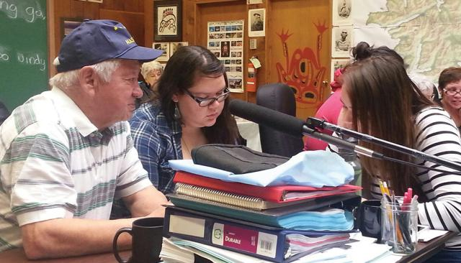
Credit: Haida Gwaii Skidegate
Published On: January 20, 2023
Take a moment to think about your favourite story.
Now imagine that story being at risk of disappearing because the language it’s written in is endangered. This is something that nine Elders from Haida Gwaii are passionately trying to change.
Once there were over 15,000 fluent speakers of Haida, but today, because of assimilation tactics like residential schools, almost all Haida people speak English at home. The nine Elders—with an average age of more than 80—represent about half of the fluent Haida speakers who remain.
With partner support, the work of these Elders in a research-based revitalization project keeps the Haida language alive and growing.
The Elders are teaching students the words, phrases, songs and stories of their ancestors. The response has been empowering, with language learners near and far dedicating themselves to study. Lessons are given through the Longhouse of Skidegate village, but the program reaches much further, with more than 120 online lessons available. The opportunity to connect across the globe has allowed Haida language, stories, and culture to be shared broadly.
The program also gives young people from the Haida Nation the opportunity to connect with the Elders to nurture their cultural pride and understanding. “I appreciate the work the Elders are doing with our language and culture,” said one young student. “They work very hard every day so that my generation can remember.”
The Haida language is not the only Indigenous language that has been endangered. Your gifts to Mission & Service support programs and partnerships for Indigenous cultural revitalization around the world.
If you would like to include a gift to Mission and Service in your PAR givings or send a one-time e-transfer please email our treasurers. Amanda Hunter-Anthony at rockwooduc.treasurer@gmail.com or Bill Allen at stoneuc.treasurer@gmail.com. Cheques can be sent to Stone United Church, PO Box 57 Rockwood, ON N0B 2K0 or Rockwood United Church, 119 Harris St., Rockwood, ON N0B 2K0.

A gift of belonging to a church is that the practice of gathering together for worship … to pray, sing, listen to scripture and share how God touches our lives – helps us grow in deeper relationship with God and each other. We are offering this practice of sharing beyond Sunday morning to deepen our connection. Each week you are offered a picture, a scripture and a question for contemplation, as well as a short reflection for you to contemplate, have conversation with people in your life and/or join an online conversation on our Rockwood Stone Facebook page.

