Contemplation and Conversation:
1st Sunday of Lent, February 26, 2023
Scripture: – Psalm 32 NRSVUE https://www.biblegateway.com/passage/?search=Psalm+32+&version=NRSVUE
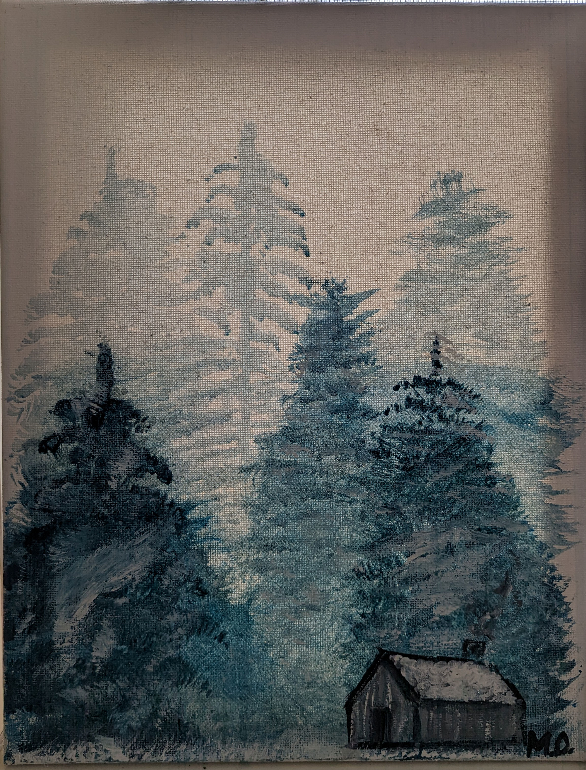
From Rev. Heather Leffler:
M Osborne
Jesus invites us to ask God to forgive our sins as we forgive those who sin against us. It isn’t easy. There are times when people hurt us deeply and we can’t imagine letting go of our pain or anger. There are things we have done or not done that hurt others which we can’t admit to ourselves let alone acknowledge to God.
The Psalmist knows that kind of holding on which impacts our body, mind and spirit. We are weighed down and sometimes become physically ill, but still we hold on to our justifications of what we have done or our judgements of others like a stubborn mule no matter how we are tormented.
The Psalmist has also experienced the gift of seeking God’s forgiveness and forgiving others. The joy of knowing the Holy One’s steadfast love and forgiveness invites us to experience them too.
Contemplation and Conversation
When have you experienced the gift of forgiveness?
Prayer
God of compassion, help us to have the courage to forgive others.
May our acts of forgiveness lead to renewed relationships
and bring us a sense of reconciliation
and peace in our daily lives. Amen.

Further Conversation … Would you like to talk more about today’s reflection? Email Heather at hleffler@rogers.com.

Our Rockwood Stone Family
If you missed today’s worship service, visit our Rockwood Stone YouTube page.
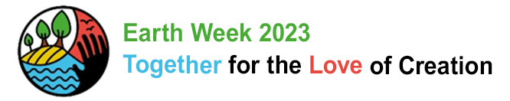
United Church of Canada
Dear UCC friends concerned about climate,
As you know, our planet is warming at unprecedented rates, changing weather patterns and disrupting the balance of nature with devastating consequences.
The challenge of climate change is large and the stakes are high. We must pull together all our best efforts.
We encourage you to participate in the Lenten effort, Give it up for the Earth. https://cpj.ca/fortheearth/
As well, During Earth Week 2023, The United Church of Canada is joining with numerous sibling denominations and faith-based organizations under one banner, Together For the Love of Creation. https://fortheloveofcreation.ca/earth-week/ During this week, we invite you to hold events to pray, learn and act for climate justice.
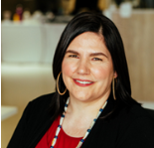
Come learn more, brainstorm possibilities and hear from our Moderator, Carmen Lansdowne.
ZOOM SESSION: Tuesday, March 7, 2023 at 12:30 pm ET
Register
If the time is not good for you, please register anyway so we can send you the link to the recording.
If you are a network or group that has climate connections in several communities of faith, please reach out ahead of time to justice@united-church.ca and we can work together to spread the word. This is a chance to lift up all our climate efforts: e.g. Faithful Footprints, Green Exodus, …
Looking forward to seeing you,
Lori Neale
For the organizing team
Response to the Phase One Findings at the Alberni Residential Institution
Published On: February 22, 2023
This information may be traumatic for residential school survivors, families, and community. If you are feeling pain or distress, please call the free 24-hour crisis line: 1-866-925-4419. You can also call the First Nations and Inuit Hope for Wellness Help Line at 1-855-242-3310. It's toll-free and open 24 hours a day, 7 days a week.
Upon hearing the preliminary research findings on deaths and unmarked graves at the Alberni residential institution, The Rt. Rev. Dr. Carmen Lansdowne, Moderator of The United Church of Canada, said: “The church will not look away from the truth that continues to be uncovered. The United Church of Canada continues our commitment to live into our Apologies, to be accountable, and to further the work of truth and reconciliation in concrete acts of justice and reparation.”
With deep remorse and grief, The United Church of Canada acknowledges the truth at the Alberni residential institution, which was run by the United Church. This is not new information for Indigenous communities; Indigenous people have been telling the world about deaths and unmarked gravesites for a very long time. We have not always listened to or heard you.
The United Church of Canada offers our deepest sympathies for the children who died at the institution, including those who did not make it home; survivors; the families; communities; and all those impacted by Canada’s residential institution system that tore Indigenous children from their families and communities.
The United Church of Canada was an active and willing participant in the operation of residential institutions. We were wrong to participate in this colonial, racist, and oppressive system.
In an effort to better live into our faith, we are taking steps to reconcile our legacy as perpetrators in this system. We know that our actions have directly contributed to trauma and death, loss of language and culture, breakdowns of the family unit, and intergenerational trauma.
The United Church of Canada, both regionally and nationally, hears the Tseshaht First Nation’s specific Calls for Truth and Justice directed to us, and commits to continued conversation with them about specific actions in response.
Every Child Matters.

From Moderator Carmen Lansdowne
A Prayer for Indigenous Peoples after the Phase 1 Results from Tseshaht First Nation
Creator,
We sit in stillness, waiting for your healing touch
We sit in stillness, tears falling down our cheeks in grief
We sit in stillness, witnessing the ways our culture breaths life back into our people
Blowing gently as a balm to our spirits
We hear the voices and feel the presence of the Old Ones who witness this reclamation,
and know that it is good
We feel the presence of the souls of children, stolen from their families and communities,
waiting to return home, even if only in how they are remembered
We release into your arms the hurts and trauma that we carry, that our forebears carried, and that our children and their children will carry
So that we can hold a newborn in our arms and say, truly, never again
So that we can watch with pride as young ones speak our language and dance our dances
So that we can take the time we need to spend time with you in prayer and gratitude
So that we can continue to thrive as Indigenous peoples
So that we can live on our land, fully who we are as you intended us to be
We pray for the continued accountability of the churches and the governments
for the harms they inflicted
We pray for reparations so that the oppressions
that have always been imposed on our peoples may be reversed
We pray for justice, that it continues to be done and our rights asserted and our land returned
We pray for hearts changed and minds opened of Canadians still in denial
about the atrocities that happened and continue to happen
We pray for our communities so that we may be gentle with ourselves and gentle with others
All this, we pray, will be done in a good way
Every child matters.
Amen.

From Moderator Carmen Lansdowne
A Prayer for the Non-Indigenous Church after the Results from Tseshaht First Nation
Creator,
You, in whom we live and move and have our being,
You created the universe and everything in it, in the fullness of your time,
which is so vast it is difficult for us to comprehend.
We, your children, caught up in the busy-ness of life, often forget there is always space and time. Always.
We continue to be held to account for or the ongoing legacy of the United Church’s role in colonization and the operation of residential institutions—the so-called “schools”.
Today we are held accountable specifically for our operation of the Alberni institution in the traditional territory of the Tseshaht (c̓išaaʔatḥ) First Nation, and that impacted so many other communities up and down the coast
This is difficult work—the messiness of repentance can be hard to do,
and we may feel tempted to rush.
There is no rush—Only your time
Your healing
We ask for your peace that surpasses all human understanding
The peace required to sit with uncomfortable news
The peace required to let our emotions come to the surface
The peace required to own our own reactions and not to burden Indigenous peoples with them
The peace required to respond, in due time, with humility and accountability
The peace and space for Indigenous peoples, inside and outside of the church, to offer their prayers and seek healing in the ways that are most meaningful to them
We ask you for the grace to create breathing space
To center the reality that children lost are not statistics
To pray for affected family members and communities of the lost ones
To listen to Indigenous peoples, especially the Tseshaht (c̓išaaʔatḥ) First Nation and other communities affected by the Alberni residential institution
To, when asked, take their direction on what is the next right thing to address the deaths
To make amends when we make mistakes, and to know we will always make mistakes
To continue to be present to our history and committed to a future
where we acknowledge the worth and dignity of all
To remember this is one step at the beginning of a journey – that the deaths confirmed and possible graves found is just one piece of information, and will not be the final numbers;
we may never know the final numbers.
We ask for your healing touch
Fill our lungs with breath
Breath that grants your peace
Because every child matters.
In the name of the one who came to teach us to reconcile,
Amen
A gift of belonging to a church is that the practice of gathering together for worship … to pray, sing, listen to scripture and share how God touches our lives – helps us grow in deeper relationship with God and each other. We are offering this practice of sharing beyond Sunday morning to deepen our connection. Each week you are offered a picture, a scripture and a question for contemplation, as well as a short reflection for you to contemplate, have conversation with people in your life and/or join an online conversation on our Rockwood Stone Facebook page.

