Contemplation and Conversation:
2nd Sunday of Lent, March 5, 2023
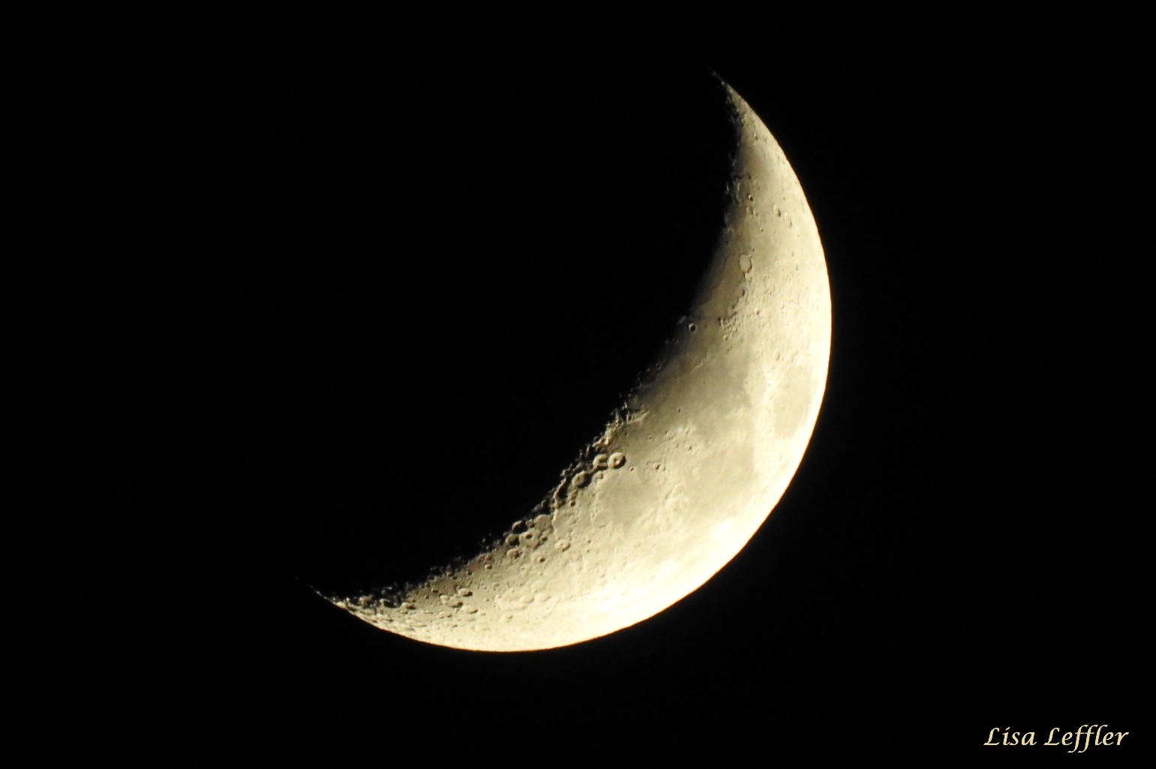
Scripture: – Psalm 121 NRSVUE https://www.biblegateway.com/passage/?search=Psalm+121+&version=NRSVUE
¹ I lift up my eyes to the hills—
from where will my help come?
² My help comes from the Lord,
who made heaven and earth.
³ He will not let your foot be moved;
he who keeps you will not slumber.
⁴ He who keeps Israel
will neither slumber nor sleep.
⁵ The Lord is your keeper;
the Lord is your shade at your right hand.
⁶ The sun shall not strike you by day
nor the moon by night.
⁷ The Lord will keep you from all evil;
he will keep your life.
⁸ The Lord will keep
your going out and your coming in
from this time on and forevermore.
From Rev. Heather Leffler:
Why is it that things seem so much more challenging in the middle of the night? When the world is quiet and it seems everyone else is asleep, my mind focuses on things I have no control over, worst case scenarios. Especially if my body is hurt or sick, I imagine the worst.
The Psalmist urges me to look to the hills for God, to know that even if everyone around me is in the midst of sweet dreams, God is with me. The Lord never slumbers or sleeps and is seeking the best for me no matter what is happening in my body or my life.
Contemplation and Conversation
Where do you find comfort in God?
Prayer
God of reassurance, help us to look to the hills
when we are in the valley of uncertainty.
May we be comforted in knowing that you are always with us
in our coming in and in our going out. Amen.

Further Conversation … Would you like to talk more about today’s reflection? Email Heather at hleffler@rogers.com.

Our Rockwood Stone Family
If you missed today’s worship service, visit our Rockwood Stone YouTube page.

United Church of Canada

A Year of War in Ukraine
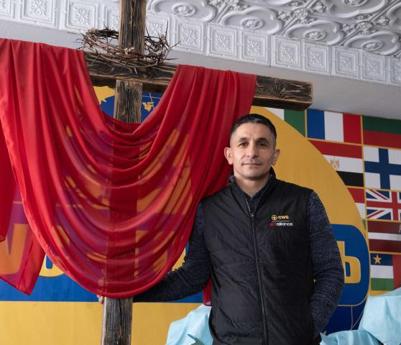
To mark the first anniversary of the war in Ukraine, The United Church of Canada Mission & Service partner ACT Alliance has shared this update on their work in the region, providing aid and assisting those fleeing the war. Your generosity through Mission & Service has long supported ACT’s humanitarian relief and advocacy efforts.
Budolai is an energetic non-governmental organization (NGO) leader in Balti, Moldova. He is also a person with strong faith. His organization, Healthy Cities, was created several years ago to help the most vulnerable people in the city: homeless, addicts, people with disabilities. Last year, when Russia invaded Ukraine, and refugees began to cross the border into Moldova in great numbers, he saw a need to reach out to this new group of people in need. Read the full story.

A gift of belonging to a church is that the practice of gathering together for worship … to pray, sing, listen to scripture and share how God touches our lives – helps us grow in deeper relationship with God and each other. We are offering this practice of sharing beyond Sunday morning to deepen our connection. Each week you are offered a picture, a scripture and a question for contemplation, as well as a short reflection for you to contemplate, have conversation with people in your life and/or join an online conversation on our Rockwood Stone Facebook page.

