Contemplation and Conversation:
3rd Sunday of Lent, March 12, 2023
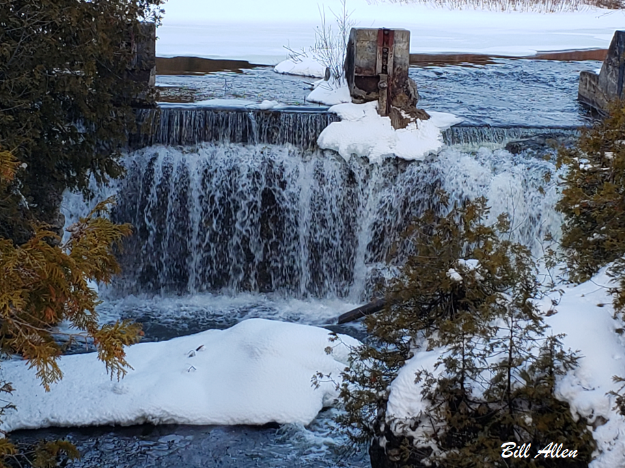
Scripture: – Psalm 95 NRSVUE https://www.biblegateway.com/passage/?search=Psalm+95+&version=NRSVUE
From Rev. Heather Leffler:
It is easy to look around at our beautiful country, seeing all the good things we enjoy and give thanks and praise to God. I love gathering in our churches or the wider church and singing praises together. It is hard for me to reconcile God’s caring for us, like a loving shepherd cares for their sheep, and then reading of the Lord loathing the Israelites because they complained against God and Moses at Meribah and Massah. What if I let Jesus down, will I find myself outside God’s love?
What if the Psalmist misinterpreted God’s actions? A Jewish friend of my father’s told him that the first generation of people who left Egypt with Moses only knew how to be slaves. They needed the time in the wilderness to learn new skills, new ways of being with each other and God. Maybe it wasn’t a punishment that they died before entering the promised land. Rather God was caring for them in the wilderness so that a new generation could grow up and be ready for the new life they would face. When it seems like God has abandoned me in a difficult time, is God preparing me for something new?
Contemplation and Conversation
What might God be preparing me for?
Prayer
God of renewal, help us to be open to new possibilities in our lives.
May we rejoice in the knowledge that you are preparing us
for even greater things as we journey together. Amen.

Further Conversation … Would you like to talk more about today’s reflection? Email Heather at hleffler@rogers.com.

Our Rockwood Stone Family
If you missed today’s worship service, visit our Rockwood Stone YouTube page.
Tuesday, March 14 at 7 pm at Stone or on Zoom join the Affirming Discernment Circle for a PIE Day Gathering. We will have a guest speaker share about their experiences of being an Affirming Church, explore further what it means for Rockwood-Stone to be affirming, share questions and enjoy delicious pie.
To learn more about PIE Day check out this video: https://www.youtube.com/watch?v=tbVwvurJEoU

United Church of Canada

Give it up for the Earth! Lenten Campaign

Give it up for the Earth! is built around three key elements: political advocacy, learning about biodiversity, and building relationships with Indigenous communities and personal action for the environment to reduce greenhouse gas emissions.
Sign on to the open letter to call for increased federal action on climate: increasing greenhouse gas emissions targets; increasing climate adaptation support; establishing a national strategy on Environmental Racism and Justice (Bill C-226); Canadian corporate accountability, especially around resource extraction (Bills C-262 and C-263); all anchored in incorporating the perspectives, knowledge, and rights of Indigenous peoples.
On March 23, at 6:00 p.m. EDT, join Citizens for Public Justice and For the Love of Creation for a thoughtful conversation on Biodiversity and Creation Care in Canada! Please register for the Preserving Biodiversity webinar, and for more details visit the Give it up for the Earth! webpage.

A gift of belonging to a church is that the practice of gathering together for worship … to pray, sing, listen to scripture and share how God touches our lives – helps us grow in deeper relationship with God and each other. We are offering this practice of sharing beyond Sunday morning to deepen our connection. Each week you are offered a picture, a scripture and a question for contemplation, as well as a short reflection for you to contemplate, have conversation with people in your life and/or join an online conversation on our Rockwood Stone Facebook page.

