Contemplation and Conversation: Palm Passion Sunday, April 2, 2023
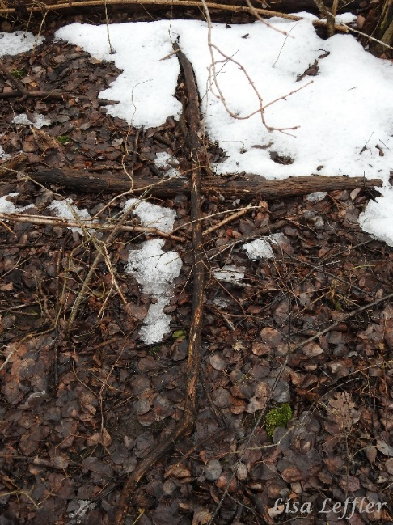
Scripture: – Psalm 22 NRSVUE https://www.biblegateway.com/passage/?search=Psalm+22&version=NRSVUE
From Rev. Heather Leffler:
Growing up we celebrated Palm Sunday. We sang of Jesus entering Jerusalem to bands of happy crowds waving palm branches. We didn’t think about the passion on Sunday, because we would come together on Maundy Thursday to share in communion and on Good Friday to hear the story of Jesus’ death.
Taking the time to read Psalm 22 that seems to foreshadow the last days of Jesus’ life reminds us there is always suffering in the world. It urges me to take time to hear the news and pray for people in far off places who are impacted by war, political unrest, economic uncertainty and climate crises. More than that it urges me to look for places closer to home where I can share someone’s struggles and bring Christ’s healing and hope.
Contemplation and Conversation
Where are you being called to stand with someone who is suffering?
Prayer
God of justice, help us to remember those who are struggling
in our midst and those farther afield.
May we be reminded of Christ’s suffering
and be inspired to join in solidarity with those in our world
who so desperately need healing and hope. Amen.

Further Conversation … Would you like to talk more about today’s reflection? Email Heather at hleffler@rogers.com.

Our Rockwood Stone Family
If you missed today’s worship service, you can watch it here: https://youtu.be/vNKWMGhXPZ0
Thank you to the Rockwood Stone Choir for their Offering Praise: https://youtu.be/Z8Zd9BzkQVU
Thank you to Auxiliary A/Insp. Brad Hull for talking to us about Safeguarding & Crime Prevention For Everyone. If you missed it you can watch it here: https://youtu.be/SBy0vTvg4YU
For more SafeGuard Resources visit: https://www.opp.ca/index.php?id=115&lng=en&entryid=570bf1a58f94ac983906709c
It is estimated fewer than 5% of fraud is reported. You can report fraud to the CANADIAN ANTI-FRAUD CENTRE. Report online through the Fraud Reporting Centre: www.antifraudcentre.ca
Report by phone: 1-888-495-8501

United Church of Canada
Your Generosity Matters ‘23: A Deeper Look: Real-Time Relief Really Makes a World of Difference
At a time when it feels like there’s a new crisis confronting us each and every day, it’s reassuring to know that Mission & Service partners provide real-time relief around the world on a daily basis. Thivan Hoang speaks to the vision and value of emergency response and long-term relief.
Your gift for Mission & Service will help address both immediate and long-term emergency response efforts.
Watch the video on YouTube here: https://www.youtube.com/watch?v=EQfnP7BjaKc&t=12s (extended version)
https://www.youtube.com/watch?v=mUEhQGGgt2A (worship version)
A gift of belonging to a church is that the practice of gathering together for worship … to pray, sing, listen to scripture and share how God touches our lives – helps us grow in deeper relationship with God and each other. We are offering this practice of sharing beyond Sunday morning to deepen our connection. Each week you are offered a picture, a scripture and a question for contemplation, as well as a short reflection for you to contemplate, have conversation with people in your life and/or join an online conversation on our Rockwood Stone Facebook page.

