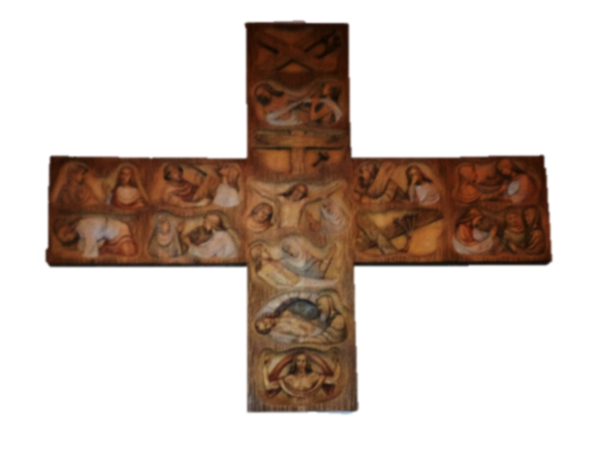
Contemplation and Conversation:
3rd Sunday of Easter, April 23, 2023
Scripture: – 1 Peter 1:17-23 NRSVUE
From Rev. Heather Leffler:
Passages like these are a huge challenge for me. The writer offers images of God as our judge and that when we are apart from God we must live in fear. Reminding us of the Jewish practice of sacrificing animals as offerings for sins, he wants to ground us in Jesus’ death being the ultimate sacrifice for us.
Accepting this seems to separate us from people who don’t know Jesus or more so have strayed from faith. It seems to leave people we love who no longer come to church and people of other faiths or no faith subject to the judgments we read in the Old Testament.
For me I need to read the passage for myself not others. It reminds me that when I let God down by hurting others or the earth, I separate myself from the Holy One. Jesus’ death assures me that God never gives up on me. When I am reconciled to people I have hurst or when I let myself be embraced by our church community after an absence, I feel again the mutual affection and strong sense of belonging that I cannot feel when I turn my back on God and our community.
Before Jesus, we might see God as the impartial judge, but it was God who sent Jesus to live with us, to die and rise from the dead for us. This is the God who judges us not to condemn us once and for all, but to teach us again and again that when we live our lives in loving, faithful community we enjoy the richest life God could imagine for us. May it be so.
Contemplation and Conversation
What does this passage say to you about God?
Prayer
Holy One, help us recognize that you judge us so that we can move to a new place.
Teach us to let go of our words, thoughts and actions that hurt ourselves or others,
so we can become the people you long for us to be. Amen.

Further Conversation … Would you like to talk more about today’s reflection? Email Heather at hleffler@rogers.com.

Our Rockwood Stone Family
If you missed today’s worship service, visit https://youtu.be/oK1NZ2pEGdk .

United Church of Canada
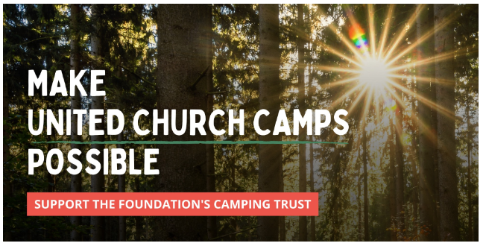
United, we: make United Church camps possible
April 23rd is Camping Sunday! It's an opportunity to celebrate the past, present and future of United Church camping.
United Church camps are places for families and young people to create community and strengthen relationships with one another, with Creation, and with God. However, like many ministries, they are impacted by budget cuts, aging facilities, and economic uncertainty.
Many camps turn to the Foundation for support to modernize and upgrade their facilities, create engaging new programming, and welcome campers of all backgrounds. Seeds of Hope grants help make United Church camp possible!
Please consider making a gift to the Camping Trust today to help lift up these communities for generations to come.
Each granting round, we receive many requests from camps, stretching the Foundation’s Camping Trust to the limit. We need your help to boost this fund so we can keep saying YES! and provide a future of sustainable support to this vital ministry.
Celebrate the blessing of camping ministry and the future of United Church camping. Let's make camp possible!

A gift of belonging to a church is that the practice of gathering together for worship … to pray, sing, listen to scripture and share how God touches our lives – helps us grow in deeper relationship with God and each other. We are offering this practice of sharing beyond Sunday morning to deepen our connection. Each week you are offered a picture, a scripture and a question for contemplation, as well as a short reflection for you to contemplate, have conversation with people in your life and/or join an online conversation on our Rockwood Stone Facebook page.

