Contemplation and Conversation:
4th Sunday of Easter/after Pentecost, April 30, 2023
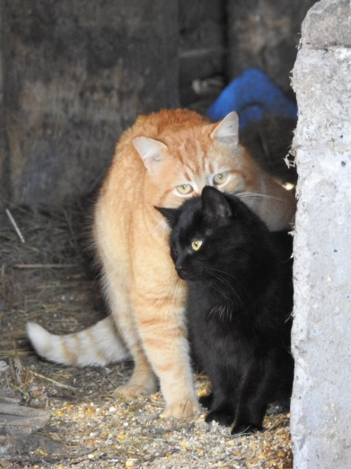
Scripture: – Acts 2:42-47 NRSVUE https://www.biblegateway.com/passage/?search=Acts%202%3A42-47&version=NIV
From Rev. Heather Leffler:
Those early days must have been amazing. The apostles teaching, sharing in communion and prayer, performing wonders and signs inspired people to come together and live in community. They gave up their possessions and property to care for each other. While we know there are still some religious communities that live in community – monasteries and convents among others, we know from stories later in Acts it wasn’t long until challenges developed.
While I can’t imagine a congregation choosing to live together in 2023, I wonder if there might be an invitation to us in this passage.
For a number of generations, we have been used to young people leaving home, possibly to live with roommates until they marry and set up their own household; leaving parents in their homes to live on their own until they downsize into retirement homes. What if we imagined different households – siblings, cousins or friends living together to save resources and be companions for each other; older adults and grandparents opening their homes to grandchildren or university students – offering affordable living for young people and help around the house for the elders. What if two friends or two couples shared a home. Not only would there be economic benefits and the opportunity to deepen relationships but we would be using fewer resources so the planet would benefit too. There would be challenges but there might be amazing opportunities. Could we be inspired by the early church.
Contemplation and Conversation
Where are you be invited into community in a new way?
Prayer
Holy One, help us hear the stories of the early church
not just as our history but as possibilities. Amen.

Further Conversation … Would you like to talk more about today’s reflection? Email Heather at hleffler@rogers.com.

Our Rockwood Stone Family
If you missed today’s worship service, you can watch it here: https://youtu.be/4igYnZfu4-s
Thank you to Kevin Ariss for talking to us about Computers and Seniors as part of Stone’s Wellness series: https://youtu.be/iQFz7K-hkd0

Moose Hide Campaign: Wear the Pin and Fast May 11th .
A commitment to take action in honour of women and children everywhere, and a symbol of honouring Indigenous medicine and belonging that is here to stay
Click on the link to view a You Tube video explaining the campaign https://youtu.be/8HwLuQlx6QM
The Moose Hide Campaign is an Indigenous-led grassroots movement that began 10 years ago to engage men and boys in ending violence towards women and children. Since the Campaign began along the Highway of Tears, thousands of communities and organizations across Canada have held Moose Hide Campaign events and joined the annual Moose Hide Campaign Day ceremony and fast. People of all ages, genders and backgrounds are invited to take part in Moose Hide Campaign activities.
The campaign is grounded in Indigenous ceremony and traditional ways of learning and healing. A cornerstone of the Moose Hide Campaign is wearing a moose hide pin and fasting for the day. Wearing the pin signifies your commitment to honour, respect, and protect the women and children in your life and speak out against gender-based and domestic violence. Moose hide is a symbol of taking a stand against violence and undoing the effects of Residential Schools. Fasting is also a traditional practice to focus the mind and create meaningful engagement in reflection.
Co-founders Paul and his daughter Raven were hunting moose to help feed their family for the winter and provide for cultural purposes. This was a grounding tradition on their land that passed knowledge from one generation to the other, something the residential school system tried to erase. They felt connected to their surroundings within their Carrier territory along the Highway of Tears in Northern BC where so many women have gone missing or been murdered. And they were inspired.
Benefits:
- Creating safe spaces and workplaces by raising awareness about gender-based violence and help create environments that are free from harassment and violence.
- Supporting reconciliation by promoting implementation of the Truth and Reconciliation Commission Calls to Action and the UN Declaration on the Rights of Indigenous Peoples and demonstrates commitment to addressing the tragic reality of missing or murdered Indigenous women and girls in Canada.
- Increases cultural sensitivity and understanding of the intergenerational impacts of colonization and residential schools. It helps address racism against Indigenous peoples.
Moose Hide Pins are available in the narthex at Rockwood or from Rosslyn Bentley 519 856 4068 rosslyn@sentex.net. Thanks to Carl Baker pins will be available at Stone.

United Church of Canada
To read more about the Moose Hide campaign go to https://united-church.ca/social-action/act-now/participate-moose-hide-campaign-combat-violence-and-call-justice . The video shared in worship today can be fund at https://www.youtube.com/watch?v=jTjcEnna7gQ&t=8s .

A gift of belonging to a church is that the practice of gathering together for worship … to pray, sing, listen to scripture and share how God touches our lives – helps us grow in deeper relationship with God and each other. We are offering this practice of sharing beyond Sunday morning to deepen our connection. Each week you are offered a picture, a scripture and a question for contemplation, as well as a short reflection for you to contemplate, have conversation with people in your life and/or join an online conversation on our Rockwood Stone Facebook page.

