Contemplation and Conversation:
5th Sunday of Easter after Pentecost, May 7, 2023
Scripture: – Psalm 31:1-5, 15-16 NRSVUE https://www.biblegateway.com/passage/?search=Psalm+31%3A1-5%2C+15-16&version=NRSVUE
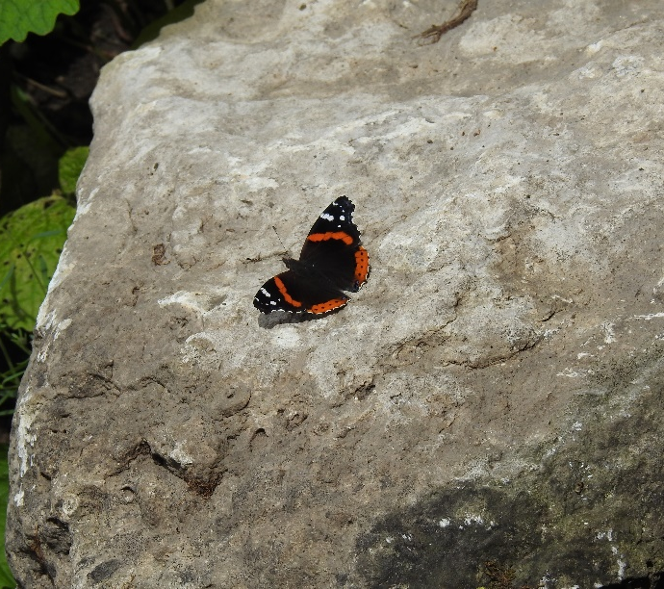
¹ In you, O Lord, I seek refuge;
do not let me ever be put to shame;
in your righteousness deliver me.
² Incline your ear to me;
rescue me speedily.
Be a rock of refuge for me,
a strong fortress to save me.
³ You are indeed my rock and my fortress;
for your name’s sake lead me and guide me;
⁴ take me out of the net that is hidden for me,
for you are my refuge.
⁵ Into your hand I commit my spirit;
you have redeemed me, O Lord, faithful God.
¹⁵ My times are in your hand;
deliver me from the hand of my enemies and persecutors.
¹⁶ Let your face shine upon your servant;
save me in your steadfast love.
From Lisa Leffler:
One of the gifts of the Psalms is that the depth of poetry reverberates throughout the centuries and speaks not only to the moment in time in which it was written but also to every moment of time the words are shared in. For the Psalmist the words likely spoke of a need find protection and strength in God in a time when many neighbouring countries often found themselves at war. Again, the words find new meaning as Jesus echoes verse five on the cross saying, “Into your hands I commit my spirit; you have redeemed me, O Lord, faithful God” – demonstrating Jesus’s commitment to God’s plan.
I can imagine these words finding new meaning throughout the generations of the church. From the early Christians meeting in secret and drawing half a fish in the sand to identify themselves to each other, trusting they are on the right path and looking to God for protection and comfort … on through to the generations to the Celtic Christians meeting in secret at night so they could continue to honour God in a way that they knew was right and good – looking to God to protect them from the doctrines and limitations of the dominant culture in religion … and on to the lonely preacher riding to settlements in North America trying to minister to people without ever being fully present in a community and needing to feel grounded in God’s love to have the conviction to continue his circuit.
Reflecting on how these words might have spoken to previous generations of Christians reminds me of the deep connection we have to one another – past, present and future – and how we are all bonded through God’s creation.
Contemplation and Conversation
What is the Psalm saying to you today?
Prayer
Creator God,
May we find strength and comfort in the words of scripture,
connections with one another, and the beautiful complexity of your creation;
reminding us wherever life takes us we are not alone.
Thanks be to God. Amen.

Further Conversation … Would you like to talk more about today’s reflection? Email Heather at hleffler@rogers.com.

Our Rockwood Stone Family
If you missed today’s worship service, you can watch it here https://youtu.be/5B-HlJgVUFI.
Thank you to the Rockwood Stone Choir for this morning’s offering praise https://youtu.be/REYhcc82rBg .

United Church of Canada
Remember May 11, 2023 is Moose Hide Campaign Day. To learn about the campaign to help end violence against women and children, go to https://moosehidecampaign.ca/ and find out how you can participate.
Your Generosity Matters – To learn more about how Mission and Service supports refugees, click on A Deeper Look: Making a Home for Refugees. Part 1 and Part 2.

A gift of belonging to a church is that the practice of gathering together for worship … to pray, sing, listen to scripture and share how God touches our lives – helps us grow in deeper relationship with God and each other. We are offering this practice of sharing beyond Sunday morning to deepen our connection. Each week you are offered a picture, a scripture and a question for contemplation, as well as a short reflection for you to contemplate, have conversation with people in your life and/or join an online conversation on our Rockwood Stone Facebook page.

