Contemplation and Conversation:
6th Sunday of Easter/Rural Life May 14, 2023
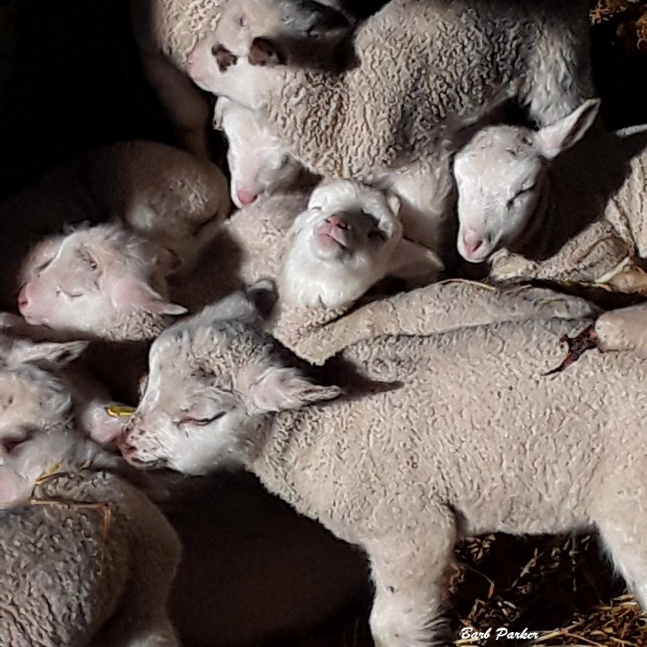
Scripture: – Psalm 66:8-20 NRSVUE https://www.biblegateway.com/passage/?search=Psalm+66%3A8-20&version=NRSVUE
⁸ Bless our God, O peoples;
let the sound of his praise be heard,
⁹ who has kept us among the living
and has not let our feet slip.
¹⁰ For you, O God, have tested us;
you have tried us as silver is tried.
¹¹ You brought us into the net;
you laid burdens on our backs;
¹² you let people ride over our heads;
we went through fire and through water;
yet you have brought us out to a spacious place.
¹³ I will come into your house with burnt offerings;
I will pay you my vows,
¹⁴ those that my lips uttered
and my mouth promised when I was in trouble.
¹⁵ I will offer to you burnt offerings of fatted calves,
with the smoke of the sacrifice of rams;
I will make an offering of bulls and goats. Selah
¹⁶ Come and hear, all you who fear God,
and I will tell what he has done for me.
¹⁷ I cried aloud to him,
and he was extolled with my tongue.
¹⁸ If I had cherished iniquity in my heart,
the Lord would not have listened.
¹⁹ But truly God has listened;
he has heard the words of my prayer.
²⁰ Blessed be God,
who has not rejected my prayer
or removed his steadfast love from me.
From Liz Guthrie:
The people called out for help and the Lord listened. He fed them manna when they were hungry. Water gushed out of the limestone rock and quenched their thirst. God parted the waters and brought them to a new place of abundance.
Look at the abundance we are fortunate to have around us. Great agricultural land grows corn, wheat and soybeans. Our farmers raise cattle, sheep and goats that in turn provide meat and milk products. Our gardens grow fruits and vegetables. Our parks and forests provide a haven for many creatures as well as areas for recreational uses.
We in turn give back by providing food items for gift baskets and the wellness events. Our donations support the Foodgrains Bank, East Wellington Community Services, Anishnabeg Outreach and the Breakfast Club at our local schools. Our Circle of Care brings new friendships.
Contemplation and Conversation
How have you shared God’s bounty with others?
Prayer
Creator God, help us to hear the cries of those in need
and reach out to help them as we can. Amen.
Further Conversation … Would you like to talk more about today’s reflection? Email Heather at hleffler@rogers.com.

Our Rockwood Stone Family
If you missed today’s worship service, visit our Rockwood Stone YouTube page.
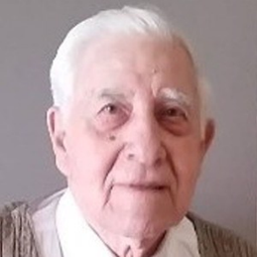
Our thoughts and prayers are with the family and friends of Gord Ostrander.
Ostrander, Gordon Frank of Rockwood, passed away peacefully at Hospice Wellington on Saturday, May 13, 2023, in his 96th year.
Beloved husband of the late Marian Velma Ostrander (nee Hamilton). Loved father of Robert (Lee ann), Kenneth (Helen Leitch), David (Alejandra Fernandez), Steven (Ramona). Loving grandpa of Leanne Minor (Mike), Murray, Cheryl Bates (Tim), Matthew (Ally), Andrew (Clara), Adam, Alexander, Kyle (Brianne), Kaitlin, Madison, Derek, Sean McCabe (Melsa), Aspen Skidmore. Great grandpa of Ray Minor, Ava Minor, Huckley Bates, Corben, Harvey, Millie. Dear brother of Marilyn Swackhammer (Doug). Will be dearly missed by many nieces, nephews, cousins, extended Ostrander, Hamilton and Oakes family members, and friends across the Rockwood and dairy farming communities.
Born in Rockwood, Ontario Gordon grew up as a 4th generation dairy farmer, and he was proud to continue the family farm legacy. His life spanned over 9 and a half decades, bridging two centuries of change. The collage of intriguing stories he shared with others ranged from being almost 1 year old when Wyatt Earp passed away, times of the great depression, wartime, one-room schoolhouses, arrival of the automobile, telephone, and electricity to owning a flatscreen tv with internet. Born only 75 years after Rockwood was established, he watched his hometown grow over the last 96 years. Family and community were of the upmost importance to him, evident in the numerous roles he took in community organizations and church, and his success as a beloved patriarch to such a large family. His family is forever grateful to Hospice Wellington for their support and compassion.
Friends will be received at the WALL-CUSTANCE FUNERAL HOME & CHAPEL, 206 Norfolk St., Guelph, Wednesday May 17, 2023 from 7 - 9pm. Funeral service will be held in the funeral home chapel on Thursday, May 18, 2023 at 11 am. Reception to follow in the Wall-Custance Family Reception Centre. Burial to follow at Rockwood Cemetery.
In lieu of flowers, the family asks for your consideration of donating, in his honour, to any of these organizations: Hospice Wellington, Rockwood United Church, Rockwood District Lions Club or Ontario 4-H Council.
A tree will be planted in memory of Gordon F. Ostrander in the Wall-Custance Memorial Forest.

United Church of Canada
A Prayer for Mother's Day
Loving God, help us make Mother’s Day more meaningful.
Help us make it even more of a celebration of those extraordinary people in our lives we call mom, who are like mothers to us, and to people of all genders, as well as trans and non-binary persons who offer mothering care.
Help us make it more supportive of mothers who have lost children, children who have lost mothers, women who long to be mothers, and those who choose not to be mothers.
Help us make it more open to those who don’t fit the traditional model of family and feel left out during this holiday.
Help us make it more caring of single moms, new moms, and those looking after their moms.
Help us make it more aware of those whose mothering responsibilities stretch across decades to span a lifetime.
Help us make it more loving for those who want to draw closer to their mother and more healing for those who need to keep a distance.
Help us make Mother’s Day more, O God.
More generous…more open…more caring.
We pray this in your holy name.
Amen.

A gift of belonging to a church is that the practice of gathering together for worship … to pray, sing, listen to scripture and share how God touches our lives – helps us grow in deeper relationship with God and each other. We are offering this practice of sharing beyond Sunday morning to deepen our connection. Each week you are offered a picture, a scripture and a question for contemplation, as well as a short reflection for you to contemplate, have conversation with people in your life and/or join an online conversation on our Rockwood Stone Facebook page.

