Contemplation and Conversation:
7th Sunday of Easter, May 21, 2023
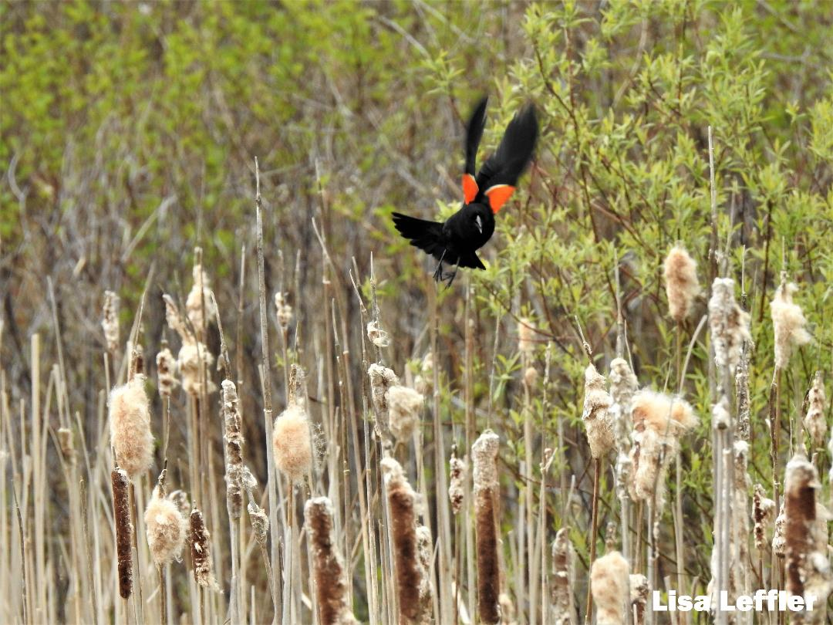
Scripture: – Acts 1:6-14 NRSVUE https://www.biblegateway.com/passage/?search=Acts%201%3A6-14&version=NRSVUE
From Rev. Heather Leffler:
Once again, the eleven and the other faithful including Mary and Jesus’ brothers were gathered with him. He had risen from the dead and they believed he had come to restore Israel to power. Instead Jesus told them the Holy Spirt had come on them so they could be his witnesses in Jerusalem, Judea, Samaria and to the ends of the earth. Then he left them again, ascending into heaven.
2,000 years has passed. We are still waiting for God’s kingdom to come fully and yet we have had glimpses of the kingdom in our lives and the world. When we go for a walk and our hearts are lifted by the breath-taking scenes of spring, when we are feeling lonely and a call or visit of a friend draws us into loving community; when people of all faiths and no faith gather and stand with those on the margins; we taste God’s kingdom and see it is good.
Contemplation and Conversation
When have you experienced a taste of God’s kingdom?
Prayer
God of Love, sometimes we long for your power and might.
Help us to see and be part of your love
that brings healing and hope to the world. Amen.

Further Conversation … Would you like to talk more about today’s reflection? Email Heather at hleffler@rogers.com.

Our Rockwood Stone Family
If you missed today’s worship service, you can watch it here: https://youtu.be/PDGdVtxNntg
Thank you to Chloe Southwell and the Rockwood Stone Choir for this morning’s Offering Praise: https://youtu.be/KLeWbqMwmLM
Please hold Linda and Burch Brown and their family in prayer as they mourn the death of their niece.
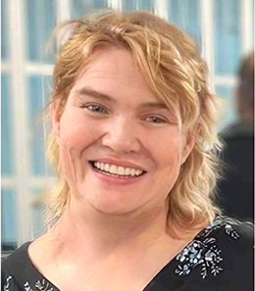
FRANKLIN, Shelley Of Guelph passed away on April 19, 2023 in her 54th year. Daughter of the late Loy (Cummings) and the late Larry Franklin. Loved and missed by her sister Tammy and nephew Tristan of London and brother Cory and Terri Lynne of Guelph. Her dog buddies Diesel Tank and Malone will miss the special treatment she gave them. Many happy memories with several Aunts and Uncles, Linda and Butch Brown of Kitchener, Bill and Kathy Cummings of Moorefield, Joyce Bell of New Hamburg, Ken and Sharon Franklin of Breslau and Dave and Ginny Franklin of Moorefield. Fondly remembered by many cousins and friends. Shelley loved doing crafts and was always looking for new challenges. She was very happy to be in attendance at her Grandma Audrey Cumming 100th Birthday party in March. Shelley would have been so happy to see the Toronto Maple Leafs make it to the next round of the playoffs as she was a huge fan. To honour Shelley’s wishes Cremation has taken place. Private family graveside service and interment in Bethesda cemetery with her mother. A Celebration of Shelley’s life will follow at Moorefield Optimist Hall, 14 Ball Street, Moorefield on Saturday May 27th, 2023 from 11:30am till 2:00pm to share memories of Shelley. Shelley loved animals and donations to Lions Foundation of Canada Guide Dogs or Nature Conservancy Canada would be appreciated and may be arranged through Heritage Funeral Home, Drayton, tel. 519-638-3072

United Church of Canada
Twenty years in the making ...
The Miracle of Multiplication
What God can accomplish when faith is turned into action
Looking back...
20 years ago, inspiration for creation of The United Church of Canada Foundation had its roots in the Old Testament.
Open your Bible to the Book of Jeremiah chapter 32, verses 1-15, and you will find the story of a remarkable investment, a visionary affirmation of faith in God‘s promise for the future.
In this story, Jeremiah‘s investment blessed his nation many times over. Similarly, your generous gifts 20 years ago had an outsized impact here at home.
Having grown from the size of a mere mustard seed in 2002, the Foundation now manages more than $93 million in assets.
And the annual harvests are bountiful.
United, we have accomplished something truly great over the past 20 years.
In 2021 alone...
- $7.6 million was granted to create a better, more equitable future throughout our United Church
- Over 400 congregations received almost $3.7 million in gifts
- $390,000 supported theological schools, United Church camps, and education centres|Also… $1 million is granted annually in support of innovative United Church programs that benefit children, youth, and seniors

Looking forward...
Just as Jeremiah put his faith into action, many years later, a young boy did the same. That one boy’s offering was so significant, that it was recorded in all four Gospels. It’s the story of how a young boy shared his lunch – five loaves and two fish – so that as many as 5,000 people could eat.
Feeding the multitude of needs that are before us, we are reminded of our dependence on Jesus both as the Bread of Life and as Living Water. We are also reminded that when a little faith is put into action, it goes a long way and has a greater impact, thanks be to God.
Over the past two decades, time and again, we have witnessed how small, simple acts of generosity by faithful people like you have grown into something much more substantial. They have made a significantly larger impact than anyone could have imagined thanks to God’s blessing and the miracle of multiplication.
The question is,
what do we believe God is calling us to do in the next 20 years?
United, we:
are focusing on the future, together!
In a world full of turmoil and chaos, it is imperative that we work towards a future that benefits everyone. The decisions we make today must benefit our children and neighbours of tomorrow.
Across Canada and beyond, we have joined with congregations, leaders, advocates, and generous donors like yourself to begin forging a new path for the long road ahead. It is one that follows our New Creed, “To live with respect in Creation, to love and serve others, to seek justice, and resist evil.”
As such, our priorities are:
- Climate Justice
- Communities of Faith
- Anti-Racism
- Reconciliation with Indigenous Peoples

A gift of belonging to a church is that the practice of gathering together for worship … to pray, sing, listen to scripture and share how God touches our lives – helps us grow in deeper relationship with God and each other. We are offering this practice of sharing beyond Sunday morning to deepen our connection. Each week you are offered a picture, a scripture and a question for contemplation, as well as a short reflection for you to contemplate, have conversation with people in your life and/or join an online conversation on our Rockwood Stone Facebook page.

