Contemplation and Conversation:
Sunday of Pentecost, May 28, 2023
Scripture: – Acts 2 :1-21 NRSVUE https://www.biblegateway.com/passage/?search=Acts%202&version‌=NRSVUE
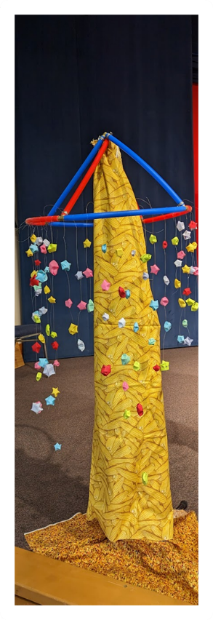
From Rev. Heather Leffler:
In the rush of a violent wind from heaven, the Holy Spirt filled the house where the followers of Jesus were gathered and touched them with tongues of fire. Filled with the Holy Spirit, they spoke in many diverse languages. Everyone gathered could hear the Good News for their lives in their own language.
Adam Creswell of the Hub Community Network told Western Ontario Waterways he saw this as the Holy Spirit’s coming out party. People of different places, cultures and languages were all included in that moment. The Spirit enabled the disciples to meet people where they were and to share Jesus’ love and forgiveness. Pentecost is a reminder that God created our incredibly diverse world … day and night … sun, moon and stars … land, seas, rivers and streams … grasses, plants and trees … fish, insects, reptiles, birds and animals. Then God created people of all shapes and sizes, skin and hair colours, gender expressions, sexualities and body types. As we recognize the incredible diversity enriches our lives, Pentecost invites us to dream about God’s possibilities for the world as we embrace each other’s diversity.
Contemplation and Conversation
What are your dreams for our churches and the world?
Prayer
Creator of all good things helps us discover the gifts you intended
as we embrace the diversity of the people you place in our lives. Amen.

Further Conversation … Would you like to talk more about today’s reflection? Email Heather at hleffler@rogers.com.

Our Rockwood Stone Family
If you missed today’s worship service, you can watch it at https://youtu.be/4oEgPOeWnqA .
Thank you to the Rockwood Stone Choir for sharing their gift of music. To hear their beautiful anthem and see pictures from the picnic visit: https://youtu.be/frEpAWL7OK4
If you enjoyed Dream: A Tale of Wonder, Wisdom & Wishes by Susan V. Bosak, you will want to read it again to see the amazing artwork by 15 artists and the wonderful quotes and explore the Legacy Project. Images for projection that were shared in worship are available from The Legacy Project website https://legacyproject.org/books/dreamslides.html . A hardcopy of the book is available through Indigo/Chapters or Amazon.ca. A YouTube video of the book being read is available at https://www.youtube.com/watch?v=i4p7BNdajk0 .

United Church of Canada
The Western Ontario Waterways Regional Council met Friday, May 26 and Saturday, May 27 at the Unifor Centre in Port Elgin. The theme Dreaming Dreams inspired wonderful worship and learning. The Celebration of Ministry at can be watched at https://www.youtube.com/watch?v=ykcBirny11c .
If you would like to learn more about the Regional Council, go to the https://wowrcucc.ca/ . Videos of the Spring Meeting will be posted on YouTube in the coming days.

A gift of belonging to a church is that the practice of gathering together for worship … to pray, sing, listen to scripture and share how God touches our lives – helps us grow in deeper relationship with God and each other. We are offering this practice of sharing beyond Sunday morning to deepen our connection. Each week you are offered a picture, a scripture and a question for contemplation, as well as a short reflection for you to contemplate, have conversation with people in your life and/or join an online conversation on our Rockwood Stone Facebook page.

