Contemplation and Conversation: Trinity Sunday, June 4, 2023
Scripture: – Psalm 8 NRSVUE https://www.biblegateway.com/passage/?search=Psalm%208&version=NRSVUE
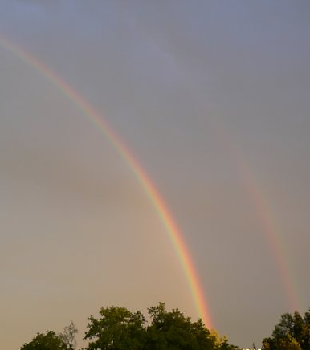
¹ O Lord, our Sovereign,
how majestic is your name in all the earth!
You have set your glory above the heavens.
² Out of the mouths of babes and infants
you have founded a bulwark because of your foes,
to silence the enemy and the avenger.
³ When I look at your heavens, the work of your fingers,
the moon and the stars that you have established;
⁴ what are humans that you are mindful of them,
mortals that you care for them?
⁵ Yet you have made them a little lower than God
and crowned them with glory and honor.
⁶ You have given them dominion over the works of your hands;
you have put all things under their feet,
⁷ all sheep and oxen,
and also the beasts of the field,
⁸ the birds of the air, and the fish of the sea,
whatever passes along the paths of the seas.
⁹ O Lord, our Sovereign,
how majestic is your name in all the earth!
From Rev. Heather Leffler:
On this Trinity Sunday, I am reminded of the words of the familiar hymn –
Holy, holy, holy!
Merciful and mighty
God in three persons
Blessed Trinity!
I find myself reflecting on the many, many different ways God meets us in our lives.
To Adam and Eve, God was creator and companion … to Abraham and Sarah – guide, protector, giver of life … to Moses – the great I am … to the Israelites – a pillar of fire by night, a cloud by night, provider of food and water … to Jesus – Father, Abba (Daddy) … to the woman at the well – living water … to the lepers, blind and lame – healer … to followers then and now – Saviour and redeemer … to the disciples and us – master, friend, Spirit, guide, comforter and protector.
The gift of the one who is Holy Mystery and Wholly Love to us is that God who gives us life is with us in life, in death and in life beyond death. Wherever we are on our journey, the Holy One is with us. Today is a day to give thanks for our Lord and Sovereign. May you feel the presence of God with you today and always.
Contemplation and Conversation
Which person of the Trinity speaks to you today?
Prayer
Creator, Redeemer, and Giver of life,
we give thanks that you are our comfort and strength;
our hope and support and our light and our way. Amen.

Further Conversation … Would you like to talk more about today’s reflection? Email Heather at hleffler@rogers.com.

Our Rockwood Stone Family
To view Stone’s worship service and UCW Celebration go to: https://youtu.be/zjteHmBNBRw
To view the pictures of the UCW go to: https://youtu.be/kfpJdxvWajs
To view Rockwood’s worship service go to: https://youtu.be/4zS80v1Dj9I
Please join us next Sunday for Rockwood’s Anniversary at 10 am in person and on Zoom. Following worship, we will be having a pastoral charge meeting to vote on becoming an affirming pastoral charge. Plan to stay for a potluck lunch.
More details about the vote will be sent this week. As in all congregational and pastoral charge votes in the United Church of Canada, you will need to join us in person or on Zoom to vote.

United Church of Canada
We affirm that gender and sexuality are gifts of God, and welcome people of all sexual orientations and gender identities. To learn more go to https://united-church.ca/community-and-faith/being-community/gender-sexuality-and-orientation .

A gift of belonging to a church is that the practice of gathering together for worship … to pray, sing, listen to scripture and share how God touches our lives – helps us grow in deeper relationship with God and each other. We are offering this practice of sharing beyond Sunday morning to deepen our connection. Each week you are offered a picture, a scripture and a question for contemplation, as well as a short reflection for you to contemplate, have conversation with people in your life and/or join an online conversation on our Rockwood Stone Facebook page.

