Contemplation and Conversation: 2nd Sunday after Pentecost, June 11, 2023
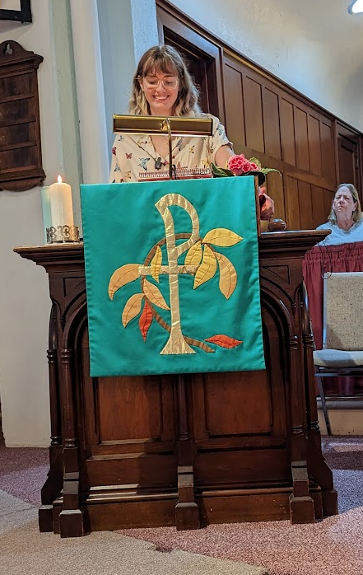
Scripture: – Genesis 12:1-9NRSVUE
https://www.biblegateway.com/passage/?search=Genesis+12%3A1-9&version=NRSVUE
From Rev. Heather Leffler:
Abram was 75 when God told him to leave his country and family and travel to a new land. He and Sarai had no children, but God promised them that their descendants would become a great nation and the families of the earth would be blessed through them.
Jews, Christians and Muslims share this heritage of descending from Abraham and Sarah through faith. At times we have struggled with each other within our Christian tradition, with our Jewish and Muslim siblings, and nonbelievers thinking God’s promise to bless those who bless us and curse those who curse us was just for our group. What we have learned over time is that when we curse others and want God’s blessing for ourselves, we don’t just hurt those outside our tradition. We also hurt ourselves. When we recognize each other as siblings – Abraham and Sarah’s descendants and bless one another, we find new relationships and can imagine God’s possibilities for all people. God chose us to bring people together so that all the families of the earth can be blessed.
Today we celebrated Rockwood’s 156 Anniversary and 98 years of our United Church of Canada. As the United Church we continue to recognize the times we set ourselves apart from others which have done harm, and we seek ways to be in relationship with other Christians, people of other faiths and people of no faith. Today our churches of Rockwood and Stone voted to become Affirming Congregations. Our guest speaker Natalie Luth shared that queer Christians will be able to see our churches as places where they can be accepted as themselves. They wouldn’t have to hide their spirituality as they do in queer groups where people have been hurt by the church or their sexuality and gender which they still have to hide in some Christian churches. This is a taste of God’s blessing to Abraham and Sarah that all the families of the world would be blessed through us their descendants.
Contemplation and Conversation
Who might you share the good news of our becoming affirming churches with?
Prayer
Holy Mystery, you are Wholly Loved, when you imagined the world into being
you intended that all people would be a blessing to each other.
Help us reach out, especially to those on the margins,
and share the blessing we have received from you. Amen.

Further Conversation … Would you like to talk more about today’s reflection? Email Heather at hleffler@rogers.com.

Our Rockwood Stone Family
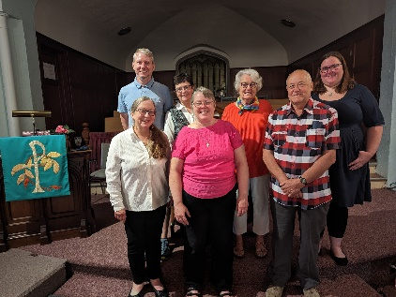
If you missed today’s worship service, you can watch it here: https://youtu.be/yRjqjV8JQkI
We are grateful thot our Rockwood Stone Pastoral Charge voted unanimously to be a designated Affirming Church this morning. Thank you to our Affirming Church Discernment Circle for their leadership, to everyone who came out to vote at Rockwood and on Zoom and all those who have been holding this decision in prayer.

United Church of Canada from Sarah Charters, President of The United Church of Canada Foundation
You see it in your morning paper and across your newsfeeds every day: globally, the hard-won progress made by LGBTIQ2S+ communities over the past decades is under attack. Discrimination and hate seem to dominate the headlines as anti-LGBTIQ2S+ rhetoric and violence not only persist, but are on the rise. Rights are being stripped, lives are in danger, and BIPOC, trans, two-spirit and non-binary folks are at disproportionate risk.
The new oppressive anti-LGBTIQ2S+ bill passed in Uganda is an especially dire development. Soon you'll be receiving my letter in the mail asking you to support the LGBTIQ2S+ Global Solidarity Fund. Given this recent news, I'm asking you to please consider getting a head start, and make your donation through our treasurers- Bill Allen at stoneuc.treasurer@gmail.com or Amanda Hunter-Anthony at rockwooduc.treasurer@gmail.com. Now is the time to support LGBTIQ2S+ folks, allies and activists around the world in every way we can.
The United Church of Canada's longtime advocacy for the human rights of LGBTIQ2S+ people, and the full inclusion of all God’s people in the church has sparked calls from around the world to share learnings with those who are fighting elsewhere in this work.
Gifts to the LGBTIQ2S+ Global Solidary Fund help the United Church and its global partners carry out this work, and make a difference in the lives of LGBTIQ2S+ people. Among the important work supported by the fund are consultations on inclusion; gatherings to share the realities of LGBTIQ2S+ communities in culturally-relevant contexts and help produce strategies for outreach, advocacy, and training. Watch the video below to see the most recent event which took place in Manila, Philippines earlier this year. https://www.youtube.com/watch?v=nIrvydIqQbk
This event and others like it are bringing hope and real change. As one participant shared: “I'm sure that what we planted together in one another's heart this time will be flowered in the rainbow garden of God”.
Right now, when the rights, safety, and well-being are at risk for LGBTIQ2S+ people, our solidarity remains our greatest strength. Solidarity shows we are a community of concerned children of God and proclaims that any action against LGBTIQ2S+ rights is action against human rights.
Your gift today for the LGBTIQ2S+ Global Solidarity Fund would be gratefully received and put to work immediately. Click here to give right now. You will directly support programs where there is an immediate serious need, while creating sustainable funding for this critically important work for years to come. Thank you for standing with the LGBTIQ2S+ community.

PS If you have a moment, I invite you to share how you're standing with the LGBTIQ2S+ community right now. You do not need any technical know-how or social media to participate. Click here to add your message. Let us know what solidarity means to you, as an LGBTIQ2S+ individual, ally, advocate or all 3! During Pride Month, and all year, we are #UnitedinSolidarity!

A gift of belonging to a church is that the practice of gathering together for worship … to pray, sing, listen to scripture and share how God touches our lives – helps us grow in deeper relationship with God and each other. We are offering this practice of sharing beyond Sunday morning to deepen our connection. Each week you are offered a picture, a scripture and a question for contemplation, as well as a short reflection for you to contemplate, have conversation with people in your life and/or join an online conversation on our Rockwood Stone Facebook page.

