Contemplation and Conversation:
3rd Sunday after Pentecost, June 18, 2023
Scripture: – Genesis 18:1-15 NRSVUE https://www.biblegateway.com/passage/?search=Genesis%2018%3A1-15&version=NRSVUE
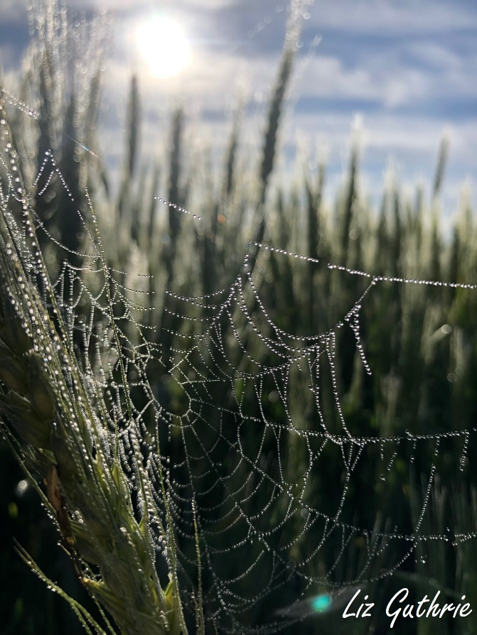
From Rev. Heather Leffler:
Abraham was 75 when God first promised him descendants would number as many as the stars in the sky and the sand on the beach. Sarah had long since passed childbearing age. When the visitors came with the message that she would have a son, Abraham was 99. For Sarah, this was too much. She laughed. How could she have a child when she was already through menopause?
Yet when the Lord, asked why she laughed she was afraid and denied it. Afraid God or Abraham would be angry with her, she insisted she hadn’t laugh. I suspect her fear wasn’t just that she would be found out but what having a child at her old age would mean. How different would if have been if she could have expressed her fears and disbelief.
How often, like Sarah, do we hide our thoughts and feelings because we are afraid of what others will think? Can we make brave, safe space where people can share what is on their mind and hearts?
Contemplation and Conversation
When have you hid what you have thought or how you felt
because you were afraid what someone else would think?
Prayer
God of all people, help us make safe, brave space
so people can share thoughts and feelings
and learn and grow together. Amen.

Further Conversation … Would you like to talk more about today’s reflection? Email Heather at hleffler@rogers.com.

Our Rockwood Stone Family
If you missed today’s worship service, visit our Rockwood Stone YouTube page.

United Church of Canada

A gift of belonging to a church is that the practice of gathering together for worship … to pray, sing, listen to scripture and share how God touches our lives – helps us grow in deeper relationship with God and each other. We are offering this practice of sharing beyond Sunday morning to deepen our connection. Each week you are offered a picture, a scripture and a question for contemplation, as well as a short reflection for you to contemplate, have conversation with people in your life and/or join an online conversation on our Rockwood Stone Facebook page.

