Contemplation and Conversation: 4th Sunday after Pentecost, June 25, 2023
Scripture: – Matthew 10:24-39 NRSVUE
https://www.biblegateway.com/passage/?search=Matthew+10%3A24-39&version=NRSVUE
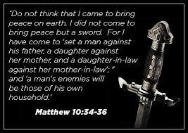
From Tammy Smits:
My last Contemplation and Conversation reading was from Matthew, and I always find him kind of…intense. He goes from offering some life advice and reassurance that God cares for individual sparrows to suddenly ripping out the sword and pitting parent against child and vice versa in His name. Very extreme!
Matthew was writing these instructions to the disciples to prepare them for their mission of spreading the Word in what was likely to be a hostile environment. While modern Christians are less likely to be murdered for their faith, professing and living beliefs today can be intimidating. Social media is an easy forum for sharing and finding connection, but it is equally likely to attract negativity, hatred and vitriol. People talk of equality, peace and embracing diversity but the increasing violence in the news, conflicts around the globe and continued hate crimes tell a different story.
It’s a different era, but Matthew’s message to promote God despite the potential negative consequences holds true, because God will care for us (right down to the last hair on our heads) as long as we are trying to do good work and live fully in His name.
Contemplation and Conversation
How will live your faith this week?
Prayer
Dear God, help us to be brave when living our faith is
frightening, overwhelming, unpopular or just plain dangerous.
Remind us of your faithful care and devotion so we can reciprocate. Amen.

Further Conversation … Would you like to talk more about today’s reflection? Email Heather at hleffler@rogers.com.

Our Rockwood Stone Family
If you missed today’s worship service, you can watch it on YouTube here: https://youtu.be/MmfWUDOhj8E
Thursday, July 6 from 4:30 pm to 7 pm at Trinity United Guelph 400 Stevenson St. N. join Anishnabeg Outreach and Trinity for their Partnership Launch Event.
If you are planning on attending, please email the church office by Tuesday, July 4 at rockwoodstoneuc@gmail.com so we can let them know how many people plan to attend.
AO is looking for a set of chain harrows for the Breslau farm property. For more information contact Cees Braamse at 905-702-3369.

United Church of Canada
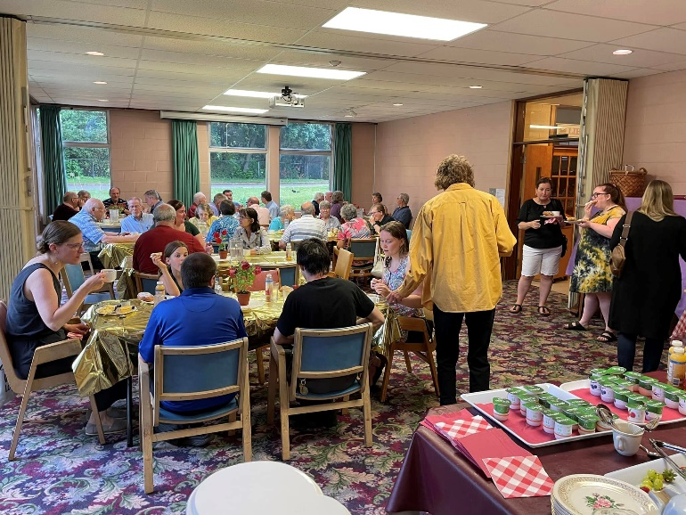
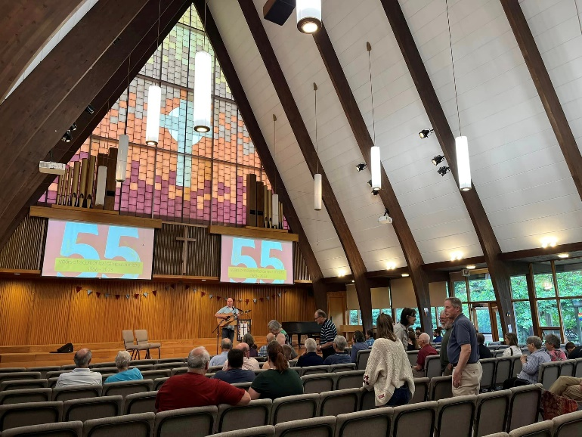
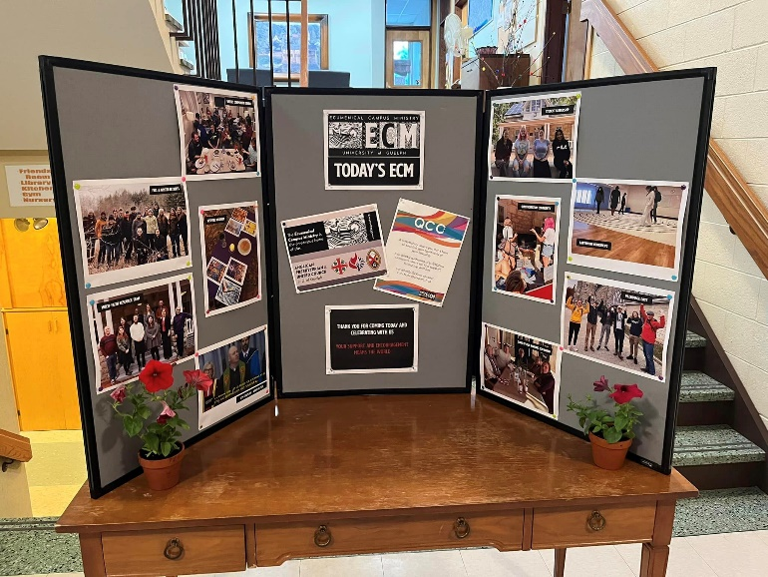
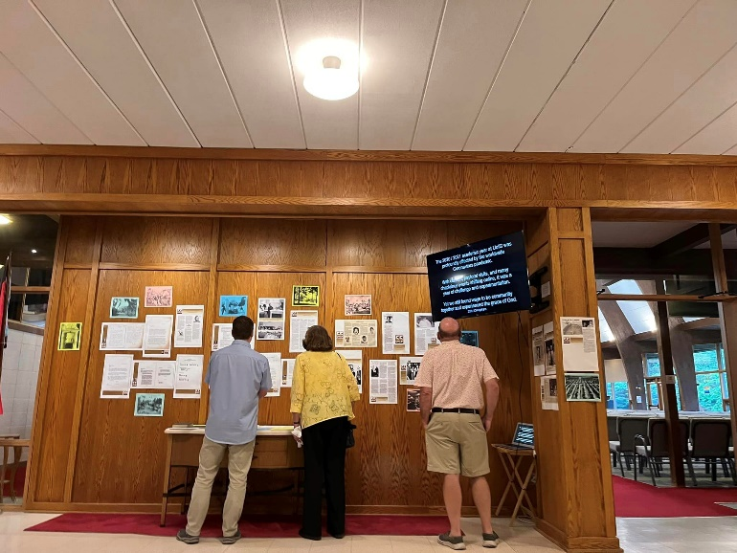
This weekend Ecumenical Campus Ministry celebrated 55 years of ministry of the University of Guelph.
At the celebration breakfast guest speakers shared memories of the past and hopes for the future.

To learn more about ECM visit: www.ecmguelph.org
To support the important work of the ministry go to https://www.ecmguelph.org/donate

A gift of belonging to a church is that the practice of gathering together for worship … to pray, sing, listen to scripture and share how God touches our lives – helps us grow in deeper relationship with God and each other. We are offering this practice of sharing beyond Sunday morning to deepen our connection. Each week you are offered a picture, a scripture and a question for contemplation, as well as a short reflection for you to contemplate, have conversation with people in your life and/or join an online conversation on our Rockwood Stone Facebook page.

