Contemplation and Conversation: 5th Sunday after Pentecost, July 2, 2023
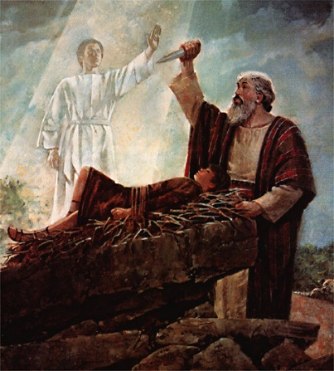
Photo from https://newlifenarrabri.wordpress.com/2017/06/26/reflection-on-genesis-221-14/
Scripture: – Genesis 22:1-14 NRSVUE
https://www.biblegateway.com/passage/?search=Genesis+22%3A1-14&version=NRSVUE
From Tammy Smits:
As a parent, I find this passage difficult to wrap my head around. How could Abraham even begin to contemplate sacrificing Isaac, the son he had wanted for so long? Would I have as much faith as Abraham? Does God still test people this way?
There are many circumstances in our lives where we have difficult decisions to make and sometimes no solution seems like the right one. Trusting God to open a window when a door closes is difficult, especially when we are scared, disappointed or angry. Believing that God has a master plan with our best interests at heart without being privileged to the relevant details, especially when that path is not the one I think is the best, is probably one of the most challenging parts of my faith journey.
In my heart of hearts, I choose to believe this is an allegorical story metaphorically teaching us about trust and faith, and that poor Abraham and Isaac weren’t actually subjected to this awful scenario. Whether they were or not, trusting God to provide no matter what the circumstances, although it is not always easy, will never lead us astray. He does always open that window, even if it doesn’t face the direction we thought it would.
Contemplation and Conversation
Do you trust God to provide when you are in a seemingly no-win situation?
Prayer
Dear God, help us to trust that you always have our best interests in mind,
whether or not they seem obvious to us.
Give us faith to follow you,
so we end up where you want us to be to serve your purpose. Amen.
Further Conversation … Would you like to talk more about today’s reflection? Email Heather at hleffler@rogers.com.

Our Rockwood Stone Family
If you missed today’s worship service, you can watch it on YouTube here: https://www.youtube.com/watch?v=kLwLNzC5g38
Thursday, July 6 from 4:30 pm to 7 pm at Trinity United Guelph 400 Stevenson St. N. join Anishnabeg Outreach and Trinity for their Partnership Launch Event.
If you are planning on attending, please email the church office by Tuesday, July 4 at rockwoodstoneuc@gmail.com so we can let them know how many people plan to attend.
AO is looking for a set of chain harrows for the Breslau farm property. For more information contact Cees Braamse at 905-702-3369.

United Church of Canada

Harvard University is talking about it. The Vatican is talking about it. UNESCO is talking about it. And also, the Moderator, The Right Rev. Dr. Carmen Lansdowne, is talking about it:
Flourishing.
Living a good, fulfilling life, a life with a sense of purpose.
The Moderator is on a three-year journey to connect with the nation on big questions. With the goal of enhancing “flourishing” in church, among our leadership, and within the broader community, she is encouraging dialogue on this question of flourishing, and how it could influence our future.
To flourish, we need to dream in ways that inspire tangible actions so individuals and communities across the nation and the world can flourish. We need solutions to particular challenges, and also invitations to collaborate so we can address them.
We need bold ideas.
To flourish, we need a strong social fabric. We need to be rooted in a sense of place, a sense of belonging. We need structures that work for everyone, a strong local economy and community.
We need daring connections.
For more details click here.

A gift of belonging to a church is that the practice of gathering together for worship … to pray, sing, listen to scripture and share how God touches our lives – helps us grow in deeper relationship with God and each other. We are offering this practice of sharing beyond Sunday morning to deepen our connection. Each week you are offered a picture, a scripture and a question for contemplation, as well as a short reflection for you to contemplate, have conversation with people in your life and/or join an online conversation on our Rockwood Stone Facebook page.

