Contemplation and Conversation:
7th Sunday after Pentecost, July 17, 2023
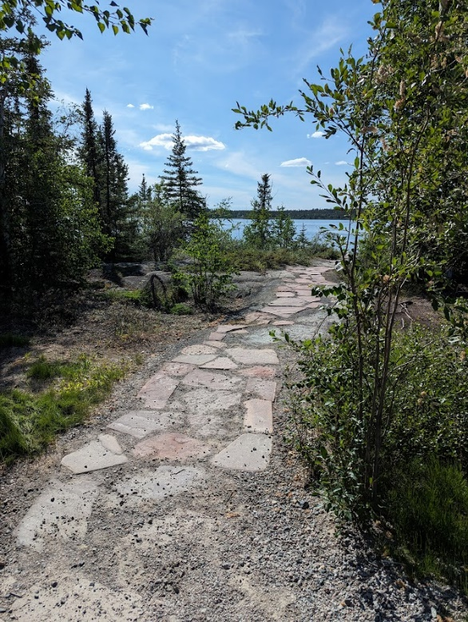
Scripture: – Psalm 119:105-112 NRSVUE https://www.biblegateway.com/passage/?search=‌Psalm%20119%3A105-112&version=NRSVUE
From Rev. Heather Leffler:
In a world that is more and more secular, where we are called to recognize and let go of long held ‘truths’ that have proven false and done harm to others, this passage from Psalm 119 reminds me that God’s ways are not our ways. Throughout history the church has clung to interpretations of scripture that have set people apart from one another and justified mistreatment of others. The Psalmist assures us these are not God’s ways.
Again and again the Holy Spirit invites us to follow God’s path. We are urged to accept God’s invitation to love one another as God loves us. As we journey through life following God’s ways, we discover that God’s law of love helps us recognize gifts in all people and brings us joy. May it be so.
Contemplation and Conversation
Where might God be inviting you to a new path?
Prayer
Faithful God, teach us to follow your path of love.
Help us recognize all people as beloved siblings in Christ. Amen.

Further Conversation … Would you like to talk more about today’s reflection? Email Heather at hleffler@rogers.com.

Our Rockwood Stone Family
If you missed today’s worship service, you can watch it here: https://youtu.be/Xno0pVrzYO8

United Church of Canada
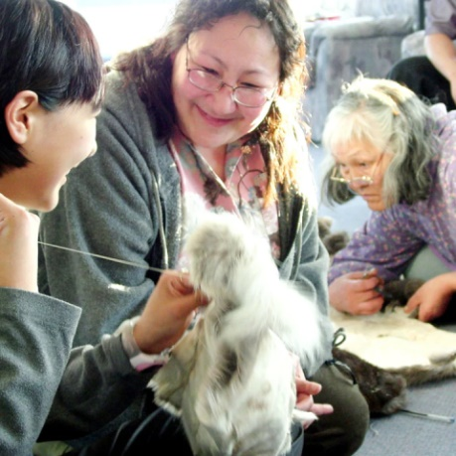
Your Gifts Help to Restore Lost Languages - Fewer than 600 people can still speak Inuinnaqtun fluently.
Published On: May 11, 2023
These days, most of us have access to technology that allows us to learn the world’s common languages. But countless languages—including many Indigenous languages—can only be learned from their few remaining speakers.
Revitalizing a lost language, as one of our partners in Nunavut is doing, is an important way to preserve not just the language but also the culture that surrounds it.
The Inuinnaqtun language is the cultural foundation of the Inuinnait people, who live in the central Canadian Arctic. The literal meaning of the word Inuinnaqtun is “to be like an Inuinnaq (a person).” Today, fewer than 600 people can still speak Inuinnaqtun fluently. Many lost the language when they were removed from their communities and sent to residential schools.
Pitquhirnikkut Ilihautiniq/Kitikmeot Heritage Society in Cambridge Bay, Nunavut, is working hard to keep Inuinnaqtun alive. One-on-one language immersion sessions with mentors inspire reconnection. Through everyday conversations at home and on the land, mentorship is helping to heal the wounds of systemic oppression.
In partnership with Mission & Service, Inuinnaqtun language mentors get resources to allow them to spend 300 hours a year working with their apprentices to begin to restore the language.
Your gifts to Mission & Service help partners continue to restore language and culture. Thank you.
Photo Credit: Pitquhirnikkut Ilihautiniq/Kitikmeot Heritage Society

A gift of belonging to a church is that the practice of gathering together for worship … to pray, sing, listen to scripture and share how God touches our lives – helps us grow in deeper relationship with God and each other. We are offering this practice of sharing beyond Sunday morning to deepen our connection. Each week you are offered a picture, a scripture and a question for contemplation, as well as a short reflection for you to contemplate, have conversation with people in your life and/or join an online conversation on our Rockwood Stone Facebook page.

