Contemplation and Conversation: 10th Sunday after Pentecost, August 6, 2023
Scripture: – Genesis 32:22-31 NRSVUE https://www.biblegateway.com/passage/?search=Genesis%2032%3A22-31&version=NRSVUE
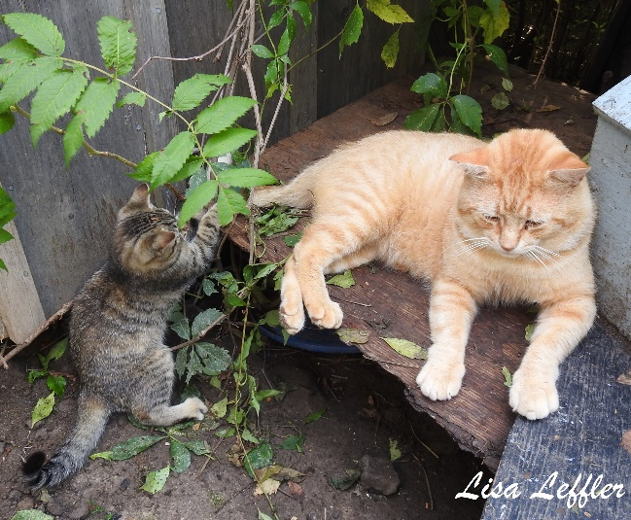
²² The same night he got up and took his two wives, his two maids, and his eleven children and crossed the ford of the Jabbok. ²³ He took them and sent them across the stream, and likewise everything that he had. ²⁴ Jacob was left alone, and a man wrestled with him until daybreak. ²⁵ When the man saw that he did not prevail against Jacob, he struck him on the hip socket, and Jacob’s hip was put out of joint as he wrestled with him. ²⁶ Then he said, “Let me go, for the day is breaking.” But Jacob said, “I will not let you go, unless you bless me.” ²⁷ So he said to him, “What is your name?” And he said, “Jacob.” 28 Then the man said, “You shall no longer be called Jacob, but Israel, for you have striven with God and with humans and have prevailed.” ²⁹ Then Jacob asked him, “Please tell me your name.” But he said, “Why is it that you ask my name?” And there he blessed him. ³⁰ So Jacob called the place Peniel, saying, “For I have seen God face to face, yet my life is preserved.” ³¹ The sun rose upon him as he passed Penuel, limping because of his hip.
From Lisa Leffler:
Jacob came into the world grasping his brother Esau’s heel – fighting for the position of firstborn. As a young man Jacob tricked Esau into giving up his birthright for a bowl of stew but it is not until Isaac is dying and Jacob tricks his father with failing eyesight into blessing him that Jacob can truly claim his place as heir.
When this happens, Esau is furious and wants to murder Jacob, so Rebekkah and Isaac encourage Jacob to leave for his own safety and seek a wife among Rabekkah’s relative, Lebon. Today’s scripture takes place after Jacob has been married, has children and accumulated livestock and servants and Jacob realizes it is time to return home because his presence is causing tension in his father-in-law’s household now that Lebon has sons. Jacob is afraid to face Esau and so he sent a messenger on ahead so Esau would know that Jacob respects his position as an elder brother.
I wonder if Jacob wasn’t carrying with him the fear of meeting his brother and all the burdens of the past if he would have experienced the same time of wrestling. Perhaps the man was a messenger from God to guide Jacob on his way but because he was holding a posture of hostility he had to wrestle and struggle to find the way forward.
Jacob’s story reminds that God doesn’t expect us to be perfect. Jacob’s early days were filled with trickery and deceit but when he was ready to let go of that and humble himself before Esau and before God, God was there with Jacob and Jacob became the father of great nation and one of the pillars of our faith tradition.
We all make mistakes in life, and we have to wrestle with how that shapes us and how we can move forward but God is always there with us inviting us to choose a loving path forward and to build a world where everyone can be the best versions of themselves.
Contemplation and Conversation
What are you wrestling with? What is God inviting you to set down and move forward from? When have you experienced a moment of transformation?
Prayer
Ever-present God,
At times your call for us is clear and strong,
other times we wrestle with which path we are meant to be on.
Help us to remember you are with us in that struggle
inviting us to a path filled with your grace and love.
Amen.

Further Conversation … Would you like to talk more about today’s reflection? Email Heather at hleffler@rogers.com.

Our Rockwood Stone Family
If you missed today’s worship service, you can watch the scripture and sermon here: https://youtu.be/U6tAce8Wj3Y


United Church of Canada
The United Church Calls on Manitoba to Search the Landfill
Morgan Harris and Marcedes Myran were murdered in 2022 and left in a Winnipeg landfill. Their families and communities are calling for a search of the landfill, but the province of Manitoba refuses.
The United Church of Canada believes that the inherent dignity of every human being must be respected. In life, and now in death, Morgan, Marcedes, and thousands of other missing and murdered Indigenous women, girls, and Two Spirit people have been denied the dignity and respect that they deserve.
We call on the government to bring Morgan and Marcedes home to their loved ones. We are in solidarity with Camp Morgan and Camp Marcedes in Winnipeg.
Join us in our social media solidarity campaign to #SearchTheLandfill
Read the news full story and visit the United Church Facebook page or Instagram channel to share graphics.

A gift of belonging to a church is that the practice of gathering together for worship … to pray, sing, listen to scripture and share how God touches our lives – helps us grow in deeper relationship with God and each other. We are offering this practice of sharing beyond Sunday morning to deepen our connection. Each week you are offered a picture, a scripture and a question for contemplation, as well as a short reflection for you to contemplate, have conversation with people in your life and/or join an online conversation on our Rockwood Stone Facebook page.

