Contemplation and Conversation: 11th Sunday after Pentecost, August 13, 2023
Scripture: – Romans 10:5-15 NRSVUE https://www.biblegateway.com/passage/?search=Romans%2010%3A5-15&version=NRSVUE
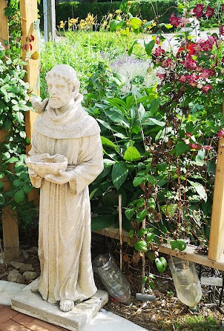
⁵ Moses writes concerning the righteousness that comes from the law, that “the person who does these things will live by them.” ⁶ But the righteousness that comes from faith says, “Do not say in your heart, ‘Who will ascend into heaven?’ ” (that is, to bring Christ down) ⁷ “or ‘Who will descend into the abyss?’ ” (that is, to bring Christ up from the dead). ⁸ But what does it say?
“The word is near you,
in your mouth and in your heart”
(that is, the word of faith that we proclaim), ⁹ because if you confess with your mouth that Jesus is Lord and believe in your heart that God raised him from the dead, you will be saved. ¹⁰ For one believes with the heart, leading to righteousness, and one confesses with the mouth, leading to salvation. ¹¹ The scripture says, “No one who believes in him will be put to shame.” ¹² For there is no distinction between Jew and Greek; the same Lord is Lord of all and is generous to all who call on him. ¹³ For “everyone who calls on the name of the Lord shall be saved.”
¹⁴ But how are they to call on one in whom they have not believed? And how are they to believe in one of whom they have never heard? And how are they to hear without someone to proclaim him? ¹⁵ And how are they to proclaim him unless they are sent? As it is written, “How beautiful are the feet of those who bring good news!”
From Rev. Heather Leffler:
Paul wants us to know that it is not following the laws of Moses to the letter or being a particular denomination, ethnicity, sexual orientation, gender or social position that saves us. It is not even the good works we do that are most important to God.
What assures us of abundant life is faith in Jesus. This doesn’t mean we ascribe to a certain set of beliefs. What matters is that we live our lives looking to Jesus … worshiping God, letting the stories of scripture engage us and sharing our faith through our thoughts, prayers, actions and words.
Paul reminds us that it is through us that others will come to know Jesus. St. Francis of Assisi said “Preach the Gospel at all times. Use words if necessary.” Most of us, unless we are in the pulpit or Bible Study are hesitant to talk about God, Jesus and the Holy Spirit. When we live out our faith in gratitude for what God has done for us, our prayers and actions can speak for us. When someone asks, why you are a follower of Jesus trust that the Spirit is inviting you to share the good news in words.
Contemplation and Conversation
How do you live out your faith?
Prayer
Faithful, loving God, we are grateful for the gift of knowing Jesus in our lives.
May our thoughts, prayers and actions share the good news of your saving grave.
May we have the courage to share the good news in words, when your Spirit nudges us. Amen.

Further Conversation … Would you like to talk more about today’s reflection? Email Heather at hleffler@rogers.com.

Our Rockwood Stone Family
If you missed today’s worship service, you can watch it here: https://youtu.be/lhwnEqvhH1Q
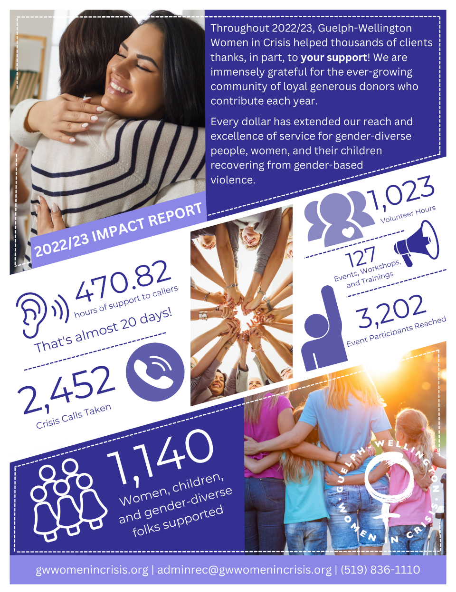
From Guelph-Wellington Women in Crisis & The Rural Women’s Support Program
You helped us extend our reach and amplify our impact - thank you!

United Church of Canada

From Western Ontario Waterways
Join the Mini Christian Pilgrimage Friday, August 25, 9:30 am – 12 pm
To register, contact Kathy Douglas, Faith Formation Minister, at Kdouglas@united-church.ca.

A gift of belonging to a church is that the practice of gathering together for worship … to pray, sing, listen to scripture and share how God touches our lives – helps us grow in deeper relationship with God and each other. We are offering this practice of sharing beyond Sunday morning to deepen our connection. Each week you are offered a picture, a scripture and a question for contemplation, as well as a short reflection for you to contemplate, have conversation with people in your life and/or join an online conversation on our Rockwood Stone Facebook page.

