Contemplation and Conversation: 12th Sunday after Pentecost, August 20, 2023
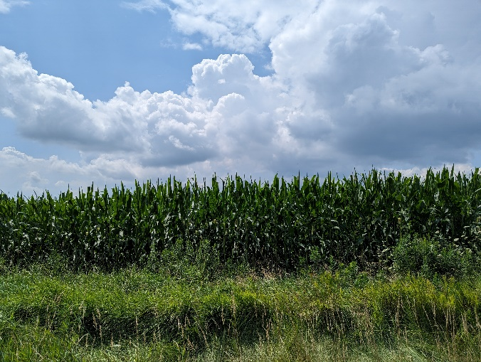
Scripture: – Genesis 45:1-15 NRSVUE https://www.biblegateway.com/passage/‌?search=Genesis%2045%3A1-15&version=NRSVUE
¹ Then Joseph could no longer control himself before all those who stood by him, and he cried out, “Send everyone away from me.” So no one stayed with him when Joseph made himself known to his brothers. ² And he wept so loudly that the Egyptians heard it, and the household of Pharaoh heard it. ³ Joseph said to his brothers, “I am Joseph. Is my father still alive?” But his brothers could not answer him, so dismayed were they at his presence.
⁴ Then Joseph said to his brothers, “Come closer to me.” And they came closer. He said, “I am your brother, Joseph, whom you sold into Egypt. ⁵ And now do not be distressed or angry with yourselves because you sold me here, for God sent me before you to preserve life. ⁶ For the famine has been in the land these two years, and there are five more years in which there will be neither plowing nor harvest. ⁷ God sent me before you to preserve for you a remnant on earth and to keep alive for you many survivors. ⁸ So it was not you who sent me here but God; he has made me a father to Pharaoh and lord of all his house and ruler over all the land of Egypt. ⁹ Hurry and go up to my father and say to him, ‘Thus says your son Joseph, God has made me lord of all Egypt; come down to me; do not delay. ¹⁰ You shall settle in the land of Goshen, and you shall be near me, you and your children and your children’s children, as well as your flocks, your herds, and all that you have. ¹¹ I will provide for you there, since there are five more years of famine to come, so that you and your household and all that you have will not come to poverty.’ ¹² And now your eyes and the eyes of my brother Benjamin see that it is my own mouth that speaks to you. ¹³ You must tell my father how greatly I am honored in Egypt and all that you have seen. Hurry and bring my father down here.” ¹⁴ Then he fell upon his brother Benjamin’s neck and wept, while Benjamin wept upon his neck. ¹⁵ And he kissed all his brothers and wept upon them, and after that his brothers talked with him.
From Rev. Heather Leffler:
Summer is a time of family reunions. Most of our reunions can’t measure up to Joseph’s. Our families and relationships can be complicated. Joseph’s is a story of moving beyond complications with the help of God’s grace.
Joseph had a father, mother, stepmother who was also his aunt, and two stepmothers who were servants of his mother and aunt, one brother, one half-sister, and ten half-brothers. Nine of his half-brothers left him at the bottom of the well to die. One came back and sold him into slavery to save his life.
Time had passed and Joseph had gone from being a slave to becoming second in command in Egypt. He was responsible for feeding all the people in the land. His dreams had caused the bad feelings with his family that lead to his brothers’ actions. It was God helping him interpret the dreams of others that rescued him from prison and connected him with Pharoah. The interpretation of dreams ensured that food in the years of plenty was stored for the years of famine. When his brothers came to buy food, he was able to watch them and see their care for their father Jacob and Joseph’s brother Benjamin.
Joseph’s story has much to offer. What stands out for me is the invitation to meet people where they are now not hold them or ourselves to what we said or did in the past. Life changes each of us. When we aren’t able to change how we see others, they will probably hold on to things we have said and done that we would like to let go of. May we all meet our family with grace and love.
Contemplation and Conversation
Who might God be inviting you to see in a new?
Prayer
Loving Parent, you gave us families to nurture and support us.
Sometimes we are not our best and relationships are strained or broken.
May we be open to your healing in your time. Amen.

Further Conversation … Would you like to talk more about today’s reflection? Email Heather at hleffler@rogers.com.

Our Rockwood Stone Family
If you missed today’s worship service, visit our Rockwood Stone YouTube page.
We wish Barb and Don Mochrie well as they move to their new home in Vulcan Alberta. We are grateful they will be able to continue to connect with us through our YouTube services and announcements and look forward to seeing them when the return to visit family and friends. Their phone number remains the same.
Our thoughts and prayers are with the family and friends of Pamela Ferguson. Pam has been on our prayer list and died at Hospice Wellington on August 17, 2023 after a brief battle with cancer. https://www.guelphtoday.com/obituaries/ferguson-pamela-d-pam-7429456

United Church of Canada
From Moderator Carmen Lansdowne
Yesterday at 00:47
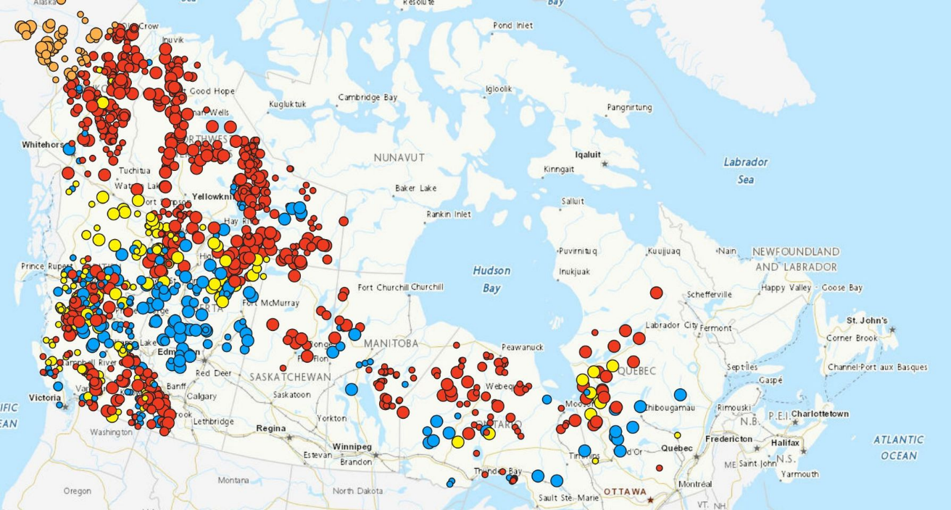
Prayers for the people of Yellowknife and Kelowna and everywhere else in Canada affected by fires this night and always. This year’s fires in Canada are the worst on record. Tonight’s fire map: #EcoGrief #ClimateEmerency
A gift of belonging to a church is that the practice of gathering together for worship … to pray, sing, listen to scripture and share how God touches our lives – helps us grow in deeper relationship with God and each other. We are offering this practice of sharing beyond Sunday morning to deepen our connection. Each week you are offered a picture, a scripture and a question for contemplation, as well as a short reflection for you to contemplate, have conversation with people in your life and/or join an online conversation on our Rockwood Stone Facebook page.

