Contemplation and Conversation: 1st Sunday of Creation, September 3, 2023
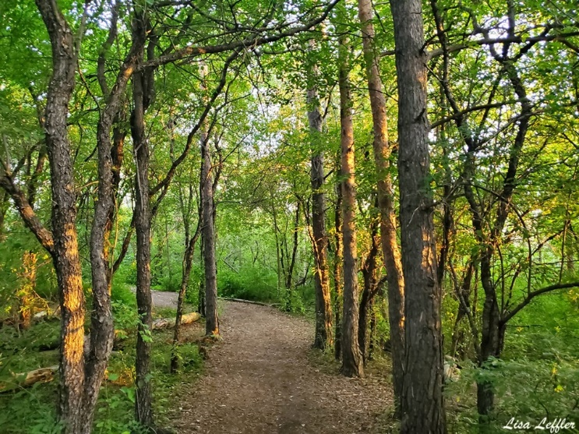
Scripture: John 3:1-16 NRSVUE https://www.biblegateway.com/passage/?search=John+3%3A1%E2%80%9316&version=NRSVUE
From Rev. Heather Leffler:
As a Pharisee, Nicodemus faithfully followed all of the laws of Moses. The laws intended to help people love God and love each other had become a way to set apart followers of the law from other Jewish people and Gentiles. Drawn to Jesus, Nicodemus knew something had to change but he was confused when Jesus said he must be born again.
We depend on the forest for wood for construction, for fuel for heating and cooking and for paper for communication and so much more. Theodore Hiebert tells us that forests shelter half the world’s known plant and animal species, protect and enrich soil, sustain water quality and quantity, absorb carbon dioxide and produce oxygen allowing us to breathe and reduce global warming.* Seeing forests as a resource to be harvested has led us to purchase products because we want and need them rather than to ask if the forest can sustain our use. Often, we shrug helplessly as we see trees come down and new home go up.
More and more we are hearing voices of our Indigenous brothers and sisters, climate change activists and other “tree huggers” inviting us to rethink our relationship to the forest and all it contains. Rather than seeing forests as a resource to be used, we are invited us to recognize them as living beings, co-inhabitants of the earth that we depend on for the very air we breathe. Like Nicodemus, we are invited to be born into a new way of seeing creation through the eyes of our Creator.
* From The Season of Creation: A Preaching Commentary by Norman C. Habel, David Rhoads, and H. Paul Santmire, Editors.2011, Fortress Press, Minneapolis.
Contemplation and Conversation
What does being born of the Spirit look like? Might it be an invitation to reevaluate our thoughts, words and actions towards the forest in light of our faith?
Prayer
God of the forest, we give thanks that you created and are still creating.
Help us to see our woodlands as a living, breathing eco-system rather than as a resource to be exploited. May we view the forest through your eyes and become a willing partner with you in re-creation. Amen.
Further Conversation … Would you like to talk more about today’s reflection? Email Heather at hleffler@rogers.com.

Our Rockwood Stone Family
If you missed today’s worship service, you can watch it here: https://youtu.be/gQDHPiiWQ3M
Thank you to Brian Mack for reading a guided meditation from Returning to the Healing Oasis by Sharon Moon for this morning’s Offering Praise: https://youtu.be/geUUv7zzOCs
If you didn’t pick up your creation pack this morning it should be delivered sometime this week. If you are able to help with deliveries, please contact Rev. Heather Leffler at 519-265-7385. Attached to this email is a digital copy of the refleections.

United Church of Canada
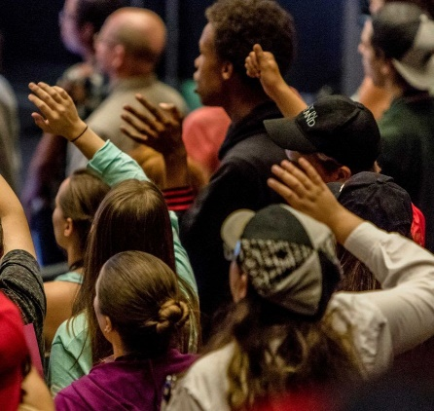
Learning to Connect: Youth Survey
The United Church of Canada is trying to learn from young people (ages 13-35 years) about what encourages a sense of connection to the church and what blocks their involvement. Please share this survey with Canadian young people that you know—they don't need to be currently connected with a church in any way!
In appreciation of participating and sharing the survey link, two individuals will be randomly selected to receive a $25 dollar gift card (options provided).

A gift of belonging to a church is that the practice of gathering together for worship … to pray, sing, listen to scripture and share how God touches our lives – helps us grow in deeper relationship with God and each other. We are offering this practice of sharing beyond Sunday morning to deepen our connection. Each week you are offered a picture, a scripture and a question for contemplation, as well as a short reflection for you to contemplate, have conversation with people in your life and/or join an online conversation on our Rockwood Stone Facebook page.

