Contemplation and Conversation: 2nd Sunday of Creation Time, September 10, 2023
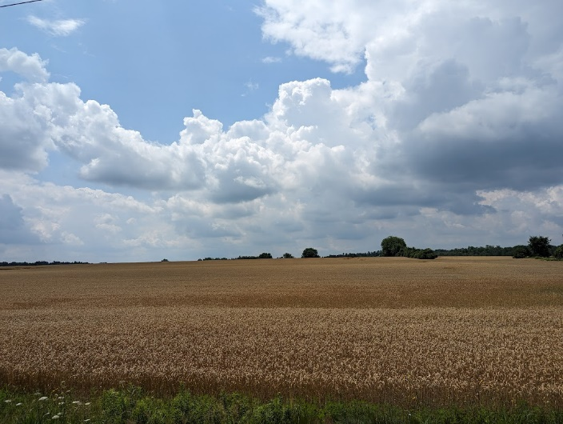
Scripture: – Matthew 12:38-40 NRSVUE https://www.biblegateway.com/‌passage/?search=Matthew%2012:38-40&version=NRSVUE
³⁸ Then some of the scribes and Pharisees said to him, “Teacher, we wish to see a sign from you.” ³⁹ But he answered them, “An evil and adulterous generation asks for a sign, but no sign will be given to it except the sign of the prophet Jonah. ⁴⁰ For just as Jonah was three days and three nights in the belly of the sea monster, so for three days and three nights the Son of Man will be in the heart of the earth.
From Rev. Heather Leffler:
These scribes and Pharisees had seen Jesus heal people who were sick, blind, deaf, mute and lame. They’d watched as he cleansed leper and cast out demons. They may even have heard how he raised the daughter of the synagogue leader from the dead and calmed the storm when he and his disciples were on the sea. Yet still they asked for a sign. They would not trust that he had come from God because he didn’t fit with their idea of the Messiah.
Jesus invited them to turn to the earth. It was from the earth that God created people. It is from the earth we receive the food and resources we need to live. Jesus told them that his body would be buried in the earth, just as Jonah was in the belly of the whale. As the land nurtures seeds, it would hold his body in the heart of the earth for three days until his resurrection.
We are invited to see ourselves as part of the land. Not to just blindly take what we need from the earth but to see how interdependent we are and find ways to live with respect in creation.
Contemplation and Conversation
How often do we take the earth for granted?
What practices might we change to live more gently on the land?
Prayer
God of the land, we give thanks for the richness of your earth.
Help us to acknowledge the ways in which we have wantonly exploited
the home which you have provided for us.
May we see ourselves as an integral part of the land
and seek imaginative ways to live in harmony with creation. Amen.

Further Conversation … Would you like to talk more about today’s reflection? Email Heather at hleffler@rogers.com.

Our Rockwood Stone Family
If you missed today’s worship service, visit our Rockwood Stone YouTube page.
Today’s Minute for Mission can be found at https://www.youtube.com/watch?v=aF9qkRlo7yE.
From Stephen Jackson
For me, Summer transitioning into fall is marked by the annual labour day return to school regimens for families across the country.
Instead of an update to mark our significant progress this summer, we offer an outcome to help support all families and children have the best school year possible. While we created these resources for Indigenous people living on reserves and in urban centres, we offer them to all families because this is September and Every Child Matters.
Attached are PDFs we created to help children and their families. Please help us share these free and useful resources with your work places, organizations, schools and network of colleagues, families and friends. These detailed worksheets provide solutions and strategies to help children who are shy, and/or experience bullying, friendship and/or academic challenges, etc. Parents can also learn strategies to prepare for back to school and ensure student safety and even find accessible tutoring resources. We hope families find these resource sheets useful. You may share the attachments or simply post the following link to our website Back-t0-School Resource Guide – Anishnabeg Outreach (aocan.org) which has all of the resource sheets. Note, we will be adding additional resources sheets on sleep, etc. in coming weeks. I encourage everyone to join our social media (facebook.com/anishnabegoutreach, twitter.com/anishnabeg, instagram.com/anishnabegoutreach/) to stay informed as roll out more resources to support children and their caregivers. Our only request to use these free resources is that everyone respects our copyright and branding.
These resource sheets are the lightest version of the tools we are creating. In our AONest, we have developed a significantly more comprehensive set of life skills which teaches essential life skills. We are also creating a much more immersive and intensive set of mental health management modules which contain many courses and worksheets on how to heal yourself and support those experiencing a wide variety of mental health challenges such as trauma, addictions, anxiety, stress, depression, grief, anger, ADHD, break ups and divorce and intimate partner and gender violence, etc. This self-directed software solution will make mental health accessible to everyone who needs but can’t afford a therapist. Our training materials are currently going through clinical review and will begin clinical trials later this fall or winter. Unfortunately, this transformative and groundbreaking initiative hasn’t been supported by any of the levels of government despite the promise it holds to heal the incarcerated, and proactively prevent people from experiencing homelessness, addictions and intimate partner and gender-based violence and as a result it has taken us longer to build and roll out than we had hoped.
If you are seeking an organization to support either philanthropically or on a volunteer basis, I would ask for your help so we can complete the tools we are creating to help families, both Indigenous and non-Indigenous, across the country overcome mental health challenges and achieve lasting prosperity.

Stephen Jackson, M.A.Sc.
CEO Anishnabeg Outreach Employment and Training Inc.
226-972-1900


United Church of Canada https://united-church.ca/social-action/act-now/honour-children-who-attended-residential-schools
On September 30, wear an orange shirt to remember and honour Indigenous children who were taken from their homes.
On September 30, people all across Canada will wear orange shirts to remember and honour Indigenous children who were taken from their communities and families to residential institutions.
This year, Indigenous communities across the country continue to share the truth they have always known: that many of the children who never returned home remain on the grounds of those institutions in unmarked burial sites. These communities are now seeking to honour the missing children.
On Orange Shirt Day we also observe the National Day for Truth and Reconciliation. For non-Indigenous Christians in particular, this is a time to reflect on their role in colonialism and the ongoing responsibility to make reparations.
Why Orange?
Phyllis Jack Webstad from the Stswecem’c Xgat’tem First Nation went to St. Joseph Mission Residential School. On her first day of school, Phyllis wore an orange shirt that her grandmother had given her. It was immediately taken away, and that marked the beginning of Phyllis’s long separation from her family and community, a separation caused by actions of the church and federal government.
Orange Shirt Day is a time for us all to remember those events and their ongoing impact. Indigenous Ministries and Justice has prepared a week of activities for all in the church to take part in.
Orange Shirt Day Activities
Sunday, September 24
Mark Orange Shirt Day in your community of faith!
Whether your community of faith is meeting in person, online, or both, please ask people to wear orange for a community picture. It could be a group photo, a Zoom call screenshot, or a photo collage. Share your photos on Facebook and Twitter (include the hashtags #OrangeShirtDay, #EveryChildMatters, and #UCCan).
Saturday, September 30
Wear an orange shirt on September 30. Whether you’re at work, at school, or at home, get out that orange shirt!
Make sure you take a picture to share on Facebook and Twitter (include the hashtags #OrangeShirtDay, #EveryChildMatters, and #UCCan), and challenge your friends and family to do the same.

A gift of belonging to a church is that the practice of gathering together for worship … to pray, sing, listen to scripture and share how God touches our lives – helps us grow in deeper relationship with God and each other. We are offering this practice of sharing beyond Sunday morning to deepen our connection. Each week you are offered a picture, a scripture and a question for contemplation, as well as a short reflection for you to contemplate, have conversation with people in your life and/or join an online conversation on our Rockwood Stone Facebook page.

