Contemplation and Conversation: 3rd Sunday of Creation Time, September 17, 2023
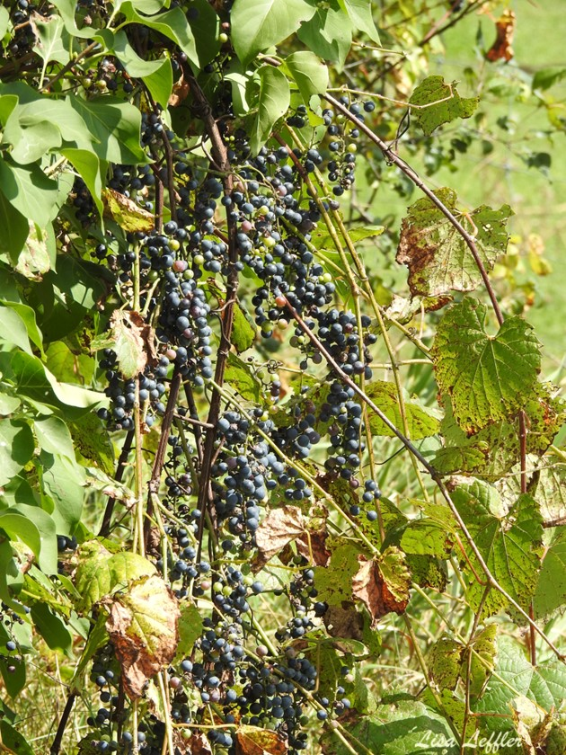
Scripture: – Mark 1:9–13 NRSVUE https://www.biblegateway.com/passage/‌?search=Mark+1%3A9%E2%80%9313&version=NRSVUE
From Rev. Heather Leffler:
We have domesticated God. Our worship is almost always held inside our beautiful sanctuaries, often behind stained glass, so we can’t see out and no one can see in. We cut ourselves off from the world to be with God.
Jesus’ experience was different. He left the sanctuary of the synagogue and the comforts of the town to meet John in the wilderness. It was there in the midst of nature, that he was baptized. Hearing God’ word that he was the Beloved Son, he went further into the wilderness to test his call. Again and again he would leave the busyness of life behind to go up the mountain or into the wilderness to pray.
We are invited to meet God wherever we are. Not only do we see the beauty and wonder of creation in new ways, we also recognize where God needs us to help bring healing to the earth.
Contemplation and Conversation
How often do we only look for God in churches
and other places we have decided are holy?
What might we discover if we looked for God in wilderness?
Prayer
God of the wilderness, we give thanks for the chance to experience you in a new way.
Help us to find stillness in the midst of the busyness of everyday life.
May we be open to the nudgings of the Spirit, as we recognize the harm
we have done to our environment and seek ways to heal our planet. Amen.

Further Conversation … Would you like to talk more about today’s reflection? Email Heather at hleffler@rogers.com.

Our Rockwood Stone Family
If you missed today’s worship service, visit our Rockwood Stone YouTube page.
From Anishnabeg Outreach
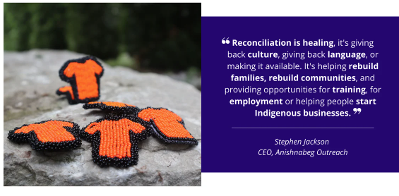
As the end of September approaches, we are reminded of the historical significance and impact of the residential school system on First Nations, Inuit, and Métis communities in Canada. The National Day for Truth and Reconciliation, observed on September 30th, stands as a solemn day to honor the resilience of Indigenous peoples and to work towards healing and reconciliation.
At Anishnabeg Outreach (AO), our mission is to actively contribute to reconciliation efforts and stand in solidarity with Indigenous communities on their journey towards healing. To take meaningful action leading up to the National Day for Truth and Reconciliation, look at ways you can get involved with AO and support our initiatives:
Five Ways you can get involved with AO
1 Inquire about reconciliation training facilitated by Anishnabeg Outreach for your corporate team. This training program empowers your team with valuable insights and tools to foster a culture of understanding and reconciliation within your organization.
Truth and Reconciliation Training
2 Make a donation to AO in support of one of our many programs that provide opportunities for healing to First Nations, Inuit, and Métis families. By contributing, you help us empower communities and foster positive change.
Donate Now through Rockwood or Stone.
3 Join us at our September 30th event! We're gathering at our Spirit Garden for Everyone, Eminidowang Kitigaan, to harvest our remaining crops that will go into food bundles for the 350 Indigenous families on our Spirit Bundle Program. Spread the word and mark your calendar!
Address: 1160 Spitzig Road, Woolwich, ON, N0B 1M0 (Off Highway 7)
Time: 9:00 am to 1:00 pm
4 Share this email with your network so more people can learn about what they can do to support. Through this process, we can raise awareness and inspire more individuals and organizations to collaborate in taking action.
5 Explore partnership opportunities with AO to collaborate on exciting projects. Partnering with us opens up new opportunities for mutual growth and success. Let's unite our efforts to achieve our shared goals and craft something exceptional! To explore partnership possibilities, please complete the form provided below.
Partner With Us
We believe that by collaborating and working together, we can create a more inclusive and compassionate society where reconciliation is a shared commitment. Let's take this opportunity to foster understanding, partnership, and teamwork in our communities.
Should you have any questions or need additional information, please feel free to reach out to us at info@aocan.org or call us at 519-208-5333.
Thank you for considering these ways to take meaningful action with Anishnabeg Outreach. Together, we can make a positive impact on the path to reconciliation.
Warm Regards,
AO Team

United Church of Canada
A Prayer for Climate Change
Loving and gracious God,
You are a God of Creation.
Create in me a faithful steward of your world,
showing me opportunities to make a difference,
that I may live with respect in your Creation.
You are a God of Incarnation.
Make me your heart and your mind,
equipping me to work for change.
You are a God of Resurrection.
Help me see new ways and new hope,
planting in me the seeds of
restoration and renewal.
God of Creation, Incarnation, and Resurrection,
help me go gently in this fragile world.
Amen.
A gift of belonging to a church is that the practice of gathering together for worship … to pray, sing, listen to scripture and share how God touches our lives – helps us grow in deeper relationship with God and each other. We are offering this practice of sharing beyond Sunday morning to deepen our connection. Each week you are offered a picture, a scripture and a question for contemplation, as well as a short reflection for you to contemplate, have conversation with people in your life and/or join an online conversation on our Rockwood Stone Facebook page.

