Contemplation and Conversation: 5th Sunday of Creation Time, October 1, 2023
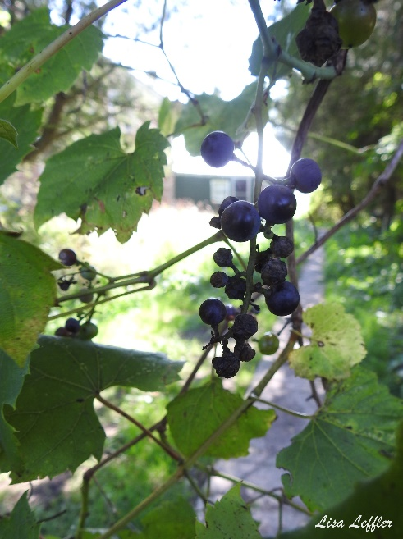
Scripture: – Revelation 22:1–5 NRSVUE https://www.biblegateway.com/passage/‌?search=Revelation+22%3A1%E2%80%935&version=NRSVUE
From Rev. Heather Leffler:
As I contemplated John’s picture of the river of life flowing from the throne of God with twelve kinds of trees, producing its fruit each month and leaves of the tree for healing nations, I was struck by the realization that this river was not in the dark, luxuriant forest or pristine wilderness. This river is following in the midst of the city.
While taking time in the forest, on the land, in the wilderness or at the river can be wonderful places to connect with the Holy One, God is with us in all places. When we see our cities as holy, we can imagine new ways of being together. Gardens on roof tops, walking trails, open air cafés surrounded by plants, markets overflowing with fruit and produce that comes no matter the season – these are gifts we can share with one another. Living close together lets us conserve fuel for heating and transportation leaving more greenspace for other creatures and to help mitigate climate change. Co-ordinating shipments means that a ship or truck that delivered cars or other goods can take back oranges or other produce instead of returning empty. Seeing ourselves as a global community, invites us to choose practices that sustain life for all of God’s creation.
Contemplation and Conversation
Where do you find creation in the city?
What might you do to encourage new life in your town or city?
Prayer
God of the city, we give you thanks for the complexity of urban landscapes.
Help us to recognize that we are all dependent upon one another.
May we find new ways to experience the joy of coming together, sharing,
and lessening the impact of our global footprint. Amen.

Further Conversation … Would you like to talk more about today’s reflection? Email Heather at hleffler@rogers.com.

Our Rockwood Stone Family
If you missed today’s worship service, visit our Rockwood Stone YouTube page.
Carl George Baker (Dec. 7, 1950- Sept.26, 2023)
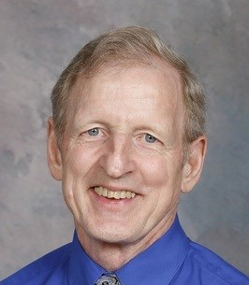
It is with deep sadness the family of Carl Baker announce his peaceful death at home, surrounded by his wife and children. Carl will be forever missed by his wife and best friend of over 47 years, Marg (Fry). Loving father of Matthew (Robin McGinnis), Robin Grace (Tim) and Paul (Brianna Kerr Baker). Carl was the proud Grandpa of Naomi and Lydia Grace. Brother of Ralph (Pat), Barbara (Hank), Fred, Jim (late Sophie). Son of the late Jim and Betty Baker (Mountain Twps.). Son-in-law of the late Howard and Audrey Fry (Sharon). Brother-in-law of the late Doug Fry.
Cremation has taken place, with a private interment at Union (Johnson) Cemetery.
A celebration of life will be held at a later date.
In lieu of flowers please donate to Stone United Church Box 57 Rockwood ON N0B 2K0, The Canadian Cancer Society or a charity of your choice.
The family would like to express special thanks to Dr. C. Lund, Dr. Muldoon and Dr. S. Thompson and Rev. H. Leffler for their care and respect.
Posted Sep 29, 2023 12:37 PM on https://www.elorafergustoday.com/obituaries/baker-carl-george-7619328

United Church of Canada
The Moderator's Orange Shirt Day Message
Moderator Carmen Lansdowne urges us to commemorate the National Day for Truth and Reconciliation, also known as Orange Shirt Day, on September 30. This is a day to reflect, pray, learn, and honour survivors, their families, and the communities affected by Indian Residential Schools and those who operated them. For non-Indigenous Christians in particular, this is a time to reflect on their role in colonialism and the ongoing responsibility to make reparations.
One way that we can show Indigenous youth that they matter is by investing in the Waase-Aabin program, which awards scholarships to post-secondary Indigenous students, ages 18-29, who demonstrate economic need and academic excellence.
On September 30, and every day, we must remember that every child matters.
Watch the Moderator's Orange Shirt Day message in English or français.

A gift of belonging to a church is that the practice of gathering together for worship … to pray, sing, listen to scripture and share how God touches our lives – helps us grow in deeper relationship with God and each other. We are offering this practice of sharing beyond Sunday morning to deepen our connection. Each week you are offered a picture, a scripture and a question for contemplation, as well as a short reflection for you to contemplate, have conversation with people in your life and/or join an online conversation on our Rockwood Stone Facebook page.

