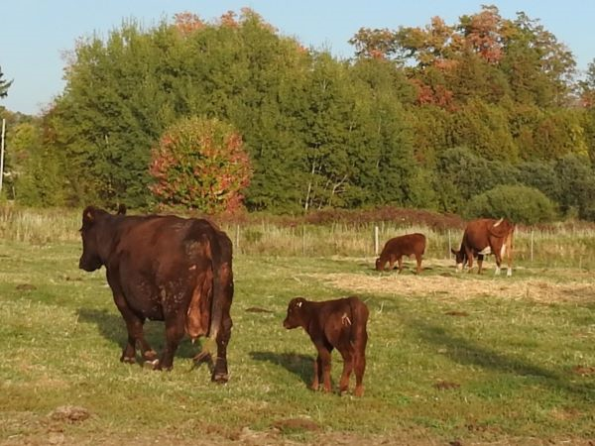
Contemplation and Conversation: Thanksgiving Sunday, October 8, 2023
Scripture: – Exodus 20:1-4, 7-9, 12-20 NRSVUE https://www.biblegateway.com/passage/?search=Exodus+20%3A1-4%2C+7-9%2C+12-20&version=NRSVUE
From Lisa Leffler:
When I was studying Early Childhood Education, I was taught that you shouldn’t use negative statements with children because if you tell a child “Don’t stand on that chair” they won’t understand the negative in the statement and will only hear “stand on that chair.” We can debate the accuracy that interpretation of child psychology, but I what I realized is that when you avoid negative statements you move from punishment to teaching and care because you will end up explaining to the child that it is safer for them to sit on the chair and if they need to reach something higher it is better to use a stool or a ladder that is designed for that purpose. It allows children to have agency and be involved in the decision-making process while learning from the experiences of others.
So why are the Ten Commandments written in the negative? Did God not want the same opportunity for agency and growth for the Hebrew people? Perhaps God knew that they weren’t ready for that yet. The Hebrew people had been enslaved for generations and they had to redefine their nation and culture. The stronger language in the Ten Commandments may have helped the people transition from having to do whatever they were told to making their own decisions. God was meeting them where they were at to help guide them forward.
I wonder if today God would reframe the language of the Ten Commandments to avoid the “thou shall not’s” and instead possibly look more like this…
- Celebrate all that God has done for you. Offer praise and thanksgiving in the name of God.
- Honour what is right and good. Reflect on and try to understand the different roles all creatures, people and God in the universe.
- Honour God’s name and keep it holy.
- Take time to for rest and restoration each week. You work hard six days a week and need to take space to recentre.
- Nurture your relationships with your parents so you can be blessed by the gifts they can offer you.
- Care for and respect all life. For it is precious and made by God.
- Commit to boundaries in relationships so you can grow together in love.
- Share the abundance of creation with one another and make sure everyone has what they need.
- Be truthful when you speak of others.
- Focus on what you have so you can care for and value it.
Contemplation and Conversation
Where is God inviting you to new patterns of language to deepen relationship?
Prayer
Ever-present God, we give you thanks for your wisdom and guidance in our lives.
Help us to use words that allow us to grow in deeper relationship with you and with each other.
Open our hearts and minds to wisdom and knowledge of each person that we meet. Amen.

Further Conversation … Would you like to talk more about today’s reflection? Email Heather at hleffler@rogers.com.

Our Rockwood Stone Family
If you missed today’s worship service, you can watch it here: https://youtu.be/2KeZOw5h2dg
Thank you to the Rockwood Choir for their Offering Praise: https://youtu.be/p3H18Cfq19Y
You are invited to join their family to help celebrate Patty and Larry Lancaster’s 50(ish) Anniversary on Saturday, October 21 from 11 am to 3 pm at Rockmosa Hall.
Saturday, October 21 from 2 to 4:30 pm join the May family in the dining room at Stone to share memories and Celebrate Diane May’s Life.

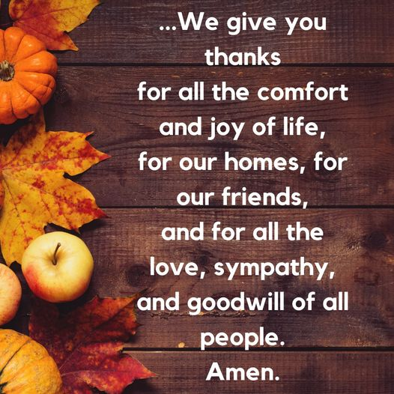
United Church of Canada
God, giver of all good,
you continually pour your benefits upon us.
Age after age the living wait upon you and find
that your faithfulness has no end,
that your care is unfailing.
We praise you that the mystery of life
is a mystery of infinite goodness.
We praise you
for the order and constancy of nature;
for the beauty and bounty of the earth;
for day and night, summer and winter,
seedtime and harvest;
for the varied gifts of loveliness which every season brings.
We give you thanks
for all the comfort and joy of life,
for our homes, for our friends,
and for all the love, sympathy, and goodwill of all people.
Amen.
—from Celebrate God's Presence: A Book of Services for The United Church of Canada (UCPH, 2000)

A gift of belonging to a church is that the practice of gathering together for worship … to pray, sing, listen to scripture and share how God touches our lives – helps us grow in deeper relationship with God and each other. We are offering this practice of sharing beyond Sunday morning to deepen our connection. Each week you are offered a picture, a scripture and a question for contemplation, as well as a short reflection for you to contemplate, have conversation with people in your life and/or join an online conversation on our Rockwood Stone Facebook page.

