Contemplation and Conversation: 21st Sunday after Pentecost, October 22, 2023
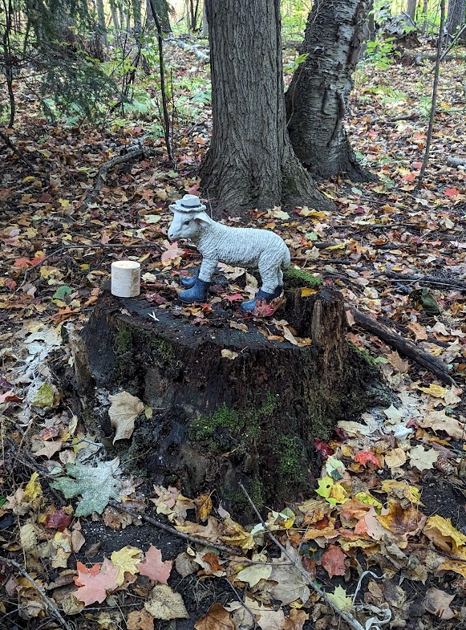
Scripture: – 1 Thessalonians 1 NRSVUE https://www.biblegateway.com/passage/?search=1%20Thessalonians%201&version=NRSVUE
¹ Paul, Silvanus, and Timothy,
To the church of the Thessalonians in God the Father and the Lord Jesus Christ:
Grace to you and peace.
² We always give thanks to God for all of you and mention you in our prayers, constantly ³ remembering before our God and Father your work of faith and labor of love and steadfastness of hope in our Lord Jesus Christ. ⁴ For we know, brothers and sisters beloved by God, that he has chosen you, ⁵ because our message of the gospel came to you not in word only but also in power and in the Holy Spirit and with full conviction; just as you know what kind of persons we proved to be among you for your sake. ⁶ And you became imitators of us and of the Lord, for in spite of persecution you received the word with joy from the Holy Spirit, ⁷ so that you became an example to all the believers in Macedonia and in Achaia. ⁸ For the word of the Lord has sounded forth from you not only in Macedonia and Achaia but in every place your faith in God has become known, so that we have no need to speak about it. ⁹ For they report about us what kind of welcome we had among you and how you turned to God from idols to serve a living and true God ¹⁰ and to wait for his Son from heaven, whom he raised from the dead—Jesus, who rescues us from the coming wrath.
From Rev. Heather Leffler:
Paul’s letter to the followers of Jesus in Thessalonica reminds me of how important our words, prayers and actions are. After praying for the church, he says that as followers of Jesus we are chosen because we have received the gospel with joy. Others come to believe because they see us at worship and working in our communities and the world.
Taking time to pray for the people around us and the places in the world where there are people in need makes a difference. Praying for peace in Ukraine and Gaza and other places where we hear there is war and violence; praying for climate change and people recovering from natural disasters; praying for people around us who are hungry or thirsty, needing clothing or shelter; visiting those who are sick or in prison; or welcoming newcomers to our community makes a difference. Prayer opens us to be responsive to the needs of others. Praying together with people around the world opens us all to new possibilities for God’s healing and hope.
May we imitate Paul, Silvanus and Timothy by using our prayers, words and actions to make a difference in the world.
Contemplation and Conversation
Who is the Spirit asking you to pray for today?
Prayer
God of peace, we see many places in the world where there is war and unrest,
help us be a part of bringing your peace. Amen.

Further Conversation … Would you like to talk more about today’s reflection? Email Heather at hleffler@rogers.com.

Our Rockwood Stone Family
If you missed today’s worship service, you can watch it here: https://youtu.be/LLnlP9U-Drw
Thank you to Lisa Leffler for Offering praise: https://youtu.be/MFMx_IN94r8
Committee chairs are asked to submit reports for the November 8 Board meeting to Heather at hleffler@rogers.com by Sunday, October 29, 2023. Please include upcoming events for the newsletter.

United Church of Canada
If you would like to learn more about the Fall Western Ontario Waterways Regional Council meeting, you can read the whole summary here.
Truth & Reconciliation Sharing
We gathered on Saturday, The National Day for Truth and Reconciliation, to reflect and pray, learn and act on the work of Truth and Reconciliation that is ours to do as the Western Ontario Waterways Regional Council.
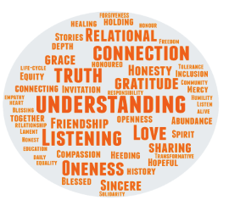
A moving worship by our worship team of Rebekah Duncan & Ann Harbridge, with guidance from Joyce Johnston, opened our meeting and our hearts.
We joined Thérèse Samuel, Minister, Right Relations & Social Justice for Western Ontario Waterways Regional Council, and Joyce Johnston, Indigenous Ministries Representative to the WOWRC Executive, in Cape Croker.
We were honoured by their willingness to be vulnerable and offer us their truths on this sacred day. Thérèse invited each of us in the court to share one word that was coming to our hearts in that moment that reflects an important aspect of the work toward reconciliation. With the words that were shared in the chat, she created this word cloud for us. Words that are bigger reflect that they were shared multiple times.

A gift of belonging to a church is that the practice of gathering together for worship … to pray, sing, listen to scripture and share how God touches our lives – helps us grow in deeper relationship with God and each other. We are offering this practice of sharing beyond Sunday morning to deepen our connection. Each week you are offered a picture, a scripture and a question for contemplation, as well as a short reflection for you to contemplate, have conversation with people in your life and/or join an online conversation on our Rockwood Stone Facebook page.

