Contemplation and Conversation: All Saints Sunday, October 29, 2023
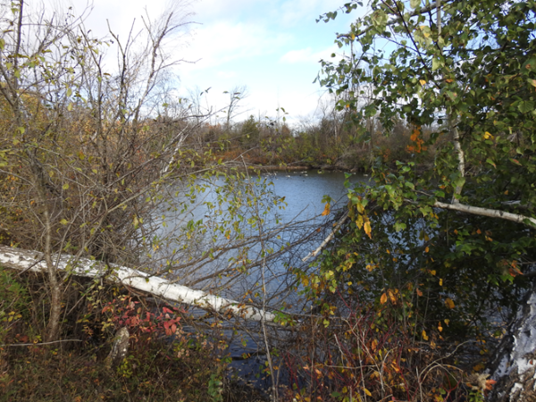
Scripture: – Deuteronomy 34:1–12 NRSVUE
https://www.biblegateway.com/passage/?search=Deuteronomy+34%3A1%E2%80%9312+&version=NRSVUE
From Lisa Leffler:
Moses led the Hebrew people out of Egypt and with God’s help he provided them with food and water in the desert where helped them to establish a new nation but after his years of leadership and guidance he did not get to enter the promised land. After all his hard work it seems a little unfair that Moses would not get to enjoy or even see the fruits of his labour.
A Jewish man my grandpa worked with explained the reason why the Israelites wandered in the wilderness for 40 years was because they were born as slaves and that was the only life they knew. Transitioning from slave to free takes time – time to develop culture and laws, to heal for the trauma of being enslaved and time to learn how to be together in community. Transitioning from slave to wanders to living in the promised land would be too overwhelming so they needed a generation of slaves to die to make space a new generation to grow up as free people.
Moses took the time to shape this new generation by helping them to learn and grow together and lifting up new leaders. By the time they reached the promised land they no longer needed him, and he could finally rest knowing he prepared them for a strong future.
Despite never setting foot in the promised land, Moses was a great prophet who helped shape not only Jewish tradition but also the Christian and Islamic faiths. Sharing in Moses’s story we are reminded the importance of sharing stories of those who shaped our faith as we look to the future of the church.
Contemplation and Conversation
Who has inspired your faith journey?
What do you hope for the church in the future?
Prayer
God of Abraham and Sarah, Isaac and Rebekah, Moses and Zipporah, Loving Parent to us all,
Open our hearts and minds to the wisdom of our ancestors,
so they may guide us as we look to the future of your church.
Amen

Further Conversation … Would you like to talk more about today’s reflection? Email Heather at hleffler@rogers.com.
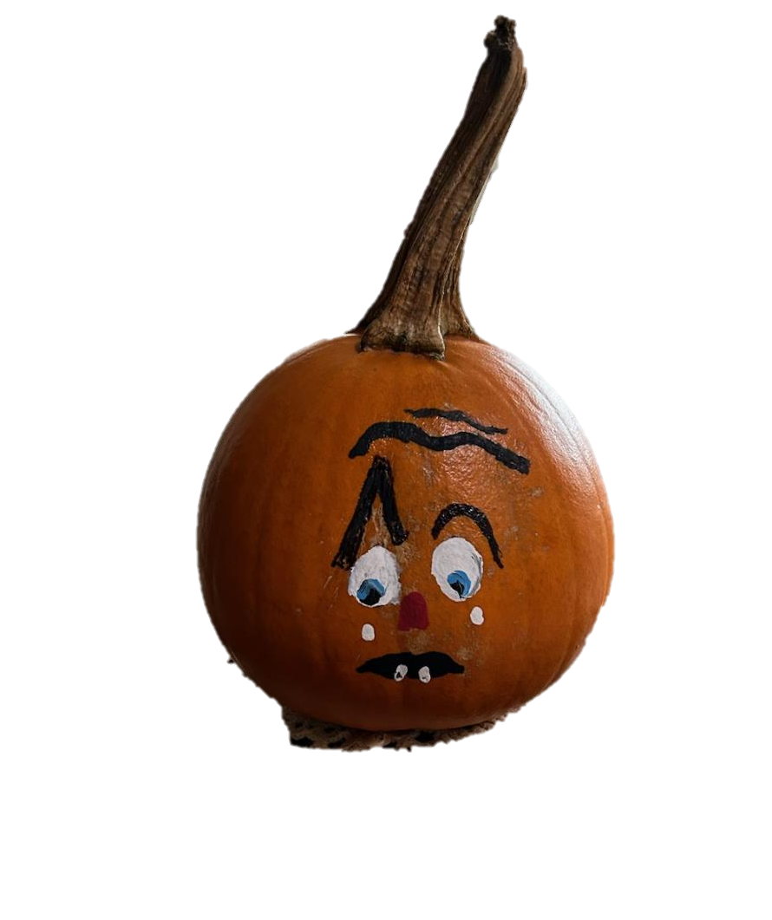
Our Rockwood Stone Family
If you missed today’s worship service, visit our Rockwood Stone YouTube page.
Pumpkin Story Contest for Foodgrains
Children ages 5 -12 are invited to write a story about:
“Why is Pumpkin shedding a tear?"🥲
to benefit the Foodgrains bank.
Submit your story by Saturday, November 25 or bring it to the Foodgrains Breakfast at Rockwood😇
The winning author will receive a $50 prize & the Foodgrains Bank will receive $100.
A panel of judges composed from both churches will decide "who has the most imaginative or touching story"😄 A prize of $25 will also be given to the most "unique" story.
Thanks to Elsa Hore for sponsoring the contest.

United Church of Canada
Support the People Impacted by the Conflict in Palestine and Israel
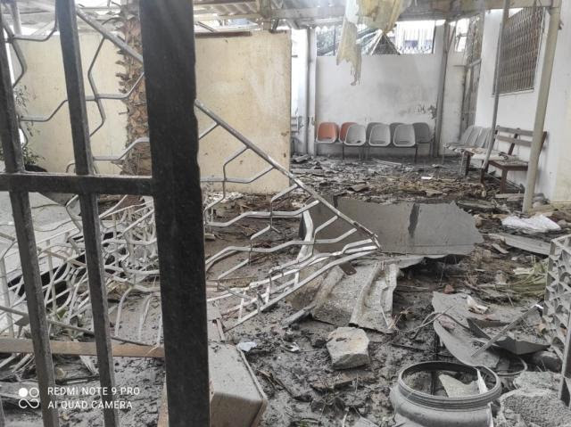
You can support the people impacted by the conflict in Palestine and Israel through your donations and advocacy.
Mission and Service partners are currently responding to those who are impacted by the conflict in the West Bank and East Jerusalem. Partners are prepared to expand their activity into Gaza when a humanitarian corridor is opened, allowing for safe access to provide relief. Currently, there is an urgent need for food as well as non-food items such as medicines, psychosocial support, and shelter.
We are working with Mission and Service partners ACT Alliance, Department of Service to Palestinian Refugees (DSPR), and the Humanitarian Coalition (as a member of the Canadian Foodgrains Bank) to provide tangible support for the people of the Middle East.
Your help is urgently needed.
You can also write a letter calling for a ceasefire, the opening of a humanitarian aid corridor, and protection of civilians and email it directly to Foreign Affairs Minister The Hon. Mélanie Joly and your local MP using our letter-writing template.
The United Church of Canada has signed on to a number of statements from our partners and other organizations calling for a ceasefire to the conflict.
Find out more about how you can act today, and pray for peace with justice for the people of Palestine and Israel.
[Image credit: Al Jedeh /DSPR]

A gift of belonging to a church is that the practice of gathering together for worship … to pray, sing, listen to scripture and share how God touches our lives – helps us grow in deeper relationship with God and each other. We are offering this practice of sharing beyond Sunday morning to deepen our connection. Each week you are offered a picture, a scripture and a question for contemplation, as well as a short reflection for you to contemplate, have conversation with people in your life and/or join an online conversation on our Rockwood Stone Facebook page.

