Contemplation and Conversation: Remembrance Sunday, November 5, 2023
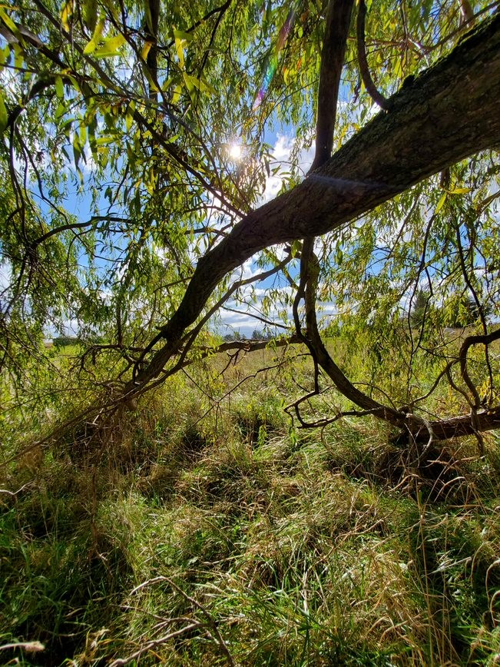
Scripture: – 1 Thessalonians 2 9-13 New American Standard Bible https://www.biblegateway.com/passage/?search=1%20‌‌Thessalonians%202%3A9-13&version=NASB
From Brian Mack
Seeking a way forward when walking is not always easy. When I walk to the bush at the back of my farm, there is no established path. Each time I undertake the trek, I have to carve out a new trail as I navigate over rough terrain, hidden stones, water in a creek that varies in depth with the seasons, and over fallen trees that have tumbled over since the last time I undertook the journey. Given these conditions, one might wonder why I would bother when it would be so much easier to walk on a groomed trail.
Taking an established route has many advantages. However, what would I be missing? On one of those walks this fall, I admired cat tails swinging in the breeze and frogs swimming lazily before the onset of the cold. Stopping under a wild apple tree to catch my breath, I was offered refreshment in the form of a delicious, uncultivated fruit. In waist high wild grass, a huge puffball beckoned me to pick it up and take it home for a delicious treat. I encountered various well trodden places which clearly were trails made by an animal over and over again as they went about their daily tasks for survival.
Normally, I make this sojourn by myself. In late October, however, I was joined on my trip by two friends. As we walked, they pointed out things about the flora and fauna that I had taken for granted and caused me to see the landscape in a new way. When we paused to rest, our seemingly idle chatter helped me explore some big questions about creation, the political state of our world, and what we are called to do as Christians living in 2023. As we explored a small part of my world together, the gift of being in community was on full display. Whether they realized it or not, they were acting in the way that Paul behaved with regards to the people of Thessalonia. I was being encouraged to “lead a life worthy of God, who calls you into his own kingdom and glory”. Thanks be to God.
Contemplation and Conversation
What does it mean for you to walk in a manner worthy of God?
Prayer
Holy One, we give you thanks for the gift of being part of a church community
where we are supported, encouraged, and loved.
As we live out our faith journey, help us to discern what it means to walk in a way
that through our every day actions gives you honor and praise. Amen

Further Conversation … Would you like to talk more about today’s reflection? Email Heather at hleffler@rogers.com.

Our Rockwood Stone Family
If you missed today’s worship service, you can watch it here: https://youtu.be/tjFgu_cc65Y

Pumpkin Story Contest for Foodgrains
Children ages 5 -12 are invited to write a story about:
“Why is Pumpkin shedding a tear?"🥲
to benefit the Foodgrains bank.
Submit your story by Saturday, November 25 or bring it to the Foodgrains Breakfast at Rockwood😇
The winning author will receive a $50 prize & the Foodgrains Bank will receive $100.
A panel of judges composed from both churches will decide "who has the most imaginative or touching story"😄 A prize of $25 will also be given to the most "unique" story.
Thanks to Elsa Hore for sponsoring the contest.

United Church of Canada
Reconciliation and Indigenous Justice News from
The United Church of Canada
Home on Native Land
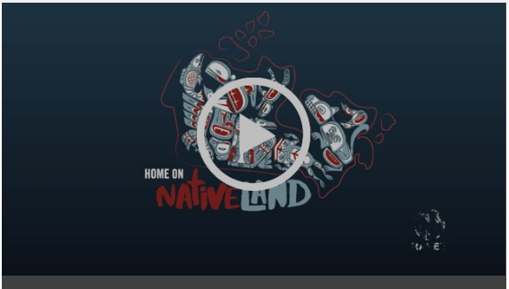
RAVEN, an Indigenous rights and environmental organization, has put together a new self-directed course on Indigenous law, designed to help non-Indigenous allies advocate with greater understanding.
Home on Native Land is a series of 10 videos, cartoon and lessons, that take you on a journey through history — and the frontlines of legal action — with Anishinaabe comedian Ryan McMahon.
[Video credit: Home on Native Land]

A gift of belonging to a church is that the practice of gathering together for worship … to pray, sing, listen to scripture and share how God touches our lives – helps us grow in deeper relationship with God and each other. We are offering this practice of sharing beyond Sunday morning to deepen our connection. Each week you are offered a picture, a scripture and a question for contemplation, as well as a short reflection for you to contemplate, have conversation with people in your life and/or join an online conversation on our Rockwood Stone Facebook page.

