Contemplation and Conversation: 24th Sunday after Pentecost, November 12, 2023

Scripture: – Joshua 24:1-3a, 14-25 https://www.biblegateway.com/passage/?search=Joshua+24%3A1-3a%2C+14-25+&version=NRSVUE
24 Then Joshua gathered all the tribes of Israel to Shechem and summoned the elders, the heads, the judges, and the officers of Israel, and they presented themselves before God. ² And Joshua said to all the people, “Thus says the Lord, the God of Israel: Long ago your ancestors—Terah and his sons Abraham and Nahor—lived beyond the Euphrates and served other gods. ³ Then I took your father Abraham from beyond the River and led him through all the land of Canaan and made his offspring many.
¹⁴ “Now, therefore, revere the Lord and serve him in sincerity and in faithfulness; put away the gods that your ancestors served beyond the River and in Egypt and serve the Lord. ¹⁵ Now if you are unwilling to serve the Lord, choose this day whom you will serve, whether the gods your ancestors served in the region beyond the River or the gods of the Amorites in whose land you are living, but as for me and my household, we will serve the Lord.”
¹⁶ Then the people answered, “Far be it from us that we should forsake the Lord to serve other gods, ¹⁷ for it is the Lord our God who brought us and our ancestors up from the land of Egypt, out of the house of slavery, and who did those great signs in our sight. He protected us along all the way that we went and among all the peoples through whom we passed, ¹⁸ and the Lord drove out before us all the peoples, the Amorites who lived in the land. Therefore, we also will serve the Lord, for he is our God.”
¹⁹ But Joshua said to the people, “You cannot serve the Lord, for he is a holy God. He is a jealous God; he will not forgive your transgressions or your sins. ²⁰ If you forsake the Lord and serve foreign gods, then he will turn and do you harm and consume you, after having done you good.” ²¹ And the people said to Joshua, “No, we will serve the Lord!” ²² Then Joshua said to the people, “You are witnesses against yourselves that you have chosen the Lord, to serve him.” And they said, “We are witnesses.” ²³ He said, “Then put away the foreign gods that are among you, and incline your hearts to the Lord, the God of Israel.” ²⁴ The people said to Joshua, “The Lord our God we will serve, and him we will obey.” ²⁵ So Joshua made a covenant with the people that day and made statutes and ordinances for them at Shechem.
From Lisa Leffler
The image of God that Joshua presents in this passage – a God who is angry and vengeful – is an image that is hard to reconcile with my understanding of a loving, merciful and forgiving God. How can these two images of God both be true? That is a mystery that is probably beyond my understanding but what we can explore is what might have led Joshua to this understanding of God.
Joshua knows God through the Mosaic covenant through Moses God helped the people of Israel establish a nation – with new law and religious practices to follow. When the people transitioned from slavery through wandering in the desert to settling in a new land it was important for them to hold strong in their new identity so they could establish their nation. When Joshua himself was living in fear of losing what they built it is not surprising he would try to use that fear to hold people together – leading to an angry and vengeful image of God.
But we no longer need to live in that fear. We live in a time when we have the security and resources to explore our faith and trust that there are many ways to no God and still co-exist with one another. Through Jesus we were invited into a new covenant – a covenant where all people can know God’s love. As part of that covenant, it is our responsibility to share the peace and love of Jesus with everyone we meet – not by preaching at people or trying to convert them but by sharing in God’s love and listening to each other so we can grow in community.
Contemplation and Conversation
How are you being called to live out a covenant with God?
Prayer
God of Abraham and Sarah, of Isaac and Rebekkah, of Moses and Zipporah,
God of the Holy Catholic Church,
of the Methodists, the Congregationalists, Presbyterians, and Evangelical United Brethren
God of Rockwood and Stone United Churches,
God of us all,
You call to us through the generations inviting us into relationship with you and with each other.
Open our hearts and minds to your word for us in scripture and song, story and silence,
so, we may be inspired to do your work in the world.
Amen

Further Conversation … Would you like to talk more about today’s reflection? Email Heather at hleffler@rogers.com.

Our Rockwood Stone Family
If you missed today’s worship service, you can watch it here: https://youtu.be/OFIBbUmzFFs

Thursday, November 16 from 10 am to noon there will be a Christmas Craft Morning to learn to make and decorate crocheted Christmas stars for the Advent and Christmas Pack. We hope to have a day at Stone as well. Please let Heather hleffler@rogers.com know if you're interested.
Friday, November 17 at 6 pm Faith, Food, Friendship and Fun will be at Stone. Let the Lefflers know if you plan to attend so we have enough places at the table.
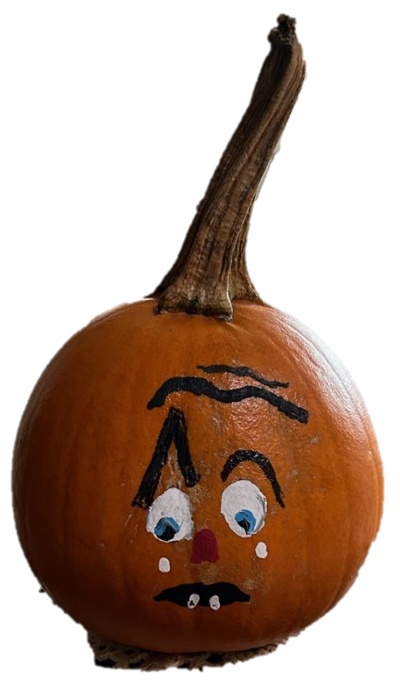
Pumpkin Story Contest for Foodgrains
Children ages 5 -12 are invited to write a story about:
“Why is Pumpkin shedding a tear?"🥲
to benefit the Foodgrains bank.
Submit your story by Saturday, November 25 or bring it to the Foodgrains Breakfast at Rockwood😇
The winning author will receive a $50 prize & the Foodgrains Bank will receive $100.
A panel of judges composed from both churches will decide "who has the most imaginative or touching story"😄 A prize of $25 will also be given to the most "unique" story.
Thanks to Elsa Hore for sponsoring the contest.

United Church of Canada
Canadian Government Matching Donations for Gaza and West Bank
Donate: As a member of the Canadian Foodgrains Bank, the United Church is participating in the Humanitarian Coalition appeal to provide tangible support to people in the Middle East. Gifts raised through the generosity of Canadians for the United Church appeal between October 7 and November 12, 2023, will be matched by the Government of Canada. Double the impact of your gift—give today.
Advocate: Also, your advocacy can make a difference! Write to Foreign Affairs Minister, The Hon. Mélanie Joly, and your local MP and call on the Canadian government to respond to the escalating violence in Palestine and Israel by calling for an immediate ceasefire and ensuring humanitarian assistance. Use our online letter-writing template to send your email directly to your government officials. Please send your email today!
The United Church has also been part of two press conferences in Ottawa advocating for peace this past week with a pan-Canadian coalition (watch the recording Pan-Canadian Coalition Calls for Ceasefire in Gaza) and a multifaith coalition including Muslim and Jewish organizations.
Pray: Your prayers matter! Please continue to pray for peace with justice for the people of Palestine and Israel. You can find a Prayer for Peace in the Middle East on our website. Additional prayers can be found on our site and on the Canadian Council of Churches website.
Keep up to date on the response of the United Church and our partners to the humanitarian crisis in the Middle East on our website and on social media accounts.
Saturday November 25 from 9 am to 2 pm plan to visit Trinity United Church’s Christmas Bazaar at 70 Mill Street East, Acton.
Check out their selection of handmade crafts, homemade jams, jigsaw puzzles, jewelry, Christmas décor, bake sale and silent auction.
Wednesday, November 29 from 7 – 9 pm join former Waterloo Presbytery delegates for a Hootenanny at Forest Hill United Church (121 Westmount Rd E. Kitchener, ON). Come to re-connect, celebrate, dream together and share in dessert – a pie for your thoughts!
RSVP at 519-744-3481 – So we know how much pie to buy.

Saturday, November 25 from 2 to 4 pm you are invited to a Christmas Tea at Barrie Hill United Church
Tickets are $25 and include: scones with jam and cream, fancy tea sandwiches, festive sweets, holiday music played by Brad Halls, 5 tickets to enter door prizes (more can be purchased on site for additional chances to win!)
Need some help with your holiday baking? Look no further!
Freezer ready containers of holiday baking will be available to purchase during the tea.
To reserve your tickets, please contact Martha call or text 519-362-3785 or email martha.amidon@gmail.com
A gift of belonging to a church is that the practice of gathering together for worship … to pray, sing, listen to scripture and share how God touches our lives – helps us grow in deeper relationship with God and each other. We are offering this practice of sharing beyond Sunday morning to deepen our connection. Each week you are offered a picture, a scripture and a question for contemplation, as well as a short reflection for you to contemplate, have conversation with people in your life and/or join an online conversation on our Rockwood Stone Facebook page.

