Contemplation and Conversation: Reign of Christ Sunday, November 26, 2023

Scripture: – Psalm 100 NRSVUE
https://www.biblegateway.com/passage/?search=psalm+101&version=NRSVUE
From Rev. Heather Leffler
Psalm 100 invites us to join all the earth in making a joyful noise to our Creator. Singing is a way to offer thanks and praise to God – in worship, whenever we sing by ourselves or with others.
Even as we honour the Holy One, lifting up our voices in song brings us joy. Whether it is singing in Sunday School or church, at camp or a conference, with a small group or whole congregation or theatre, singing together creates community. I have a wonderful memory of taking part in a training at Five Oaks Retreat Centre. At the end of worship, one of the leaders brought out his guitar. For hours we sang songs – sacred and silly, popular and from childhood. No one wanted the time to come to an end.
God asks us for offerings not for God’s benefit but to enrich our lives. Singing brings us joy, serving in church roots us in loving community, volunteering offers us a sense of purpose. May it be so.
Contemplation and Conversation
When have you found joy in singing to God?
Prayer
Joyful, Joyful, we adore you
God of glory, Lord of love,
Hearts unfold like flowers before you,
opening to the sun above.
Melt the clouds of sin and sadness,
drive the dark of doubt away,
giver of immortal gladness,
fill us with the light of day.
- Henry van Dyke

Further Conversation … Would you like to talk more about today’s reflection? Email Heather at hleffler@rogers.com.

Our Rockwood Stone Family
If you missed today’s worship service, you can watch it here: https://youtu.be/ciqicq-DKE4

United Church of Canada …from https://united-church.ca/news/dear-prime-minister
A response to partners’ requests from the Middle East
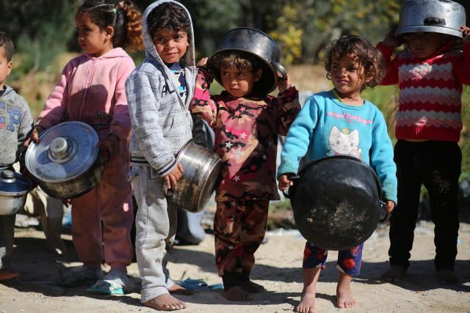
Credit: Hosny Salah, DSPR
Published On: November 20, 2023
This weekend, the General Council Executive, its corresponding members, and the members of the National Indigenous Council issued a plea to Prime Minister Trudeau to advocate for a ceasefire in the Israel-Hamas war, recognizing that, in the view of legal experts, genocide is currently taking place.

November 18, 2023
The Right Honorable Justin Trudeau, P.C., M.P.
Prime Minister of Canada
House of Commons
Ottawa, Ontario K1A 0A6
Justin.Trudeau@parl.gc.ca(opens in a new tab)
Dear Prime Minister,
This letter is to address the immediate and urgent need to stop genocide.
We have a long history of relationship with churches and partners in the region; for decades, we have joined our voices to theirs seeking an end to the illegal occupation of Palestine and the blockade of Gaza, and towards a just peace for all, upholding the rights of both Palestinians and Israelis to life and freedom.
We join in the international shock and outrage at the brutal attacks on Israeli communities by Hamas militants on October 7, 2023. We condemn the attacks on civilians, the killing of so many innocent children and people, as well as the taking of hostages and putting civilians in harm’s way.
The people of The United Church of Canada are outraged by and condemn Israel’s ongoing military action in Gaza, and the collective punishment of 2.2 million Gazans. We watch with horror and grief as more and more innocents in one of the world’s most densely populated areas are being killed.
We condemn the attacks by Hamas as war crimes; we condemn the Israeli bombings of Gaza as a war crime. Canada has rightly and unequivocally condemned Hamas’s actions. We call on Canada to unequivocally hold Israel to account for its legal obligations under international law as an occupying military power.
Israel’s brutal bombardment of Gaza has resulted in the deaths of more than 11,000 Palestinians, including more than 4,500 children as of November 17. Thousands are trapped under the rubble. The shocking death toll rises with every hour. There is an unprecedented humanitarian crisis in Gaza because of the restriction of water, food, medical supplies, fuel, electricity, destruction of most of the medical facilities, the forced displacement of more than one million people, closure of all hospitals, and the complete collapse of the medical system.
This must end, now.
Legal experts at the United Nations(opens in a new tab) have warned that the world is witnessing a genocide, and very little is being done to stop it. To the contrary, Canada, the United States, and other allies of the Israeli government have openly and repeatedly stated their unwavering support for Israel’s actions. Fears over the safety of Palestinian civilians are growing as Israel suggests its bombardment of Gaza will shift to southern areas, having destroyed swaths of the north.
Meanwhile, the Israeli hostages remain in captivity in Gaza and their security is becoming more and more uncertain.
As is evident from the current tragedy, Canada’s approach is not working nor is it conducive to a just peace. We urgently call upon your office to:
- recognize the genocide;
- uphold international human rights and humanitarian law without exception;
- call for an immediate ceasefire;
- advocate for the release of hostages;
- demand the opening of humanitarian corridors;
- and engage meaningfully in the pursuit of a just and lasting peace in the region.
The failure to clearly do so is unconscionable.
The people of The United Church of Canada have long raised our voices for just and lasting peace in the region. Since the intensification of conflict, we have issued statements, written letters, raised funds for humanitarian aid, and engaged in civil society and ecumenical actions—in deep concern for all lives in the land called “Holy.”
We despair that, despite the cries of Canadians across the country, our government has failed to listen and to call for a ceasefire. We, the members of the Executive of the General Council and the National Indigenous Council of The United Church of Canada, add our voices to those cries.
We pray that you show moral courage and conviction and call for an immediate ceasefire in the interests of a just and lasting peace for both Palestinians and Israelis.
May it be so.
Moderator Carmen Lansdowne
With the Executive of the 44th General Council and corresponding members
Chair Leeann Shimoda
With the National Indigenous Council
The United Church of Canada

A gift of belonging to a church is that the practice of gathering together for worship … to pray, sing, listen to scripture and share how God touches our lives – helps us grow in deeper relationship with God and each other. We are offering this practice of sharing beyond Sunday morning to deepen our connection. Each week you are offered a picture, a scripture and a question for contemplation, as well as a short reflection for you to contemplate, have conversation with people in your life and/or join an online conversation on our Rockwood Stone Facebook page.

