Contemplation and Conversation: 2nd Sunday of Advent, December 10, 2023
Scripture: – Isaiah 2:2-5a CEB https://www.biblegateway.com/passage/‌?search=Isaiah+2%3A2-5a&version=CEB

From Rev. Heather Leffler
Watching, listening or scrolling through the news, it is not easy to imagine peace in the world. So many people are hurt and grieving, angry and afraid – is world peace possible?
As Assyria took over the Northern Kingdom of Israel, Isaiah was inspired by God to write of a time of peace. The world has had countless wars since then and yet people across the globe continue to work for peace.
Jesus came not as a conqueror to force people to submit to the Roman style peace where the wealthy lived a life of abundance while the majority were forced into service. The peace Jesus invites us to be a part of is the one where we love our enemies and neighbours, family and friends, ourselves and God. While we may not be able to change the world, we can reach out in reconciliation to those closest to us.
This is the beginning of peace.
Contemplation and Conversation
Who might you reach out to in peace and love?
Prayer
Holy One, we give thanks for the encouraging message of Isaiah.
We remember that swords can be turned into plowshares,
spears into pruning tools, and the ways of war unlearned.
Help us to better understand the peace that Jesus offers
and to reach out to all in the spirit of true reconciliation. Amen.

Further Conversation … Would you like to talk more about today’s reflection? Email Heather at hleffler@rogers.com.

Our Rockwood Stone Family
If you missed today’s worship service, visit our Rockwood Stone YouTube page.

From Darlene McPhedran …
O - Outreach thrives when believers authentically live out their faith demonstrating
Love, Unity, Open Hearts, and Selfless Generosity to Others
U - Urgency & Passion
T - Then I heard the voice of the Lord saying: “Whom Shall I Send”?
“And who will go for us”? And I said, “Here I am, Send Me!”
R - Readiness, Respect and Kindness
E - Empowerment in Our Endeavours
A - Actively Engaging
C - Called through Christ
H - “His Light Shines Through Out Us All”
Thanks Be to God. Amen.

Thank you for your generous support of Stone’s Canadian Foodgrains Project helping to raise over $9,000 to offer food security to people around the world and Rockwood Outreach’s Country Market that raised over $4,000 to help make Christmas brighter for people using the East Wellington Community Services Foodbank and the Rural Women’s Support Program.

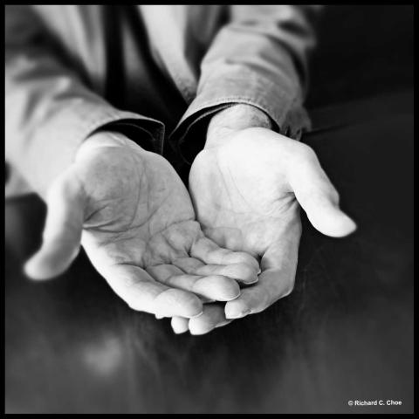
United Church of Canada
For Advent Unwrapped, Rev. Richard C. Choe reflects on the peace symbolism found in the simple image of extended hands.
Published On: December 1, 2022
Let’s take a minute to engage with the image.
What do you notice?
Does it remind you of a story? Feelings?
“We come empty handed and we leave empty handed.” I heard that message growing up in South Korea. A teaching about who we are as human beings.
Peace looks like these extended hands. Peace through the extended hands of friends. Peace experienced when I was able to let go – to empty of my ego needs. I see a manger in these cupped hands.
— Rev. Richard C. Choe is currently ministering with College Street United Church in downtown Toronto as an Intentional Interim Minister. Experiencing beauty on his daily walks is part of his spiritual practice.
This microblog is part of the Advent Unwrapped collection of worship resources and spiritual practices.

A gift of belonging to a church is that the practice of gathering together for worship … to pray, sing, listen to scripture and share how God touches our lives – helps us grow in deeper relationship with God and each other. We are offering this practice of sharing beyond Sunday morning to deepen our connection. Each week you are offered a picture, a scripture and a question for contemplation, as well as a short reflection for you to contemplate, have conversation with people in your life and/or join an online conversation on our Rockwood Stone Facebook page.

