Contemplation and Conversation: 3rd Sunday of Advent, December 17, 2023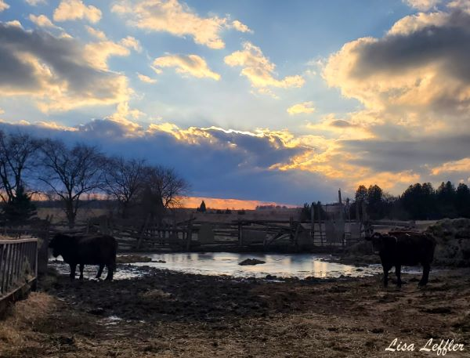
Scripture: – Isaiah 55:6-12 CEB https://www.biblegateway.com/passage/‌?search=isaiah+55%3A6-12&version=CEB
From Rev. Heather Leffler
I can’t imagine what it is like for people to have to flee their homes in the face of floods, forest fires or the threat of a volcano that hasn’t erupted in 800 years. What is it like to see all of your life swept away and have to start again?
What is it like for God to see people suffering because some of us have used more than our share of the earth’s resources? Yet throughout history, when people have let God down, the Holy One has sent prophets to assure us that this is not the end.
Again and again Jesus used stories of nature and the landscapes themselves to remind us of our connections to God, each other and all of creation. Once again, a way will be found for the mountains to sing and the trees and fields to clap their hands. These sacred stories invite us to examine our own lives and see what we can to change to help bring healing to the earth.
We can join creation in singing a song of joy.
Contemplation and Conversation
What can you do for the healing of creation?
Prayer
Holy Mystery, we give thanks for the uplifting message of Isaiah.
We remember the majestic images of field and mountain.
Help us to recognize the beauty of the world you created
and to take steps to heal that which we have destroyed
so that the whole earth may burst into song
and clap with joy. Amen.

Further Conversation … Would you like to talk more about today’s reflection? Email Heather at hleffler@rogers.com.

Our Rockwood Stone Family
If you missed today’s worship service, you can watch it here: https://youtu.be/30UuzF_gnTI .

United Church of Canada …from Advent Unwrapped
It is hard to wait alone
Others help us to not skip to the celebration at the end
without doing the hard planning work in the middle.
Response:
God, help us to avoid the temptation of jumping to the place of arrival without spending the time needed on the journey. 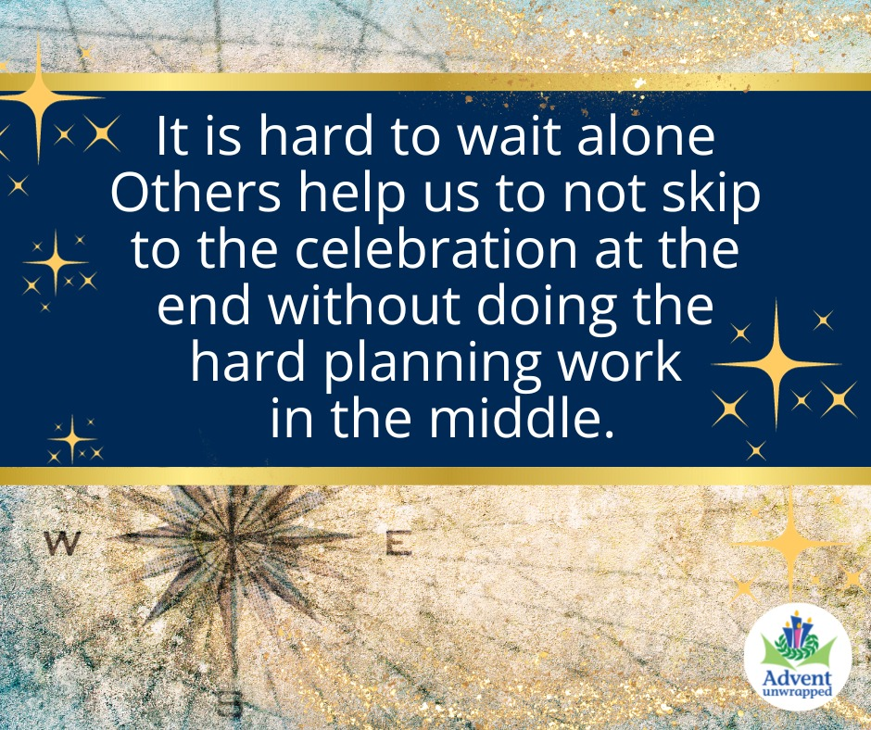
For more prayers and Advent inspiration, check out Advent Unwrapped: https://united-church.ca/worship-theme/advent-unwrapped
#AdventUnwrapped2023 #AdventPrayers #UCCan #Prayers

A gift of belonging to a church is that the practice of gathering together for worship … to pray, sing, listen to scripture and share how God touches our lives – helps us grow in deeper relationship with God and each other. We are offering this practice of sharing beyond Sunday morning to deepen our connection. Each week you are offered a picture, a scripture and a question for contemplation, as well as a short reflection for you to contemplate, have conversation with people in your life and/or join an online conversation on our Rockwood Stone Facebook page.

