Contemplation and Conversation: 4th Sunday of Advent, December 24, 2023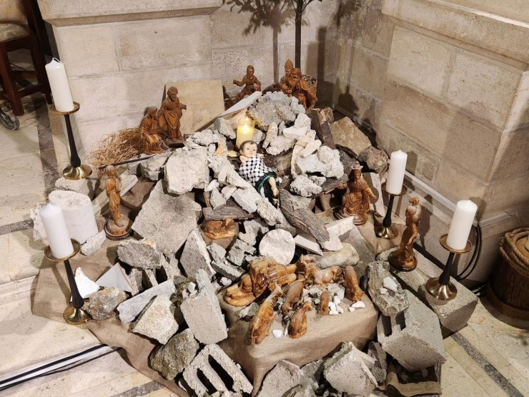
Scripture: – Exodus 3:1-6 CEB https://www.biblegateway.com/passage/‌?search=Exodus%203%3A1-6&version=CEB
¹ Moses was taking care of the flock for his father-in-law Jethro, Midian’s priest. He led his flock out to the edge of the desert, and he came to God’s mountain called Horeb. ² The Lord’s messenger appeared to him in a flame of fire in the middle of a bush. Moses saw that the bush was in flames, but it didn’t burn up. ³ Then Moses said to himself, Let me check out this amazing sight and find out why the bush isn’t burning up.
⁴ When the Lord saw that he was coming to look, God called to him out of the bush, “Moses, Moses!”
Moses said, “I’m here.”
⁵ Then the Lord said, “Don’t come any closer! Take off your sandals, because you are standing on holy ground.” ⁶ He continued, “I am the God of your father, Abraham’s God, Isaac’s God, and Jacob’s God.” Moses hid his face because he was afraid to look at God.
From Rev. Heather Leffler
Slowly I am beginning to understand terms like microaggressions – what it means for someone who has been called names and excluded because they are seen as different, only to be asked about those differences again and again. The questioner never intended harm, but all the past hurts come back with comments about a unique hair style, a dead name or a residential school.
Moses tried to leave his life in Egypt behind. He was content caring for his father-in-law’s sheep, but God had other plans. From the flames of the burning bush, the Holy One drew Moses from his quiet life to lead God’s beloved people. The Lord traveled with the people in a pillar of cloud by day and a column of fire by night. God’s fire of God’s love drew out Moses and offered guidance and comfort to God’s people.
Jesus’ love could be fiery. He didn’t mince words when his followers or the crowd had let God down or hurt another. The love we are invited into is the one that takes time to listen deeply, take care our words don’t open old wounds or cause new hurts and is willing to risk standing with people who are experiencing discrimination or oppression.
Flames of love call us from complacency to care for people the world ignores and harms.
Contemplation and Conversation
When has God called you out of your comfort zone
to love God’s people?
Prayer
Holy One, we give thanks for the Old Testament stories in Exodus.
We remember the dialogue between you and Moses
at the place of the burning bush.
Help us to be open to the call of the Spirit,
to emulate the example set by Jesus, and to reach out
in love to the lonely and the oppressed. Amen.

Further Conversation … Would you like to talk more about today’s reflection? Email Heather at hleffler@rogers.com.

Our Rockwood Stone Family
If you missed today’s worship service, visit our Rockwood Stone YouTube page.

United Church of Canada
General Secretary Michael Blair shared this moving and powerful prayer reflection by African-American theologian Howard Thurman at the recent General Council staff Christmas gathering:
Where refugees seek deliverance that never comes,
And the heart consumes itself, if it would live,
Where little children age before their time,
And life wears down the edges of the mind,
Where the old man sits with mind grown cold,
While bones and sinew, blood and cell, go slowly down to death,
Where fear companions each day’s life, And Perfect Love seems long delayed.
Christmas is waiting to be born:
In you, in me, in all of humankind.
from The Mood Of Christmas & Other Celebrations
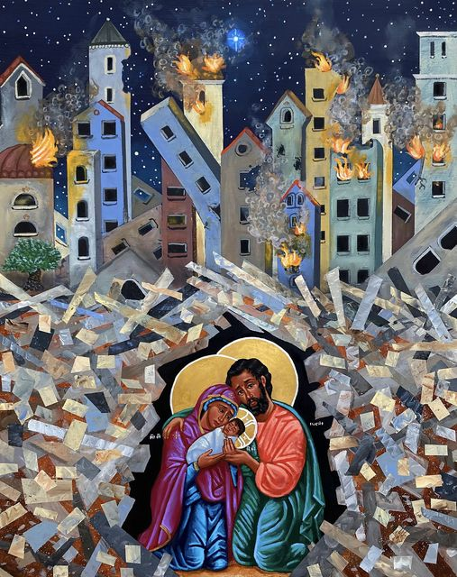
📸: Kelly Latimore Icons Howard Thurman

A gift of belonging to a church is that the practice of gathering together for worship … to pray, sing, listen to scripture and share how God touches our lives – helps us grow in deeper relationship with God and each other. We are offering this practice of sharing beyond Sunday morning to deepen our connection. Each week you are offered a picture, a scripture and a question for contemplation, as well as a short reflection for you to contemplate, have conversation with people in your life and/or join an online conversation on our Rockwood Stone Facebook page.

