
Contemplation and Conversation: 1st Sunday after Christmas, December 31, 2023
Scripture: – John 1:1-5 CEB https://www.biblegateway.com/passage/‌‌?search=john+1%3A1-5&version=CEB
¹ In the beginning was the Word
and the Word was with God
and the Word was God.
² The Word was with God in the beginning.
³ Everything came into being through the Word,
and without the Word
nothing came into being.
What came into being
⁴through the Word was life,
and the life was the light for all people.
⁵ The light shines in the darkness,
and the darkness doesn’t extinguish the light.
From Rev. Heather Leffler
John’s gospel begins before creation. Jesus is the Word that was with God, co-creating all that is. What kind of love gives up everything to become a helpless infant completely dependent on others? What kind of love willing journey to death on a cross?
People of all faith and no faith enjoy Christmas. Gift giving and celebrating together can always lead to deeper relationship, joy, peace and love. The gift we have knowing Jesus in our lives is hope. In times of joy like Christmas and in the darkest times, we trust that we are not alone. God is with us. The Spirit is with us guiding, comforting and protecting us. We have the gift of our church family who share our joys and support us in our struggles.
Knowing Jesus offers us hope, peace, joy and love and invites us to be part of sharing these gifts with all people.
Contemplation and Conversation
When have you felt God’s presence with you this Christmas?
Prayer
Holy Mystery, we give thanks for the poetry of John.
We remember that the One who became flesh
was with God even before creation.
Help us to know that light does shine in the darkness
as we seek to grow closer to God as our confidante,
Jesus as the emissary of love,
and the Holy Spirit as our guide. Amen.

Further Conversation … Would you like to talk more about today’s reflection? Email Heather at hleffler@rogers.com.

Our Rockwood Stone Family
If you missed today’s worship service, visit our Rockwood Stone YouTube page.

United Church of Canada …from Advent Unwrapped
The Rev. Stephen Milton talks about how the representation of the visit of the magi has changed over time… and how it might look in the future.
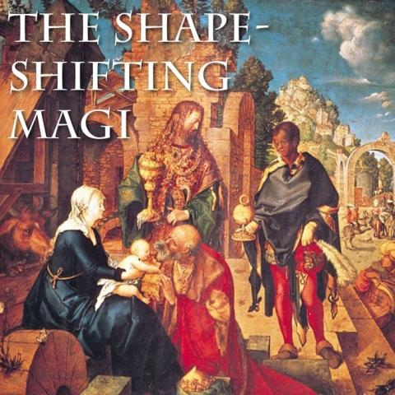
Published On: December 27, 2023
One of the interesting things about mythic stories is that the best ones have very few details. Less is more. Take the Magi who bring gifts to Jesus. We know them as the “three wise men” or “the three kings”, but the gospel account in Matthew doesn’t say either of those things. It simply mentions Magi who bring frankincense, gold, and myrrh. But as the story got told and retold, people wanted to fill in the blanks. How many Magi? Three, since there were three gifts. Wise men? Wise because they sought out Jesus by reading the stars. Men? An assumption. Some medieval paintings show a wise woman. In time, they even gained racial characteristics, and ages too. This picture shows men of three different stages of life, young, middle-aged, and old. Three races, too, representing the three known continents at the time: Asia, Africa, and Europe. They were given names: Melchior, Balthasar, Caspar. Over time, these unnamed, vague astrologers came to represent all of (male) humanity. Totally dropped the ball on gender. That’s patriarchy for you.
This “magi-cal” visit is a reminder that Christianity offered its insights to all the peoples and nations of the world. A lovely idea, but one that also justified a lot of coercive, colonial Christianity over the centuries. Indeed, starting early on, there was a belief that when the Magi met Jesus, any magical powers they possessed simply stopped. Their visit was not just to honour the newborn king, but a capitulation on behalf of pagan cultures. Paganism and its magic had been defeated. (John Milton’s poem “On the morning of Christ’s Nativity” plays on this idea.) So, as the Magi became better defined in the West, they also became tools in an imperial view of Christianity, justifying the conquest of other cultures.
Perhaps at this time, we could benefit from telling new stories about Christians who come with gifts to other faiths and cultures. Not to conquer or convert, but to show respect and listen. Those would be wise visitors, and this time, perhaps not all of them would be remembered as men.
—Rev. Stephen Milton came to Lawrence Park Community Church in Toronto in 2019, after decades of work as a documentary filmmaker. His passion is creating new ways to explore spirituality, appealing to people who aren’t interested in regular Sunday morning church services.
The views contained within these blogs are personal and do not necessarily reflect those of The United Church of Canada.

A gift of belonging to a church is that the practice of gathering together for worship … to pray, sing, listen to scripture and share how God touches our lives – helps us grow in deeper relationship with God and each other. We are offering this practice of sharing beyond Sunday morning to deepen our connection. Each week you are offered a picture, a scripture and a question for contemplation, as well as a short reflection for you to contemplate, have conversation with people in your life and/or join an online conversation on our Rockwood Stone Facebook page.

